###### **MOUNT CARMEL COLLEGE, AUTONOMOUS**

**No. 58, Palace Road, Bengaluru – 560052**

**ADVANCED WEB PROGRAMMING LAB**

**LAB RECORD**



**Submitted**

**By**

**NAME:**

**Register No:**

**I Semester MCA**

**Batch: 2020-2022**

###### LOGO-BLACK**Mount Carmel College, Autonomous**

**No.58, Palace Road, Bengaluru - 52**

###### **CERTIFICATE**

This is to certify that by Name( Register No), student of Master of computer applications, batch [2020-2022], of Mount Carmel College, Autonomous has successfully completed the practical programs in Advanced Web Programming Lab prescribed by the Board of Studies, Department of MCA, Mount Carmel College, Autonomous, Bengaluru affiliated to Bengaluru City University and approved by AICTE for I semester MCA for the academic year 2020-2021.

**Faculty in Charge Coordinator,**

**MCA Programme**

**Date:**

**Examiners: College Seal**

**1. ____________________**

**2. ______________________**

**INDEX**

**Program 1:**

TYPOGRAPHY

<html>

  <head>

    <title>TYPOGRAPHY</title>

 </head>

  <body>

    <div class="container">

         <h1 class="display-4"><center>Courses offered in ABC pu collage</center></h1>

         <center><blockquote class="blockquote">

         <pre><mark>" IF YOU ARE INTERESTED YOU NEED TO APPLY THROW ONLINE."</mark>"</pre>

         <footer class="blockquote.footer"><small><code>DETAILS ARE</code></small></footer></blockquote>

         </center>

    <p>ABC pu college offers three combination of commerce, science, arts,

         that contains different types of streams

           </p>

            <p>use <kbd>ctrl +p</kbd>to open the print dilog box.</p>

              <dl><h2>courses offered</h2></dl>

                 <dt><h3>courses in commerce</h3></dt>

                 <p> in commerce we offer 4 types of combination  SEBA,CEBA,SCBA,MEBA this all combination is of  2 years

                    the abrivations are  Accounts, Business Studies, Mathematics, Statistics , computer science .

                     the students can apply throw online.

                 </p>

                 <dt><h3>courses in science</h3></dt>

                 <p> in science we offer 3 types of combination  PCMB.PCMC,PCME this all combination is of  2 years

                     the abrivations are Physics,Chemistry,Maths,Biology .

                      student can apply throw online

                 </p>

                 <dt><h3>courses in arts</h3></dt>

                 <p> in arts we offer 3 types of combination  HEPG,HEBG,GBEP this all combination is of  2 years

                    History,Economics,Sociology,Political science.student can apply throw online

                 </p>

    </div>

  </body>

</html>

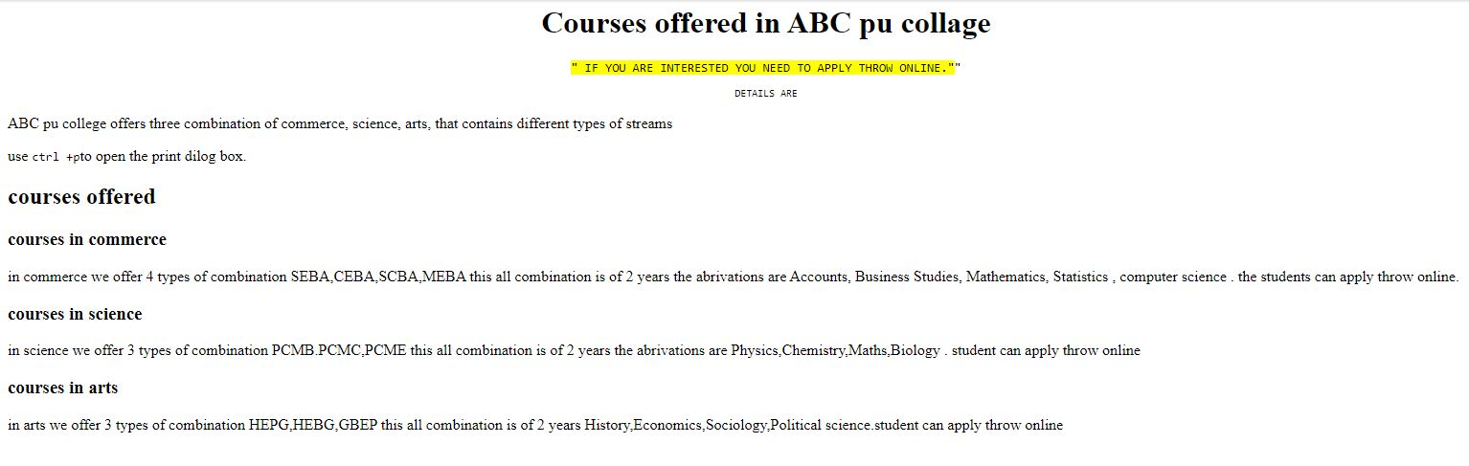

Table and image

<!DOCTYPE html>

<html lang="en">

<head>

  <title>Tables and Images</title>

  <meta charset="utf-8">

  <meta name="viewport" content="width=device-width, initial-scale=1">

  <link rel="stylesheet" href="https://maxcdn.bootstrapcdn.com/bootstrap/4.5.2/css/bootstrap.min.css">

  <script src="https://ajax.googleapis.com/ajax/libs/jquery/3.5.1/jquery.min.js"></script>

  <script src="https://cdnjs.cloudflare.com/ajax/libs/popper.js/1.16.0/umd/popper.min.js"></script>

  <script src="https://maxcdn.bootstrapcdn.com/bootstrap/4.5.2/js/bootstrap.min.js"></script>

</head>

<body>

    <div class="container">

        <center><h3>AIRLINES TIMINGS</h3></center></div>

    <td class="w-25">

        <center><img src="C:\Users\student\Desktop\awp lab\table and image.jpg" class="img-fluid img-thumbnail" alt="Sheep"></center>

    </td>

</tbody>

</table>

</div>

</div>

</div><div class="container">

  <table class="table"border="2">

    <thead class="thead-dark">

  <thead>

    <tr>

      <tr style="background-color:cornflowerblue">

      <th scope="col">IMAGE</th>

      <th scope="col">DATE</th>

      <th scope="col">FROM-TO</th>

      <th scope="col">NAME</th>

      <th scope="col">ARRIVAL</th>

      <th scope="col">DEPARTUER</th>

      </tr>

    </tr>

  </thead>

  <tbody>

    <tr>

      <tr style="background-color:mediumseagreen">

        <td><img src="C:\Users\student\Desktop\awp lab\table and image.jpg" class="rounded" height="100px"></td>

      <th scope="row">23/1/2021</th>

      <td>BANGALORE-MANGALORE</td>

      <td>ABCD AIRLINES</td>

      <td>7:00 AM</td>

      <td>9:00 AM</td>

    </tr></tr>

    <tr>

      <tr style="background-color:mediumseagreen">

        <td><img src="C:\Users\student\Desktop\awp lab\table and image.jpg" class="rounded-circle" height="100px"></td>

      <th scope="row">23/1/2021</th>

      <td>MANGALORE- BANGALORE</td>

      <td>WXYZ AIRLINES</td>

      <td>3:00 PM</td>

      <td>5:00 PM</td>

    </tr></tr>

    <tr>

      <tr style="background-color:mediumseagreen">

        <td><img src="C:\Users\student\Desktop\awp lab\table and image.jpg" class="img-thumbnail" height="100px"></td>

        <th scope="row">24/1/2021</th>

        <td>MANGALORE- BANGALORE</td>

        <td>WXYZ AIRLINES</td>

        <td>3:00 PM</td>

        <td>5:00 PM</td>

      </tr>

      </tr>

    </tbody>

    </table>

    </div>

    </div>

    </div>

    </body>

</html>

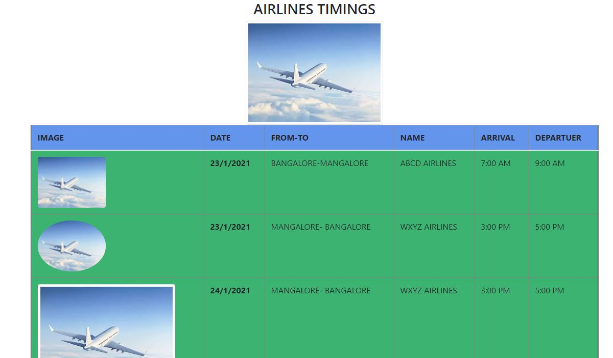

Jumbotorn

<!DOCTYPE html>

<html lang="en">

    <head>

        <title>Jumbotron and alerts</title>

        <meta charset="utf-8">

        <meta name="viewport" content="width=device-width,initial-scale=1">

        <link rel="stylesheet" href="https://maxcdn.bootstrapcdn.com/bootstrap/4.5.2/css/bootstrap.min.css">

        <script src="https://ajax.googleapis.com/ajax/libs/jquery/3.5.1/jquery.min.js"></script>

        <script src="https://cdnjs.cloudflare.com/ajax/libs/popper.js/1.16.0/umd/popper.min.js"></script>

        <script src="https://maxcdn.bootstrapcdn.com/bootstrap/4.5.2/js/bootstrap.min.js"></script>

    </head>

    <body>

        <div class="jumbotron jumbotron-fluid" style="background-color:crimson">

        <div class="container">

            <center><h1 class="text-white display-4">Planning a Trip</h1></center>

            <center><p>Gearing up for a trip to the outback?Let's make your Flecterview visit great.</p></center>

            <img src="C:\Users\student\Desktop\awp lab\jumbotorn.jpg" class="rounded img-thumbnail mx-auto d-block" width="80" height="80">

            <center><p><mark>Visit</mark></p></center>

        </div>

        </div>

        <center><p>Before you can experience authentic Spanish tapas, piazzas in Rome, or rooftop terraces in Prague, an important to-do list stands between you and your European vacation. The logistics involved in planning a trip to Europe may seem tedious or overwhelming, but the more prepared you are, the greater your chances of a successful trip that lives up to your expectations. </p></center>

        <div class="alert alert-info alert-dismissible fade show">

            <button type="button" class="close" data-dismiss="alert">&times;</button>

            <strong>Info!!</strong> Tickets available.

        </div>

    </body>

    </html>

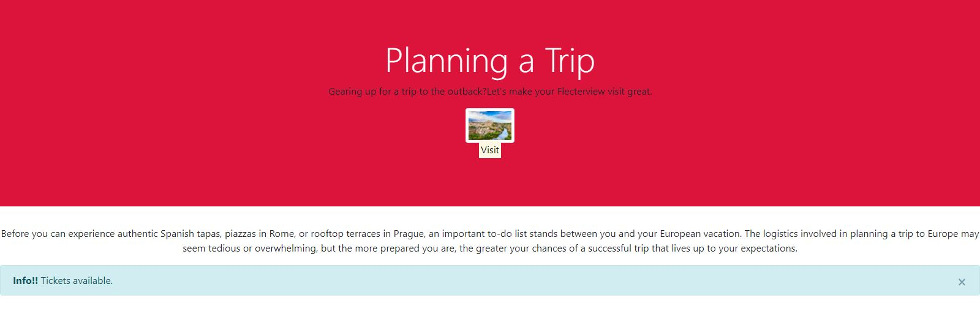

Button4

<!DOCTYPE html>

<html lang="en">

    <head>

        <title>Button</title>

        <meta charset="utf-8">

        <meta name="viewport" content="width=device-width,initial-scale=1">

        <link rel="stylesheet" href="https://maxcdn.bootstrapcdn.com/bootstrap/4.5.2/css/bootstrap.min.css">

        <script src="https://ajax.googleapis.com/ajax/libs/jquery/3.5.1/jquery.min.js"></script>

        <script src="https://cdnjs.cloudflare.com/ajax/libs/popper.js/1.16.0/umd/popper.min.js"></script>

        <script src="https://maxcdn.bootstrapcdn.com/bootstrap/4.5.2/js/bootstrap.min.js"></script>

    </head>

    <body>

        <body class="container">

            <h1 class="display-4"><center><pre><mark>Feedback Form</mark></pre></center></h1>

            <p><center>Fill out the form with honesty </center> </p>

            <div class="form group row mt-4 justify-content-center"><!--label name-->

            <label for="_name" class="text-dark col-sm-3 col-form-label">Name</label>

            <div class="col-sm-6">

                <input class="form-control" type="text" id="_name" placeholder="carpool">

            </div>

        </div>

        <div class="form group row mt-3 justify-content-center"><!--email-->

        <label for="_email" class="text-dark col-sm-3 col-form-label">Email</label>

        <div class="col-sm-6">

            <input type="email" class="form-control" id="_email" placeholder="carpool@example.com">

        </div>

        </div>

            <div class="form-group row mt-3 justify-content-center"><!--recommend-->

            <label for="_email" class="text-dark col-sm-3 col-form-label">Share this page?</label>

            <div class="col-sm-6 mt-3">

                <div class="btn-group" role="group" id="will_recommend">

                    <button type="button" class="btn btn-dark" id="yes">Yes</button>

                    <button type="button" class="btn btn-secondary " id="no">May Be</button>

                    <button type="button" class="btn btn-light " id="may_be">No</button>

                    <button type="button" class="btn btn-link">Open Link</button>

                </div>

            </div>

            </div>

            <div class="form-group row mt-3 justify-content-center"><!--email-->

                <label for="_email" class="text-dark col-sm-3 col-form-label">Remarks</label>

                <div class="col-sm-6">

                    <textarea class="form-control" id="Suggestion" rows="3" cols="10"></textarea>

                </div>

            </div>

            <div class="form-group row justify-content-center">

                <div class="col-sm-3">

                </div>

                <div class="col-sm-6 justify-content-center">

                    <button type="button" class="btn btn-outline-primary" onclick="function()" id="feed_bck"stlye="font-family:j_text;">Submit Feedback</button>

                    <button class="btn btn-primary">

                        <span class="spinner-border spinner-border-sm"></span>

                      </button>

                    <div class="mt-3 progress-bar progress-bar-striped" id="pg_bar" role="progressbar" aria-valuenow="0" ariavaluemax="100" stlye="width:0%">Updating!</div>

                </div>

            </div>

        </body>

        </body>

        </html>

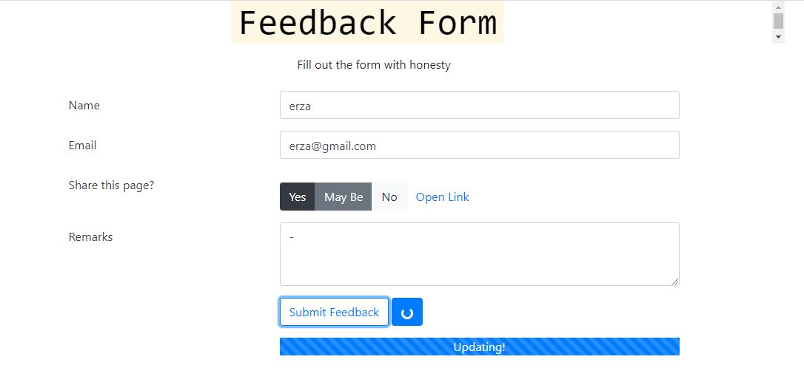

Navbar

<!DOCTYPE html>

<html lang="en">

    <head>

        <title>Button</title>

        <meta charset="utf-8">

        <meta name="viewport" content="width=device-width,initial-scale=1">

        <link rel="stylesheet" href="https://maxcdn.bootstrapcdn.com/bootstrap/4.5.2/css/bootstrap.min.css">

        <script src="https://ajax.googleapis.com/ajax/libs/jquery/3.5.1/jquery.min.js"></script>

        <script src="https://cdnjs.cloudflare.com/ajax/libs/popper.js/1.16.0/umd/popper.min.js"></script>

        <script src="https://maxcdn.bootstrapcdn.com/bootstrap/4.5.2/js/bootstrap.min.js"></script>

    </head>

    <body>

        <nav class="navbar navbar-expand-sm bg-dark navbar-dark">

            <!-- Brand/logo -->

            <a class="navbar-brand" href="#">

              <img src="C:\Users\Hi\Downloads\wp lab work\lab 2,3.jpg." alt="logo" style="width:40px;">

            </a>

            <!-- Links -->

            <ul class="navbar-nav">

              <li class="nav-item">

                <a class="nav-link" href="table and image.html">Link 1</a>

              </li>

              <li class="nav-item">

                <a class="nav-link" href="table and image.html">Link 2</a>

              </li>

              <li class="nav-item">

                <a class="nav-link" href="table and image.html">Link 3</a>

              </li>

            </ul>

          </nav>

          <div class="container-fluid">

            <h3>AIRLINE</h3>

          </div>

          <div class="container-fluid">

            <h3>Airline timings</h3>

            <p>please do click on link to check the flight timings and date.</p>

          </div>

    <div class="container">

      <h2>REGISTRATION</h2>

      <action="/action_page.php">

        <div class="form-group">

          <label for="email">Email:</label>

          <input type="email" class="form-control" id="email" placeholder="Enter email" name="email">

        </div>

        <div class="form-group">

          <label for="pwd">Password:</label>

          <input type="password" class="form-control" id="pwd" placeholder="Enter password" name="pswd">

        </div>

        <div class="form-group form-check">

          <label class="form-check-label">

            <input class="form-check-input" type="checkbox" name="remember"> Remember me

          </label>

        </div>

        <button type="submit" class="btn btn-primary">Submit</button>

      </form>

    </div>

    </body>

    </html>

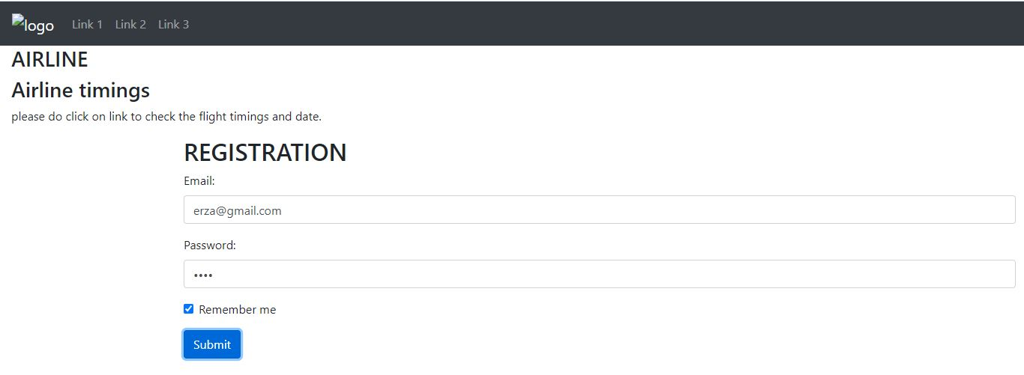

Pagenation

!DOCTYPE html>

<html lang="en">

<head>

  <title>PAGENATION AND GRID</title>

  <meta charset="utf-8">

  <meta name="viewport" content="width=device-width, initial-scale=1">

  <link rel="stylesheet" href="https://maxcdn.bootstrapcdn.com/bootstrap/4.5.2/css/bootstrap.min.css">

  <script src="https://ajax.googleapis.com/ajax/libs/jquery/3.5.1/jquery.min.js"></script>

  <script src="https://cdnjs.cloudflare.com/ajax/libs/popper.js/1.16.0/umd/popper.min.js"></script>

  <script src="https://maxcdn.bootstrapcdn.com/bootstrap/4.5.2/js/bootstrap.min.js"></script>

</head>

<body>

<div class="container">

    <h1 class="display-4"><center>ADVANCED WEB PROGRAMMING</center></h1>

    <center><blockquote class="blockquote"></blockquote></center>

  <div class pagination style="background-color:rgb(7, 137, 243)">

  <p>ADVANCED WEB PROGRAMMING, LAB PROGRAMS WHICH ARE COMPLETED TILL JANUARY 31/01/2021:</p>

  <ul class="pagination">

    <li class="page-item active"><a class="page-link" href="table and image.html">1</a></li>

    <li class="page-item active"><a class="page-link" href="typography.html">2</a></li>

    <li class="page-item active"><a class="page-link" href="navbar.html">3</a></li>

    <li class="page-item active"><a class="page-link" href="jumbotorn.html">4</a></li>

    <li class="page-item active"><a class="page-link" href="button4.html">5</a></li> CLICK

  </ul>

  </div>

  </div>

</div>

<div class="container-fluid">

    <h2>TO BE COMPLETED IN THEORY AND LAB</h2>

    <p>THE POSIONS SHOULD BE COMPLETED BY APRIL 10TH 2021.</p>

  </div>

  <div class="container-fluid">

    <div class="row">

        <div class="col bg-warning"><h4>THEORY TO BE COMPLETED:</h4> They are 3 units to be completed by 10th april 2021.</div>

        <div class="col bg-success"><h4>THEORY THAT IS COMPLETED</h4> out of 5 units 2 units are complited till january 31/01/2021</div>

      <div class="col bg-warning"><h4>LAB PROGRAM TO BE COMPLETED</h4>They are 14 programs out of that 5 are completed,you can check it above</div>

    </div>

  </div>

</body>

</html>

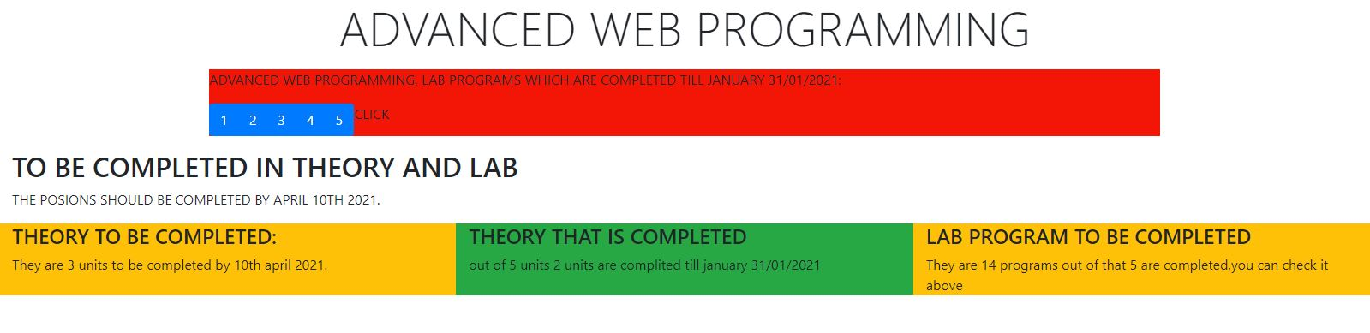

Title of the Project:

**Online Car Rental System**

**Introduction and objective of the project:**

1. **Introduction**

This project is designed so as to be used by Car Rental Company specializing in renting cars to customers. It is an online system through which customers can view available cars, register, view profile and book car. The advancement in Information Technology and internet penetration has greatly enhanced various business processes and communication between companies (services provider) and their customers of which car rental industry is not left out.

The Car Rental System is being developed for customers so that they can book their vehicles from any part of the world. This application takes information from the customers through filling their details. A customer being registered in the website has the facility to book a vehicle which he requires.

The proposed system is completely integrated online systems. It automates manual procedure in an effective and efficient way. This automated system facilitates customer and provides to fill up the details according to their requirements. It includes type of vehicle they are trying to hire and location. The purpose of this system is to develop a web site for the people who can book their vehicles along with requirements from any part of the world.

Objectives:

* Enhance Business Processes: To be able to use internet technology toproject

the rental company to the global world instead of limiting their services to their local domain alone, thus increase their return on investment (ROI).

* Online Vehicle Reservation: A tools through which customers canreserve

available cars online prior to their expected pick-up date or time.

* Customer’sregistration:Aregistrationportaltoholdcustomer’sdetails,

monitor their transaction and used same to offer better and improve services to them.

* Group bookings: Allows the customer to book space for a group in the caseof

weddings or corporate meetings (Event management).

* The content management system (CMS) for managing the content of thecars
* The data securitysystem
* Reporting of the cars, bookingetc

**Modules**

* 1. Adminmodule:
     + Registration:

1. EmployeeRegistration
2. UserRegistration,
3. VehiclesRegistration,
   * + BookingDetail:
4. Onlinebooking

b. Manualbooking

* + - BookingOperation:

1. BookingConformation
2. BookingCancellation
   * + Search
   1. Usermodule:
      * VehiclesCatalogs
      * Booking
3. Onlinebooking
4. Manualbooking
   * + SearchCar
   1. Reports
      * DailyReport
      * WeeklyReport
      * MonthlyReport
      * YearlyReport

The proposed system facilitates the customers to fill up their details, and to give a brief description of a vehicle they want to book. This new system is very helpful for customers who want to hire their vehicles through thissite.

**ER Diagram:**

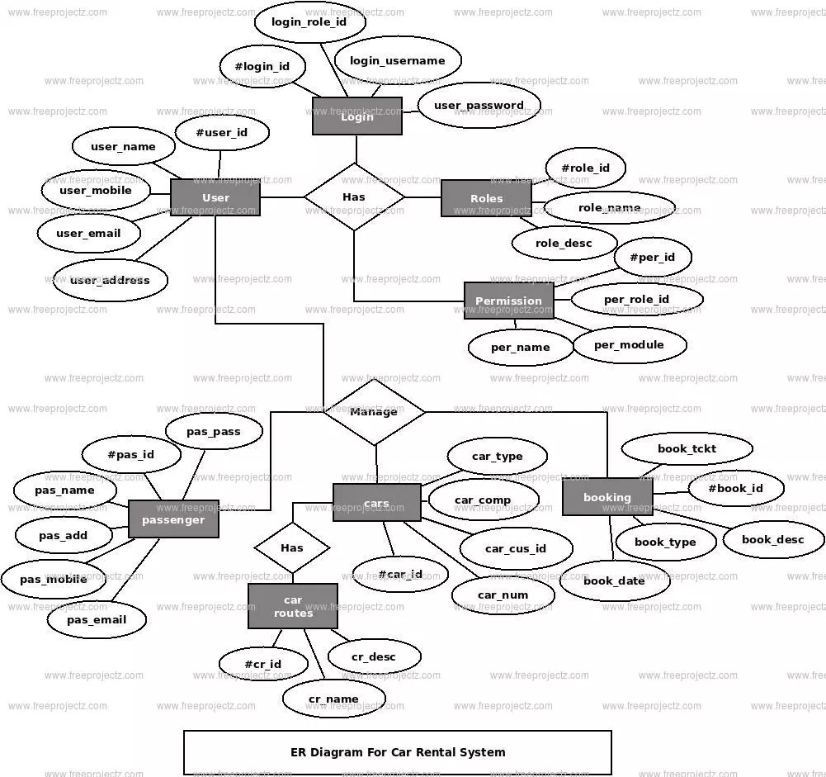

**DFD Diagram:**

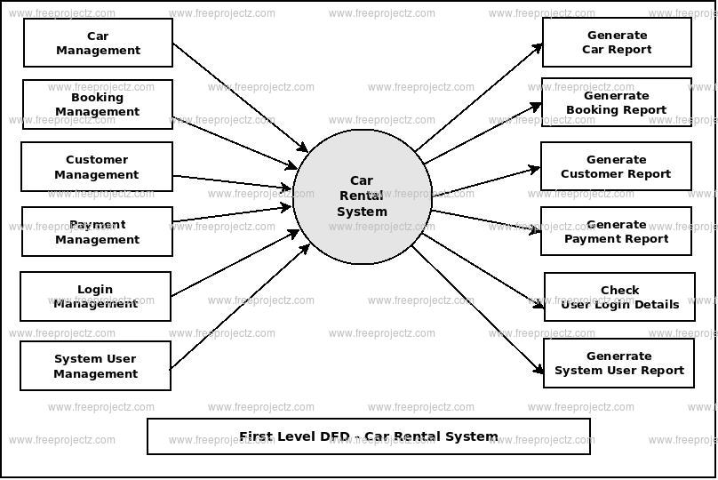

**CODING**

**Car-listing**

<?php

session_start();

include('includes/config.php');

error_reporting(0);

?>

<!DOCTYPE HTML>

<html lang="en">

<head>

<title>Car Rental Portal | Car Listing</title>

<!--Bootstrap -->

<link rel="stylesheet" href="assets/css/bootstrap.min.css" type="text/css">

<!--Custome Style -->

<link rel="stylesheet" href="assets/css/style.css" type="text/css">

<!--OWL Carousel slider-->

<link rel="stylesheet" href="assets/css/owl.carousel.css" type="text/css">

<link rel="stylesheet" href="assets/css/owl.transitions.css" type="text/css">

<!--slick-slider -->

<link href="assets/css/slick.css" rel="stylesheet">

<!--bootstrap-slider -->

<link href="assets/css/bootstrap-slider.min.css" rel="stylesheet">

<!--FontAwesome Font Style -->

<link href="assets/css/font-awesome.min.css" rel="stylesheet">

<!-- SWITCHER -->

    <link rel="stylesheet" id="switcher-css" type="text/css" href="assets/switcher/css/switcher.css" media="all" />

    <link rel="alternate stylesheet" type="text/css" href="assets/switcher/css/red.css" title="red" media="all" data-default-color="true" />

    <link rel="alternate stylesheet" type="text/css" href="assets/switcher/css/orange.css" title="orange" media="all" />

    <link rel="alternate stylesheet" type="text/css" href="assets/switcher/css/blue.css" title="blue" media="all" />

    <link rel="alternate stylesheet" type="text/css" href="assets/switcher/css/pink.css" title="pink" media="all" />

    <link rel="alternate stylesheet" type="text/css" href="assets/switcher/css/green.css" title="green" media="all" />

    <link rel="alternate stylesheet" type="text/css" href="assets/switcher/css/purple.css" title="purple" media="all" />

<!-- Fav and touch icons -->

<link rel="apple-touch-icon-precomposed" sizes="144x144" href="assets/images/favicon-icon/apple-touch-icon-144-precomposed.png">

<link rel="apple-touch-icon-precomposed" sizes="114x114" href="assets/images/favicon-icon/apple-touch-icon-114-precomposed.html">

<link rel="apple-touch-icon-precomposed" sizes="72x72" href="assets/images/favicon-icon/apple-touch-icon-72-precomposed.png">

<link rel="apple-touch-icon-precomposed" href="assets/images/favicon-icon/apple-touch-icon-57-precomposed.png">

<link rel="shortcut icon" href="assets/images/favicon-icon/favicon.png">

<link href="https://fonts.googleapis.com/css?family=Lato:300,400,700,900" rel="stylesheet">

</head>

<body>

<!-- Start Switcher -->

<?php include('includes/colorswitcher.php');?>

<!-- /Switcher -->

<!--Header-->

<?php include('includes/header.php');?>

<!-- /Header -->

<!--Page Header-->

<section class="page-header listing_page">

  <div class="container">

    <div class="page-header_wrap">

      <div class="page-heading">

        <h1>Car Listing</h1>

      </div>

      <ul class="coustom-breadcrumb">

        <li><a href="#">Home</a></li>

        <li>Car Listing</li>

      </ul>

    </div>

  </div>

  <!-- Dark Overlay-->

  <div class="dark-overlay"></div>

</section>

<!-- /Page Header-->

<!--Listing-->

<section class="listing-page">

  <div class="container">

    <div class="row">

      <div class="col-md-9 col-md-push-3">

        <div class="result-sorting-wrapper">

          <div class="sorting-count">

<?php

//Query for Listing count

$sql = "SELECT id from tblvehicles";

$query = $dbh -> prepare($sql);

$query->bindParam(':vhid',$vhid, PDO::PARAM_STR);

$query->execute();

$results=$query->fetchAll(PDO::FETCH_OBJ);

$cnt=$query->rowCount();

?>

<p><span><?php echo htmlentities($cnt);?> Listings</span></p>

</div>

</div>

<?php $sql = "SELECT tblvehicles.*,tblbrands.BrandName,tblbrands.id as bid  from tblvehicles join tblbrands on tblbrands.id=tblvehicles.VehiclesBrand";

$query = $dbh -> prepare($sql);

$query->execute();

$results=$query->fetchAll(PDO::FETCH_OBJ);

$cnt=1;

if($query->rowCount() > 0)

{

foreach($results as $result)

{  ?>

        <div class="product-listing-m gray-bg">

          <div class="product-listing-img"><img src="admin/img/vehicleimages/<?php echo htmlentities($result->Vimage1);?>" class="img-responsive" alt="Image" /> </a>

          </div>

          <div class="product-listing-content">

            <h5><a href="vehical-details.php?vhid=<?php echo htmlentities($result->id);?>"><?php echo htmlentities($result->BrandName);?> , <?php echo htmlentities($result->VehiclesTitle);?></a></h5>

            <p class="list-price">$<?php echo htmlentities($result->PricePerDay);?> Per Day</p>

            <ul>

              <li><i class="fa fa-user" aria-hidden="true"></i><?php echo htmlentities($result->SeatingCapacity);?> seats</li>

              <li><i class="fa fa-calendar" aria-hidden="true"></i><?php echo htmlentities($result->ModelYear);?> model</li>

              <li><i class="fa fa-car" aria-hidden="true"></i><?php echo htmlentities($result->FuelType);?></li>

            </ul>

            <a href="vehical-details.php?vhid=<?php echo htmlentities($result->id);?>" class="btn">View Details <span class="angle_arrow"><i class="fa fa-angle-right" aria-hidden="true"></i></span></a>

          </div>

        </div>

      <?php }} ?>

         </div>

      <!--Side-Bar-->

      <aside class="col-md-3 col-md-pull-9">

        <div class="sidebar_widget">

          <div class="widget_heading">

            <h5><i class="fa fa-filter" aria-hidden="true"></i> Find Your  Car </h5>

          </div>

          <div class="sidebar_filter">

            <form action="search-carresult.php" method="post">

              <div class="form-group select">

                <select class="form-control" name="brand">

                  <option>Select Brand</option>

                  <?php $sql = "SELECT * from  tblbrands ";

$query = $dbh -> prepare($sql);

$query->execute();

$results=$query->fetchAll(PDO::FETCH_OBJ);

$cnt=1;

if($query->rowCount() > 0)

{

foreach($results as $result)

{       ?>

<option value="<?php echo htmlentities($result->id);?>"><?php echo htmlentities($result->BrandName);?></option>

<?php }} ?>

                </select>

              </div>

              <div class="form-group select">

                <select class="form-control" name="fueltype">

                  <option>Select Fuel Type</option>

<option value="Petrol">Petrol</option>

<option value="Diesel">Diesel</option>

<option value="CNG">CNG</option>

                </select>

              </div>

              <div class="form-group">

                <button type="submit" class="btn btn-block"><i class="fa fa-search" aria-hidden="true"></i> Search Car</button>

              </div>

            </form>

          </div>

        </div>

        <div class="sidebar_widget">

          <div class="widget_heading">

            <h5><i class="fa fa-car" aria-hidden="true"></i> Recently Listed Cars</h5>

          </div>

          <div class="recent_addedcars">

            <ul>

<?php $sql = "SELECT tblvehicles.*,tblbrands.BrandName,tblbrands.id as bid  from tblvehicles join tblbrands on tblbrands.id=tblvehicles.VehiclesBrand order by id desc limit 4";

$query = $dbh -> prepare($sql);

$query->execute();

$results=$query->fetchAll(PDO::FETCH_OBJ);

$cnt=1;

if($query->rowCount() > 0)

{

foreach($results as $result)

{  ?>

              <li class="gray-bg">

                <div class="recent_post_img"> <a href="vehical-details.php?vhid=<?php echo htmlentities($result->id);?>"><img src="admin/img/vehicleimages/<?php echo htmlentities($result->Vimage1);?>" alt="image"></a> </div>

                <div class="recent_post_title"> <a href="vehical-details.php?vhid=<?php echo htmlentities($result->id);?>"><?php echo htmlentities($result->BrandName);?> , <?php echo htmlentities($result->VehiclesTitle);?></a>

                  <p class="widget_price">$<?php echo htmlentities($result->PricePerDay);?> Per Day</p>

                </div>

              </li>

              <?php }} ?>

            </ul>

          </div>

        </div>

      </aside>

      <!--/Side-Bar-->

    </div>

  </div>

</section>

<!-- /Listing-->

<!--Footer -->

<?php include('includes/footer.php');?>

<!-- /Footer-->

<!--Back to top-->

<div id="back-top" class="back-top"> <a href="#top"><i class="fa fa-angle-up" aria-hidden="true"></i> </a> </div>

<!--/Back to top-->

<!--Login-Form -->

<?php include('includes/login.php');?>

<!--/Login-Form -->

<!--Register-Form -->

<?php include('includes/registration.php');?>

<!--/Register-Form -->

<!--Forgot-password-Form -->

<?php include('includes/forgotpassword.php');?>

<!-- Scripts -->

<script src="assets/js/jquery.min.js"></script>

<script src="assets/js/bootstrap.min.js"></script>

<script src="assets/js/interface.js"></script>

<!--Switcher-->

<script src="assets/switcher/js/switcher.js"></script>

<!--bootstrap-slider-JS-->

<script src="assets/js/bootstrap-slider.min.js"></script>

<!--Slider-JS-->

<script src="assets/js/slick.min.js"></script>

<script src="assets/js/owl.carousel.min.js"></script>

</body>

</html>

**Check availability:**

<?php

require_once("includes/config.php");

// code user email availablity

if(!empty($_POST["emailid"])) {

    $email= $_POST["emailid"];

    if (filter_var($email, FILTER_VALIDATE_EMAIL)===false) {

        echo "error : You did not enter a valid email.";

    }

    else {

        $sql ="SELECT EmailId FROM tblusers WHERE EmailId=:email";

$query= $dbh -> prepare($sql);

$query-> bindParam(':email', $email, PDO::PARAM_STR);

$query-> execute();

$results = $query -> fetchAll(PDO::FETCH_OBJ);

$cnt=1;

if($query -> rowCount() > 0)

{

echo "<span style='color:red'> Email already exists .</span>";

 echo "<script>$('#submit').prop('disabled',true);</script>";

} else{

    echo "<span style='color:green'> Email available for Registration .</span>";

 echo "<script>$('#submit').prop('disabled',false);</script>";

}

}

}

?>

**Contact us**

<?php

session_start();

error_reporting(0);

include('includes/config.php');

if(isset($_POST['send']))

  {

$name=$_POST['fullname'];

$email=$_POST['email'];

$contactno=$_POST['contactno'];

$message=$_POST['message'];

$sql="INSERT INTO  tblcontactusquery(name,EmailId,ContactNumber,Message) VALUES(:name,:email,:contactno,:message)";

$query = $dbh->prepare($sql);

$query->bindParam(':name',$name,PDO::PARAM_STR);

$query->bindParam(':email',$email,PDO::PARAM_STR);

$query->bindParam(':contactno',$contactno,PDO::PARAM_STR);

$query->bindParam(':message',$message,PDO::PARAM_STR);

$query->execute();

$lastInsertId = $dbh->lastInsertId();

if($lastInsertId)

{

$msg="Query Sent. We will contact you shortly";

}

else

{

$error="Something went wrong. Please try again";

}

}

?>

<!DOCTYPE HTML>

<html lang="en">

<head>

<title>Car Rental|| Contact Us Page</title>

<!--Bootstrap -->

<link rel="stylesheet" href="assets/css/bootstrap.min.css" type="text/css">

<!--Custome Style -->

<link rel="stylesheet" href="assets/css/style.css" type="text/css">

<!--OWL Carousel slider-->

<link rel="stylesheet" href="assets/css/owl.carousel.css" type="text/css">

<link rel="stylesheet" href="assets/css/owl.transitions.css" type="text/css">

<!--slick-slider -->

<link href="assets/css/slick.css" rel="stylesheet">

<!--bootstrap-slider -->

<link href="assets/css/bootstrap-slider.min.css" rel="stylesheet">

<!--FontAwesome Font Style -->

<link href="assets/css/font-awesome.min.css" rel="stylesheet">

<!-- SWITCHER -->

    <link rel="stylesheet" id="switcher-css" type="text/css" href="assets/switcher/css/switcher.css" media="all" />

    <link rel="alternate stylesheet" type="text/css" href="assets/switcher/css/red.css" title="red" media="all" data-default-color="true" />

    <link rel="alternate stylesheet" type="text/css" href="assets/switcher/css/orange.css" title="orange" media="all" />

    <link rel="alternate stylesheet" type="text/css" href="assets/switcher/css/blue.css" title="blue" media="all" />

    <link rel="alternate stylesheet" type="text/css" href="assets/switcher/css/pink.css" title="pink" media="all" />

    <link rel="alternate stylesheet" type="text/css" href="assets/switcher/css/green.css" title="green" media="all" />

    <link rel="alternate stylesheet" type="text/css" href="assets/switcher/css/purple.css" title="purple" media="all" />

<!-- Fav and touch icons -->

<link rel="apple-touch-icon-precomposed" sizes="144x144" href="assets/images/favicon-icon/apple-touch-icon-144-precomposed.png">

<link rel="apple-touch-icon-precomposed" sizes="114x114" href="assets/images/favicon-icon/apple-touch-icon-114-precomposed.html">

<link rel="apple-touch-icon-precomposed" sizes="72x72" href="assets/images/favicon-icon/apple-touch-icon-72-precomposed.png">

<link rel="apple-touch-icon-precomposed" href="assets/images/favicon-icon/apple-touch-icon-57-precomposed.png">

<link rel="shortcut icon" href="assets/images/favicon-icon/favicon.png">

<link href="https://fonts.googleapis.com/css?family=Lato:300,400,700,900" rel="stylesheet">

 <style>

    .errorWrap {

    padding: 10px;

    margin: 0 0 20px 0;

    background: #fff;

    border-left: 4px solid #dd3d36;

    -webkit-box-shadow: 0 1px 1px 0 rgba(0,0,0,.1);

    box-shadow: 0 1px 1px 0 rgba(0,0,0,.1);

}

.succWrap{

    padding: 10px;

    margin: 0 0 20px 0;

    background: #fff;

    border-left: 4px solid #5cb85c;

    -webkit-box-shadow: 0 1px 1px 0 rgba(0,0,0,.1);

    box-shadow: 0 1px 1px 0 rgba(0,0,0,.1);

}

    </style>

</head>

<body>

<<!-- Start Switcher -->

<?php include('includes/colorswitcher.php');?>

<!-- /Switcher -->

<!--Header-->

<?php include('includes/header.php');?>

<!-- /Header -->

<!--Page Header-->

<section class="page-header contactus_page">

  <div class="container">

    <div class="page-header_wrap">

      <div class="page-heading">

        <h1>Contact Us</h1>

      </div>

      <ul class="coustom-breadcrumb">

        <li><a href="#">Home</a></li>

        <li>Contact Us</li>

      </ul>

    </div>

  </div>

  <!-- Dark Overlay-->

  <div class="dark-overlay"></div>

</section>

<!-- /Page Header-->

<!--Contact-us-->

<section class="contact_us section-padding">

  <div class="container">

    <div  class="row">

      <div class="col-md-6">

        <h3>Get in touch using the form below</h3>

          <?php if($error){?><div class="errorWrap"><strong>ERROR</strong>:<?php echo htmlentities($error); ?> </div><?php }

        else if($msg){?><div class="succWrap"><strong>SUCCESS</strong>:<?php echo htmlentities($msg); ?> </div><?php }?>

        <div class="contact_form gray-bg">

          <form  method="post">

            <div class="form-group">

              <label class="control-label">Full Name <span>*</span></label>

              <input type="text" name="fullname" class="form-control white_bg" id="fullname" required>

            </div>

            <div class="form-group">

              <label class="control-label">Email Address <span>*</span></label>

              <input type="email" name="email" class="form-control white_bg" id="emailaddress" required>

            </div>

            <div class="form-group">

              <label class="control-label">Phone Number <span>*</span></label>

              <input type="text" name="contactno" class="form-control white_bg" id="phonenumber" required maxlength="10" pattern="[0-9]+">

            </div>

            <div class="form-group">

              <label class="control-label">Message <span>*</span></label>

              <textarea class="form-control white_bg" name="message" rows="4" required></textarea>

            </div>

            <div class="form-group">

              <button class="btn" type="submit" name="send" type="submit">Send Message <span class="angle_arrow"><i class="fa fa-angle-right" aria-hidden="true"></i></span></button>

            </div>

          </form>

        </div>

      </div>

      <div class="col-md-6">

        <h3>Contact Info</h3>

        <div class="contact_detail">

              <?php

$pagetype=$_GET['type'];

$sql = "SELECT Address,EmailId,ContactNo from tblcontactusinfo";

$query = $dbh -> prepare($sql);

$query->bindParam(':pagetype',$pagetype,PDO::PARAM_STR);

$query->execute();

$results=$query->fetchAll(PDO::FETCH_OBJ);

$cnt=1;

if($query->rowCount() > 0)

{

foreach($results as $result)

{ ?>

          <ul>

            <li>

              <div class="icon_wrap"><i class="fa fa-map-marker" aria-hidden="true"></i></div>

              <div class="contact_info_m"><?php   echo htmlentities($result->Address); ?></div>

            </li>

            <li>

              <div class="icon_wrap"><i class="fa fa-phone" aria-hidden="true"></i></div>

              <div class="contact_info_m"><a href="tel:61-1234-567-90"><?php   echo htmlentities($result->EmailId); ?></a></div>

            </li>

            <li>

              <div class="icon_wrap"><i class="fa fa-envelope-o" aria-hidden="true"></i></div>

              <div class="contact_info_m"><a href="mailto:contact@exampleurl.com"><?php   echo htmlentities($result->ContactNo); ?></a></div>

            </li>

          </ul>

        <?php }} ?>

        </div>

      </div>

    </div>

  </div>

</section>

<!-- /Contact-us-->

<!--Footer -->

<?php include('includes/footer.php');?>

<!-- /Footer-->

<!--Back to top-->

<div id="back-top" class="back-top"> <a href="#top"><i class="fa fa-angle-up" aria-hidden="true"></i> </a> </div>

<!--/Back to top-->

<!--Login-Form -->

<?php include('includes/login.php');?>

<!--/Login-Form -->

<!--Register-Form -->

<?php include('includes/registration.php');?>

<!--/Register-Form -->

<!--Forgot-password-Form -->

<?php include('includes/forgotpassword.php');?>

<!--/Forgot-password-Form -->

<!-- Scripts -->

<script src="assets/js/jquery.min.js"></script>

<script src="assets/js/bootstrap.min.js"></script>

<script src="assets/js/interface.js"></script>

<!--Switcher-->

<script src="assets/switcher/js/switcher.js"></script>

<!--bootstrap-slider-JS-->

<script src="assets/js/bootstrap-slider.min.js"></script>

<!--Slider-JS-->

<script src="assets/js/slick.min.js"></script>

<script src="assets/js/owl.carousel.min.js"></script>

</body>

<!-- Mirrored from themes.webmasterdriver.net/carforyou/demo/contact-us.html by HTTrack Website Copier/3.x [XR&CO'2014], Fri, 16 Jun 2017 07:26:55 GMT -->

</html>

**Index**

<?php

session_start();

include('includes/config.php');

error_reporting(0);

?>

<!DOCTYPE HTML>

<html lang="en">

<head>

<title>Car Rental Portal</title>

<!--Bootstrap -->

<link rel="stylesheet" href="assets/css/bootstrap.min.css" type="text/css">

<link rel="stylesheet" href="assets/css/style.css" type="text/css">

<link rel="stylesheet" href="assets/css/owl.carousel.css" type="text/css">

<link rel="stylesheet" href="assets/css/owl.transitions.css" type="text/css">

<link href="assets/css/slick.css" rel="stylesheet">

<link href="assets/css/bootstrap-slider.min.css" rel="stylesheet">

<link href="assets/css/font-awesome.min.css" rel="stylesheet">

    <link rel="stylesheet" id="switcher-css" type="text/css" href="assets/switcher/css/switcher.css" media="all" />

    <link rel="alternate stylesheet" type="text/css" href="assets/switcher/css/red.css" title="red" media="all" data-default-color="true" />

    <link rel="alternate stylesheet" type="text/css" href="assets/switcher/css/orange.css" title="orange" media="all" />

    <link rel="alternate stylesheet" type="text/css" href="assets/switcher/css/blue.css" title="blue" media="all" />

    <link rel="alternate stylesheet" type="text/css" href="assets/switcher/css/pink.css" title="pink" media="all" />

    <link rel="alternate stylesheet" type="text/css" href="assets/switcher/css/green.css" title="green" media="all" />

    <link rel="alternate stylesheet" type="text/css" href="assets/switcher/css/purple.css" title="purple" media="all" />

<link rel="apple-touch-icon-precomposed" sizes="144x144" href="assets/images/favicon-icon/apple-touch-icon-144-precomposed.png">

<link rel="apple-touch-icon-precomposed" sizes="114x114" href="assets/images/favicon-icon/apple-touch-icon-114-precomposed.html">

<link rel="apple-touch-icon-precomposed" sizes="72x72" href="assets/images/favicon-icon/apple-touch-icon-72-precomposed.png">

<link rel="apple-touch-icon-precomposed" href="assets/images/favicon-icon/apple-touch-icon-57-precomposed.png">

<link rel="shortcut icon" href="assets/images/favicon-icon/favicon.png">

<link href="https://fonts.googleapis.com/css?family=Lato:300,400,700,900" rel="stylesheet">

</head>

<body>

<!-- Start Switcher -->

<?php include('includes/colorswitcher.php');?>

<!-- /Switcher -->

<!--Header-->

<?php include('includes/header.php');?>

<!-- /Header -->

<!-- Banners -->

<section id="banner" class="banner-section">

  <div class="container">

    <div class="div_zindex">

      <div class="row">

        <div class="col-md-5 col-md-push-7">

          <div class="banner_content">

            <h1>&nbsp;</h1>

            <p>&nbsp; </p>

            </div>

        </div>

      </div>

    </div>

  </div>

</section>

<!-- /Banners -->

<!-- Resent Cat-->

<section class="section-padding gray-bg">

  <div class="container">

    <div class="section-header text-center">

      <h2>Find the Best <span>CarForYou</span></h2>

      <p>There are many variations of passages of Lorem Ipsum available, but the majority have suffered alteration in some form, by injected humour, or randomised words which don't look even slightly believable. If you are going to use a passage of Lorem Ipsum, you need to be sure there isn't anything embarrassing hidden in the middle of text.</p>

    </div>

    <div class="row">

      <!-- Nav tabs -->

      <div class="recent-tab">

        <ul class="nav nav-tabs" role="tablist">

          <li role="presentation" class="active"><a href="#resentnewcar" role="tab" data-toggle="tab">New Car</a></li>

        </ul>

      </div>

      <!-- Recently Listed New Cars -->

      <div class="tab-content">

        <div role="tabpanel" class="tab-pane active" id="resentnewcar">

<?php $sql = "SELECT tblvehicles.VehiclesTitle,tblbrands.BrandName,tblvehicles.PricePerDay,tblvehicles.FuelType,tblvehicles.ModelYear,tblvehicles.id,tblvehicles.SeatingCapacity,tblvehicles.VehiclesOverview,tblvehicles.Vimage1 from tblvehicles join tblbrands on tblbrands.id=tblvehicles.VehiclesBrand limit 9";

$query = $dbh -> prepare($sql);

$query->execute();

$results=$query->fetchAll(PDO::FETCH_OBJ);

$cnt=1;

if($query->rowCount() > 0)

{

foreach($results as $result)

{

?>

<div class="col-list-3">

<div class="recent-car-list">

<div class="car-info-box"> <a href="vehical-details.php?vhid=<?php echo htmlentities($result->id);?>"><img src="admin/img/vehicleimages/<?php echo htmlentities($result->Vimage1);?>" class="img-responsive" alt="image"></a>

<ul>

<li><i class="fa fa-car" aria-hidden="true"></i><?php echo htmlentities($result->FuelType);?></li>

<li><i class="fa fa-calendar" aria-hidden="true"></i><?php echo htmlentities($result->ModelYear);?> Model</li>

<li><i class="fa fa-user" aria-hidden="true"></i><?php echo htmlentities($result->SeatingCapacity);?> seats</li>

</ul>

</div>

<div class="car-title-m">

<h6><a href="vehical-details.php?vhid=<?php echo htmlentities($result->id);?>"> <?php echo htmlentities($result->VehiclesTitle);?></a></h6>

<span class="price">$<?php echo htmlentities($result->PricePerDay);?> /Day</span>

</div>

<div class="inventory_info_m">

<p><?php echo substr($result->VehiclesOverview,0,70);?></p>

</div>

</div>

</div>

<?php }}?>

      </div>

    </div>

  </div>

</section>

<!-- /Resent Cat -->

<!-- Fun Facts-->

<section class="fun-facts-section">

  <div class="container div_zindex">

    <div class="row">

      <div class="col-lg-3 col-xs-6 col-sm-3">

        <div class="fun-facts-m">

          <div class="cell">

            <h2><i class="fa fa-calendar" aria-hidden="true"></i>40+</h2>

            <p>Years In Business</p>

          </div>

        </div>

      </div>

      <div class="col-lg-3 col-xs-6 col-sm-3">

        <div class="fun-facts-m">

          <div class="cell">

            <h2><i class="fa fa-car" aria-hidden="true"></i>1200+</h2>

            <p>New Cars For Sale</p>

          </div>

        </div>

      </div>

      <div class="col-lg-3 col-xs-6 col-sm-3">

        <div class="fun-facts-m">

          <div class="cell">

            <h2><i class="fa fa-car" aria-hidden="true"></i>1000+</h2>

            <p>Used Cars For Sale</p>

          </div>

        </div>

      </div>

      <div class="col-lg-3 col-xs-6 col-sm-3">

        <div class="fun-facts-m">

          <div class="cell">

            <h2><i class="fa fa-user-circle-o" aria-hidden="true"></i>600+</h2>

            <p>Satisfied Customers</p>

          </div>

        </div>

      </div>

    </div>

  </div>

  <!-- Dark Overlay-->

  <div class="dark-overlay"></div>

</section>

<!-- /Fun Facts-->

<!--Testimonial -->

<section class="section-padding testimonial-section parallex-bg">

  <div class="container div_zindex">

    <div class="section-header white-text text-center">

      <h2>Our Satisfied <span>Customers</span></h2>

    </div>

    <div class="row">

      <div id="testimonial-slider">

<?php

$tid=1;

$sql = "SELECT tbltestimonial.Testimonial,tblusers.FullName from tbltestimonial join tblusers on tbltestimonial.UserEmail=tblusers.EmailId where tbltestimonial.status=:tid limit 4";

$query = $dbh -> prepare($sql);

$query->bindParam(':tid',$tid, PDO::PARAM_STR);

$query->execute();

$results=$query->fetchAll(PDO::FETCH_OBJ);

$cnt=1;

if($query->rowCount() > 0)

{

foreach($results as $result)

{  ?>

        <div class="testimonial-m">

          <div class="testimonial-content">

            <div class="testimonial-heading">

              <h5><?php echo htmlentities($result->FullName);?></h5>

            <p><?php echo htmlentities($result->Testimonial);?></p>

          </div>

        </div>

        </div>

        <?php }} ?>

      </div>

    </div>

  </div>

  <!-- Dark Overlay-->

  <div class="dark-overlay"></div>

</section>

<!-- /Testimonial-->

<!--Footer -->

<?php include('includes/footer.php');?>

<!-- /Footer-->

<!--Back to top-->

<div id="back-top" class="back-top"> <a href="#top"><i class="fa fa-angle-up" aria-hidden="true"></i> </a> </div>

<!--/Back to top-->

<!--Login-Form -->

<?php include('includes/login.php');?>

<!--/Login-Form -->

<!--Register-Form -->

<?php include('includes/registration.php');?>

<!--/Register-Form -->

<!--Forgot-password-Form -->

<?php include('includes/forgotpassword.php');?>

<!--/Forgot-password-Form -->

<!-- Scripts -->

<script src="assets/js/jquery.min.js"></script>

<script src="assets/js/bootstrap.min.js"></script>

<script src="assets/js/interface.js"></script>

<!--Switcher-->

<script src="assets/switcher/js/switcher.js"></script>

<!--bootstrap-slider-JS-->

<script src="assets/js/bootstrap-slider.min.js"></script>

<!--Slider-JS-->

<script src="assets/js/slick.min.js"></script>

<script src="assets/js/owl.carousel.min.js"></script>

</body>

<!-- Mirrored from themes.webmasterdriver.net/carforyou/demo/index.html by HTTrack Website Copier/3.x [XR&CO'2014], Fri, 16 Jun 2017 07:22:11 GMT -->

</html>

**logout**

<?php

session_start();

$_SESSION = array();

if (ini_get("session.use_cookies")) {

    $params = session_get_cookie_params();

    setcookie(session_name(), '', time() - 60*60,

        $params["path"], $params["domain"],

        $params["secure"], $params["httponly"]

    );

}

unset($_SESSION['login']);

session_destroy(); // destroy session

header("location:index.php");

?>

**Manage bookings**

<?php

session_start();

error_reporting(0);

include('includes/config.php');

if(strlen($_SESSION['alogin'])==0)

    {

header('location:index.php');

}

else{

if(isset($_REQUEST['eid']))

    {

$eid=intval($_GET['eid']);

$status="2";

$sql = "UPDATE tblbooking SET Status=:status WHERE  id=:eid";

$query = $dbh->prepare($sql);

$query -> bindParam(':status',$status, PDO::PARAM_STR);

$query-> bindParam(':eid',$eid, PDO::PARAM_STR);

$query -> execute();

$msg="Booking Successfully Cancelled";

}

if(isset($_REQUEST['aeid']))

    {

$aeid=intval($_GET['aeid']);

$status=1;

$sql = "UPDATE tblbooking SET Status=:status WHERE  id=:aeid";

$query = $dbh->prepare($sql);

$query -> bindParam(':status',$status, PDO::PARAM_STR);

$query-> bindParam(':aeid',$aeid, PDO::PARAM_STR);

$query -> execute();

$msg="Booking Successfully Confirmed";

}

 ?>

<!doctype html>

<html lang="en" class="no-js">

<head>

    <meta charset="UTF-8">

    <meta http-equiv="X-UA-Compatible" content="IE=edge">

    <meta name="viewport" content="width=device-width, initial-scale=1, minimum-scale=1, maximum-scale=1">

    <meta name="description" content="">

    <meta name="author" content="">

    <meta name="theme-color" content="#3e454c">

    <title>Car Rental Portal |Admin Manage testimonials   </title>

    <!-- Font awesome -->

    <link rel="stylesheet" href="css/font-awesome.min.css">

    <!-- Sandstone Bootstrap CSS -->

    <link rel="stylesheet" href="css/bootstrap.min.css">

    <!-- Bootstrap Datatables -->

    <link rel="stylesheet" href="css/dataTables.bootstrap.min.css">

    <!-- Bootstrap social button library -->

    <link rel="stylesheet" href="css/bootstrap-social.css">

    <!-- Bootstrap select -->

    <link rel="stylesheet" href="css/bootstrap-select.css">

    <!-- Bootstrap file input -->

    <link rel="stylesheet" href="css/fileinput.min.css">

    <!-- Awesome Bootstrap checkbox -->

    <link rel="stylesheet" href="css/awesome-bootstrap-checkbox.css">

    <!-- Admin Stye -->

    <link rel="stylesheet" href="css/style.css">

  <style>

        .errorWrap {

    padding: 10px;

    margin: 0 0 20px 0;

    background: #fff;

    border-left: 4px solid #dd3d36;

    -webkit-box-shadow: 0 1px 1px 0 rgba(0,0,0,.1);

    box-shadow: 0 1px 1px 0 rgba(0,0,0,.1);

}

.succWrap{

    padding: 10px;

    margin: 0 0 20px 0;

    background: #fff;

    border-left: 4px solid #5cb85c;

    -webkit-box-shadow: 0 1px 1px 0 rgba(0,0,0,.1);

    box-shadow: 0 1px 1px 0 rgba(0,0,0,.1);

}

        </style>

</head>

<body>

    <?php include('includes/header.php');?>

    <div class="ts-main-content">

        <?php include('includes/leftbar.php');?>

        <div class="content-wrapper">

            <div class="container-fluid">

                <div class="row">

                    <div class="col-md-12">

                        <h2 class="page-title">Manage Bookings</h2>

                        <!-- Zero Configuration Table -->

                        <div class="panel panel-default">

                            <div class="panel-heading">Bookings Info</div>

                            <div class="panel-body">

                            <?php if($error){?><div class="errorWrap"><strong>ERROR</strong>:<?php echo htmlentities($error); ?> </div><?php }

                else if($msg){?><div class="succWrap"><strong>SUCCESS</strong>:<?php echo htmlentities($msg); ?> </div><?php }?>

                                <table id="zctb" class="display table table-striped table-bordered table-hover" cellspacing="0" width="100%">

                                    <thead>

                                        <tr>

                                        <th>#</th>

                                            <th>Name</th>

                                            <th>Vehicle</th>

                                            <th>From Date</th>

                                            <th>To Date</th>

                                            <th>Message</th>

                                            <th>Status</th>

                                            <th>Posting date</th>

                                            <th>Action</th>

                                        </tr>

                                    </thead>

                                    <tfoot>

                                        <tr>

                                        <th>#</th>

                                        <th>Name</th>

                                            <th>Vehicle</th>

                                            <th>From Date</th>

                                            <th>To Date</th>

                                            <th>Message</th>

                                            <th>Status</th>

                                            <th>Posting date</th>

                                            <th>Action</th>

                                        </tr>

                                    </tfoot>

                                    <tbody>

                                    <?php $sql = "SELECT tblusers.FullName,tblbrands.BrandName,tblvehicles.VehiclesTitle,tblbooking.FromDate,tblbooking.ToDate,tblbooking.message,tblbooking.VehicleId as vid,tblbooking.Status,tblbooking.PostingDate,tblbooking.id  from tblbooking join tblvehicles on tblvehicles.id=tblbooking.VehicleId join tblusers on tblusers.EmailId=tblbooking.userEmail join tblbrands on tblvehicles.VehiclesBrand=tblbrands.id  ";

$query = $dbh -> prepare($sql);

$query->execute();

$results=$query->fetchAll(PDO::FETCH_OBJ);

$cnt=1;

if($query->rowCount() > 0)

{

foreach($results as $result)

{               ?>

                                        <tr>

                                            <td><?php echo htmlentities($cnt);?></td>

                                            <td><?php echo htmlentities($result->FullName);?></td>

                                            <td><a href="edit-vehicle.php?id=<?php echo htmlentities($result->vid);?>"><?php echo htmlentities($result->BrandName);?> , <?php echo htmlentities($result->VehiclesTitle);?></td>

                                            <td><?php echo htmlentities($result->FromDate);?></td>

                                            <td><?php echo htmlentities($result->ToDate);?></td>

                                            <td><?php echo htmlentities($result->message);?></td>

                                            <td><?php

if($result->Status==0)

{

echo htmlentities('Not Confirmed yet');

} else if ($result->Status==1) {

echo htmlentities('Confirmed');

}

 else{

    echo htmlentities('Cancelled');

 }

                                        ?></td>

                                            <td><?php echo htmlentities($result->PostingDate);?></td>

                                        <td><a href="manage-bookings.php?aeid=<?php echo htmlentities($result->id);?>" onclick="return confirm('Do you really want to Confirm this booking')"> Confirm</a> /

<a href="manage-bookings.php?eid=<?php echo htmlentities($result->id);?>" onclick="return confirm('Do you really want to Cancel this Booking')"> Cancel</a>

</td>

                                        </tr>

                                        <?php $cnt=$cnt+1; }} ?>

                                    </tbody>

                                </table>

                            </div>

                        </div>

                    </div>

                </div>

            </div>

        </div>

    </div>

    <!-- Loading Scripts -->

    <script src="js/jquery.min.js"></script>

    <script src="js/bootstrap-select.min.js"></script>

    <script src="js/bootstrap.min.js"></script>

    <script src="js/jquery.dataTables.min.js"></script>

    <script src="js/dataTables.bootstrap.min.js"></script>

    <script src="js/Chart.min.js"></script>

    <script src="js/fileinput.js"></script>

    <script src="js/chartData.js"></script>

    <script src="js/main.js"></script>

</body>

</html>

<?php } ?>

**My-bookings**

<?php

session_start();

error_reporting(0);

include('includes/config.php');

if(strlen($_SESSION['login'])==0)

  {

header('location:index.php');

}

else{

?><!DOCTYPE HTML>

<html lang="en">

<head>

<title>Car Rental Portal - My Booking</title>

<!--Bootstrap -->

<link rel="stylesheet" href="assets/css/bootstrap.min.css" type="text/css">

<!--Custome Style -->

<link rel="stylesheet" href="assets/css/style.css" type="text/css">

<!--OWL Carousel slider-->

<link rel="stylesheet" href="assets/css/owl.carousel.css" type="text/css">

<link rel="stylesheet" href="assets/css/owl.transitions.css" type="text/css">

<!--slick-slider -->

<link href="assets/css/slick.css" rel="stylesheet">

<!--bootstrap-slider -->

<link href="assets/css/bootstrap-slider.min.css" rel="stylesheet">

<!--FontAwesome Font Style -->

<link href="assets/css/font-awesome.min.css" rel="stylesheet">

<!-- SWITCHER -->

    <link rel="stylesheet" id="switcher-css" type="text/css" href="assets/switcher/css/switcher.css" media="all" />

    <link rel="alternate stylesheet" type="text/css" href="assets/switcher/css/red.css" title="red" media="all" data-default-color="true" />

    <link rel="alternate stylesheet" type="text/css" href="assets/switcher/css/orange.css" title="orange" media="all" />

    <link rel="alternate stylesheet" type="text/css" href="assets/switcher/css/blue.css" title="blue" media="all" />

    <link rel="alternate stylesheet" type="text/css" href="assets/switcher/css/pink.css" title="pink" media="all" />

    <link rel="alternate stylesheet" type="text/css" href="assets/switcher/css/green.css" title="green" media="all" />

    <link rel="alternate stylesheet" type="text/css" href="assets/switcher/css/purple.css" title="purple" media="all" />

<!-- Fav and touch icons -->

<link rel="apple-touch-icon-precomposed" sizes="144x144" href="assets/images/favicon-icon/apple-touch-icon-144-precomposed.png">

<link rel="apple-touch-icon-precomposed" sizes="114x114" href="assets/images/favicon-icon/apple-touch-icon-114-precomposed.html">

<link rel="apple-touch-icon-precomposed" sizes="72x72" href="assets/images/favicon-icon/apple-touch-icon-72-precomposed.png">

<link rel="apple-touch-icon-precomposed" href="assets/images/favicon-icon/apple-touch-icon-57-precomposed.png">

<link rel="shortcut icon" href="assets/images/favicon-icon/favicon.png">

<!-- Google-Font-->

<link href="https://fonts.googleapis.com/css?family=Lato:300,400,700,900" rel="stylesheet">

<!-- HTML5 Shim and Respond.js IE8 support of HTML5 elements and media queries -->

<!-- WARNING: Respond.js doesn't work if you view the page via file:// -->

<!--[if lt IE 9]>

        <script src="https://oss.maxcdn.com/libs/html5shiv/3.7.0/html5shiv.js"></script>

        <script src="https://oss.maxcdn.com/libs/respond.js/1.4.2/respond.min.js"></script>

<![endif]-->

</head>

<body>

<!-- Start Switcher -->

<?php include('includes/colorswitcher.php');?>

<!-- /Switcher -->

<!--Header-->

<?php include('includes/header.php');?>

<!--Page Header-->

<!-- /Header -->

<!--Page Header-->

<section class="page-header profile_page">

  <div class="container">

    <div class="page-header_wrap">

      <div class="page-heading">

        <h1>My Booking</h1>

      </div>

      <ul class="coustom-breadcrumb">

        <li><a href="#">Home</a></li>

        <li>My Booking</li>

      </ul>

    </div>

  </div>

  <!-- Dark Overlay-->

  <div class="dark-overlay"></div>

</section>

<!-- /Page Header-->

<?php

$useremail=$_SESSION['login'];

$sql = "SELECT * from tblusers where EmailId=:useremail ";

$query = $dbh -> prepare($sql);

$query -> bindParam(':useremail',$useremail, PDO::PARAM_STR);

$query->execute();

$results=$query->fetchAll(PDO::FETCH_OBJ);

$cnt=1;

if($query->rowCount() > 0)

{

foreach($results as $result)

{ ?>

<section class="user_profile inner_pages">

  <div class="container">

    <div class="user_profile_info gray-bg padding_4x4_40">

      <div class="upload_user_logo"> <img src="assets/images/dealer-logo.jpg" alt="image">

      </div>

      <div class="dealer_info">

        <h5><?php echo htmlentities($result->FullName);?></h5>

        <p><?php echo htmlentities($result->Address);?><br>

          <?php echo htmlentities($result->City);?>&nbsp;<?php echo htmlentities($result->Country); }}?></p>

      </div>

    </div>

    <div class="row">

      <div class="col-md-3 col-sm-3">

       <?php include('includes/sidebar.php');?>

      <div class="col-md-8 col-sm-8">

        <div class="profile_wrap">

          <h5 class="uppercase underline">My Booikngs </h5>

          <div class="my_vehicles_list">

            <ul class="vehicle_listing">

<?php

$useremail=$_SESSION['login'];

 $sql = "SELECT tblvehicles.Vimage1 as Vimage1,tblvehicles.VehiclesTitle,tblvehicles.id as vid,tblbrands.BrandName,tblbooking.FromDate,tblbooking.ToDate,tblbooking.message,tblbooking.Status,tblvehicles.PricePerDay,DATEDIFF(tblbooking.ToDate,tblbooking.FromDate) as totaldays,tblbooking.BookingNumber  from tblbooking join tblvehicles on tblbooking.VehicleId=tblvehicles.id join tblbrands on tblbrands.id=tblvehicles.VehiclesBrand where tblbooking.userEmail=:useremail order by tblbooking.id desc";

$query = $dbh -> prepare($sql);

$query-> bindParam(':useremail', $useremail, PDO::PARAM_STR);

$query->execute();

$results=$query->fetchAll(PDO::FETCH_OBJ);

$cnt=1;

if($query->rowCount() > 0)

{

foreach($results as $result)

{  ?>

<li>

    <h4 style="color:red">Booking No #<?php echo htmlentities($result->BookingNumber);?></h4>

                <div class="vehicle_img"> <a href="vehical-details.php?vhid=<?php echo htmlentities($result->vid);?>"><img src="admin/img/vehicleimages/<?php echo htmlentities($result->Vimage1);?>" alt="image"></a> </div>

                <div class="vehicle_title">

                  <h6><a href="vehical-details.php?vhid=<?php echo htmlentities($result->vid);?>"> <?php echo htmlentities($result->BrandName);?> , <?php echo htmlentities($result->VehiclesTitle);?></a></h6>

                  <p><b>From </b> <?php echo htmlentities($result->FromDate);?> <b>To </b> <?php echo htmlentities($result->ToDate);?></p>

                  <div style="float: left"><p><b>Message:</b> <?php echo htmlentities($result->message);?> </p></div>

                </div>

                <?php if($result->Status==1)

                { ?>

                <div class="vehicle_status"> <a href="#" class="btn outline btn-xs active-btn">Confirmed</a>

                           <div class="clearfix"></div>

        </div>

              <?php } else if($result->Status==2) { ?>

 <div class="vehicle_status"> <a href="#" class="btn outline btn-xs">Cancelled</a>

            <div class="clearfix"></div>

        </div>

                <?php } else { ?>

 <div class="vehicle_status"> <a href="#" class="btn outline btn-xs">Not Confirm yet</a>

            <div class="clearfix"></div>

        </div>

                <?php } ?>

              </li>

<h5 style="color:blue">Invoice</h5>

<table>

  <tr>

    <th>Car Name</th>

    <th>From Date</th>

    <th>To Date</th>

    <th>Total Days</th>

    <th>Rent / Day</th>

  </tr>

  <tr>

    <td><?php echo htmlentities($result->VehiclesTitle);?>, <?php echo htmlentities($result->BrandName);?></td>

     <td><?php echo htmlentities($result->FromDate);?></td>

      <td> <?php echo htmlentities($result->ToDate);?></td>

       <td><?php echo htmlentities($tds=$result->totaldays);?></td>

        <td> <?php echo htmlentities($ppd=$result->PricePerDay);?></td>

  </tr>

  <tr>

    <th colspan="4" style="text-align:center;"> Grand Total</th>

    <th><?php echo htmlentities($tds*$ppd);?></th>

  </tr>

</table>

<hr />

              <?php }}  else { ?>

                <h5 align="center" style="color:red">No booking yet</h5>

              <?php } ?>

            </ul>

          </div>

        </div>

      </div>

    </div>

  </div>

</section>

<!--/my-vehicles-->

<?php include('includes/footer.php');?>

<!-- Scripts -->

<script src="assets/js/jquery.min.js"></script>

<script src="assets/js/bootstrap.min.js"></script>

<script src="assets/js/interface.js"></script>

<!--Switcher-->

<script src="assets/switcher/js/switcher.js"></script>

<!--bootstrap-slider-JS-->

<script src="assets/js/bootstrap-slider.min.js"></script>

<!--Slider-JS-->

<script src="assets/js/slick.min.js"></script>

<script src="assets/js/owl.carousel.min.js"></script>

</body>

</html>

<?php } ?>

**My testimonials**

<?php

session_start();

error_reporting(0);

include('includes/config.php');

if(strlen($_SESSION['login'])==0)

  {

header('location:index.php');

}

else{

?>

<!DOCTYPE HTML>

<html lang="en">

<head>

<title>Car Rental Portal | My Testimonials </title>

<!--Bootstrap -->

<link rel="stylesheet" href="assets/css/bootstrap.min.css" type="text/css">

<!--Custome Style -->

<link rel="stylesheet" href="assets/css/style.css" type="text/css">

<!--OWL Carousel slider-->

<link rel="stylesheet" href="assets/css/owl.carousel.css" type="text/css">

<link rel="stylesheet" href="assets/css/owl.transitions.css" type="text/css">

<!--slick-slider -->

<link href="assets/css/slick.css" rel="stylesheet">

<!--bootstrap-slider -->

<link href="assets/css/bootstrap-slider.min.css" rel="stylesheet">

<!--FontAwesome Font Style -->

<link href="assets/css/font-awesome.min.css" rel="stylesheet">

<!-- SWITCHER -->

    <link rel="stylesheet" id="switcher-css" type="text/css" href="assets/switcher/css/switcher.css" media="all" />

    <link rel="alternate stylesheet" type="text/css" href="assets/switcher/css/red.css" title="red" media="all" data-default-color="true" />

    <link rel="alternate stylesheet" type="text/css" href="assets/switcher/css/orange.css" title="orange" media="all" />

    <link rel="alternate stylesheet" type="text/css" href="assets/switcher/css/blue.css" title="blue" media="all" />

    <link rel="alternate stylesheet" type="text/css" href="assets/switcher/css/pink.css" title="pink" media="all" />

    <link rel="alternate stylesheet" type="text/css" href="assets/switcher/css/green.css" title="green" media="all" />

    <link rel="alternate stylesheet" type="text/css" href="assets/switcher/css/purple.css" title="purple" media="all" />

<!-- Fav and touch icons -->

<link rel="apple-touch-icon-precomposed" sizes="144x144" href="assets/images/favicon-icon/apple-touch-icon-144-precomposed.png">

<link rel="apple-touch-icon-precomposed" sizes="114x114" href="assets/images/favicon-icon/apple-touch-icon-114-precomposed.html">

<link rel="apple-touch-icon-precomposed" sizes="72x72" href="assets/images/favicon-icon/apple-touch-icon-72-precomposed.png">

<link rel="apple-touch-icon-precomposed" href="assets/images/favicon-icon/apple-touch-icon-57-precomposed.png">

<link rel="shortcut icon" href="assets/images/favicon-icon/favicon.png">

<!-- Google-Font-->

<link href="https://fonts.googleapis.com/css?family=Lato:300,400,700,900" rel="stylesheet">

</head>

<body>

<?php include('includes/colorswitcher.php');?>

<!-- /Switcher -->

<!--Header-->

<?php include('includes/header.php');?>

<!--Page Header-->

<section class="page-header profile_page">

  <div class="container">

    <div class="page-header_wrap">

      <div class="page-heading">

        <h1>My Testimonials</h1>

      </div>

      <ul class="coustom-breadcrumb">

        <li><a href="#">Home</a></li>

        <li>My Testimonials</li>

      </ul>

    </div>

  </div>

  <!-- Dark Overlay-->

  <div class="dark-overlay"></div>

</section>

<!-- /Page Header-->

<?php

$useremail=$_SESSION['login'];

$sql = "SELECT * from tblusers where EmailId=:useremail";

$query = $dbh -> prepare($sql);

$query -> bindParam(':useremail',$useremail, PDO::PARAM_STR);

$query->execute();

$results=$query->fetchAll(PDO::FETCH_OBJ);

$cnt=1;

if($query->rowCount() > 0)

{

foreach($results as $result)

{ ?>

<section class="user_profile inner_pages">

  <div class="container">

    <div class="user_profile_info gray-bg padding_4x4_40">

      <div class="upload_user_logo"> <img src="assets/images/dealer-logo.jpg" alt="image">

      </div>

      <div class="dealer_info">

        <h5><?php echo htmlentities($result->FullName);?></h5>

        <p><?php echo htmlentities($result->Address);?><br>

          <?php echo htmlentities($result->City);?>&nbsp;<?php echo htmlentities($result->Country); }}?></p>

      </div>

    </div>

  <div class="row">

      <div class="col-md-3 col-sm-3">

        <?php include('includes/sidebar.php');?>

      <div class="col-md-8 col-sm-8">

        <div class="profile_wrap">

          <h5 class="uppercase underline">My Testimonials </h5>

          <div class="my_vehicles_list">

            <ul class="vehicle_listing">

<?php

$useremail=$_SESSION['login'];

$sql = "SELECT * from tbltestimonial where UserEmail=:useremail";

$query = $dbh -> prepare($sql);

$query -> bindParam(':useremail',$useremail, PDO::PARAM_STR);

$query->execute();

$results=$query->fetchAll(PDO::FETCH_OBJ);

if($cnt=$query->rowCount() > 0)

{

foreach($results as $result)

{ ?>

              <li>

                <div>

                 <p><?php echo htmlentities($result->Testimonial);?> </p>

                   <p><b>Posting Date:</b><?php echo htmlentities($result->PostingDate);?> </p>

                </div>

                <?php if($result->status==1){ ?>

                 <div class="vehicle_status"> <a class="btn outline btn-xs active-btn">Active</a>

                  <div class="clearfix"></div>

                  </div>

                  <?php } else {?>

               <div class="vehicle_status"> <a href="#" class="btn outline btn-xs">Waiting for approval</a>

                  <div class="clearfix"></div>

                  </div>

                  <?php } ?>

              </li>

              <?php } } ?>

            </ul>

          </div>

        </div>

      </div>

    </div>

  </div>

</section>

<!--/my-vehicles-->

<<!--Footer -->

<?php include('includes/footer.php');?>

<!-- /Footer-->

<!--Back to top-->

<div id="back-top" class="back-top"> <a href="#top"><i class="fa fa-angle-up" aria-hidden="true"></i> </a> </div>

<!-- Scripts -->

<script src="assets/js/jquery.min.js"></script>

<script src="assets/js/bootstrap.min.js"></script>

<script src="assets/js/interface.js"></script>

<!--Switcher-->

<script src="assets/switcher/js/switcher.js"></script>

<!--bootstrap-slider-JS-->

<script src="assets/js/bootstrap-slider.min.js"></script>

<!--Slider-JS-->

<script src="assets/js/slick.min.js"></script>

<script src="assets/js/owl.carousel.min.js"></script>

</body>

</html>

<?php } ?>

**Page**

<?php

session_start();

error_reporting(0);

include('includes/config.php');

?>

<!DOCTYPE HTML>

<html lang="en">

<head>

<title>Car Rental Portal | Page details</title>

<!--Bootstrap -->

<link rel="stylesheet" href="assets/css/bootstrap.min.css" type="text/css">

<!--Custome Style -->

<link rel="stylesheet" href="assets/css/style.css" type="text/css">

<!--OWL Carousel slider-->

<link rel="stylesheet" href="assets/css/owl.carousel.css" type="text/css">

<link rel="stylesheet" href="assets/css/owl.transitions.css" type="text/css">

<!--slick-slider -->

<link href="assets/css/slick.css" rel="stylesheet">

<!--bootstrap-slider -->

<link href="assets/css/bootstrap-slider.min.css" rel="stylesheet">

<!--FontAwesome Font Style -->

<link href="assets/css/font-awesome.min.css" rel="stylesheet">

<!-- SWITCHER -->

    <link rel="stylesheet" id="switcher-css" type="text/css" href="assets/switcher/css/switcher.css" media="all" />

    <link rel="alternate stylesheet" type="text/css" href="assets/switcher/css/red.css" title="red" media="all" data-default-color="true" />

    <link rel="alternate stylesheet" type="text/css" href="assets/switcher/css/orange.css" title="orange" media="all" />

    <link rel="alternate stylesheet" type="text/css" href="assets/switcher/css/blue.css" title="blue" media="all" />

    <link rel="alternate stylesheet" type="text/css" href="assets/switcher/css/pink.css" title="pink" media="all" />

    <link rel="alternate stylesheet" type="text/css" href="assets/switcher/css/green.css" title="green" media="all" />

    <link rel="alternate stylesheet" type="text/css" href="assets/switcher/css/purple.css" title="purple" media="all" />

<!-- Fav and touch icons -->

<link rel="apple-touch-icon-precomposed" sizes="144x144" href="assets/images/favicon-icon/apple-touch-icon-144-precomposed.png">

<link rel="apple-touch-icon-precomposed" sizes="114x114" href="assets/images/favicon-icon/apple-touch-icon-114-precomposed.html">

<link rel="apple-touch-icon-precomposed" sizes="72x72" href="assets/images/favicon-icon/apple-touch-icon-72-precomposed.png">

<link rel="apple-touch-icon-precomposed" href="assets/images/favicon-icon/apple-touch-icon-57-precomposed.png">

<link rel="shortcut icon" href="assets/images/favicon-icon/favicon.png">

<link href="https://fonts.googleapis.com/css?family=Lato:300,400,700,900" rel="stylesheet">

</head>

<body>

<<!-- Start Switcher -->

<?php include('includes/colorswitcher.php');?>

<!-- /Switcher -->

<!--Header-->

<?php include('includes/header.php');?>

                      <?php

$pagetype=$_GET['type'];

$sql = "SELECT type,detail,PageName from tblpages where type=:pagetype";

$query = $dbh -> prepare($sql);

$query->bindParam(':pagetype',$pagetype,PDO::PARAM_STR);

$query->execute();

$results=$query->fetchAll(PDO::FETCH_OBJ);

$cnt=1;

if($query->rowCount() > 0)

{

foreach($results as $result)

{ ?>

<section class="page-header aboutus_page">

  <div class="container">

    <div class="page-header_wrap">

      <div class="page-heading">

        <h1><?php   echo htmlentities($result->PageName); ?></h1>

      </div>

      <ul class="coustom-breadcrumb">

        <li><a href="#">Home</a></li>

        <li><?php   echo htmlentities($result->PageName); ?></li>

      </ul>

    </div>

  </div>

  <!-- Dark Overlay-->

  <div class="dark-overlay"></div>

</section>

<section class="about_us section-padding">

  <div class="container">

    <div class="section-header text-center">

      <h2><?php   echo htmlentities($result->PageName); ?></h2>

      <p><?php  echo $result->detail; ?> </p>

    </div>

   <?php } }?>

  </div>

</section>

<!-- /About-us-->

<<!--Footer -->

<?php include('includes/footer.php');?>

<!-- /Footer-->

<!--Back to top-->

<div id="back-top" class="back-top"> <a href="#top"><i class="fa fa-angle-up" aria-hidden="true"></i> </a> </div>

<!--/Back to top-->

<!--Login-Form -->

<?php include('includes/login.php');?>

<!--/Login-Form -->

<!--Register-Form -->

<?php include('includes/registration.php');?>

<!--/Register-Form -->

<!--Forgot-password-Form -->

<?php include('includes/forgotpassword.php');?>

<!--/Forgot-password-Form -->

<!-- Scripts -->

<script src="assets/js/jquery.min.js"></script>

<script src="assets/js/bootstrap.min.js"></script>

<script src="assets/js/interface.js"></script>

<!--Switcher-->

<script src="assets/switcher/js/switcher.js"></script>

<!--bootstrap-slider-JS-->

<script src="assets/js/bootstrap-slider.min.js"></script>

<!--Slider-JS-->

<script src="assets/js/slick.min.js"></script>

<script src="assets/js/owl.carousel.min.js"></script>

</body>

<!-- Mirrored from themes.webmasterdriver.net/carforyou/demo/about-us.html by HTTrack Website Copier/3.x [XR&CO'2014], Fri, 16 Jun 2017 07:26:12 GMT -->

</html>

**Post testimonial**

<?php

session_start();

error_reporting(0);

include('includes/config.php');

if(strlen($_SESSION['login'])==0)

  {

header('location:index.php');

}

else{

if(isset($_POST['submit']))

  {

$testimonoial=$_POST['testimonial'];

$email=$_SESSION['login'];

$sql="INSERT INTO  tbltestimonial(UserEmail,Testimonial) VALUES(:email,:testimonoial)";

$query = $dbh->prepare($sql);

$query->bindParam(':testimonoial',$testimonoial,PDO::PARAM_STR);

$query->bindParam(':email',$email,PDO::PARAM_STR);

$query->execute();

$lastInsertId = $dbh->lastInsertId();

if($lastInsertId)

{

$msg="Testimonail submitted successfully";

}

else

{

$error="Something went wrong. Please try again";

}

}

?>

  <!DOCTYPE HTML>

<html lang="en">

<head>

<title>Car Rental Portal |Post testimonial</title>

<!--Bootstrap -->

<link rel="stylesheet" href="assets/css/bootstrap.min.css" type="text/css">

<!--Custome Style -->

<link rel="stylesheet" href="assets/css/style.css" type="text/css">

<!--OWL Carousel slider-->

<link rel="stylesheet" href="assets/css/owl.carousel.css" type="text/css">

<link rel="stylesheet" href="assets/css/owl.transitions.css" type="text/css">

<!--slick-slider -->

<link href="assets/css/slick.css" rel="stylesheet">

<!--bootstrap-slider -->

<link href="assets/css/bootstrap-slider.min.css" rel="stylesheet">

<!--FontAwesome Font Style -->

<link href="assets/css/font-awesome.min.css" rel="stylesheet">

<!-- SWITCHER -->

    <link rel="stylesheet" id="switcher-css" type="text/css" href="assets/switcher/css/switcher.css" media="all" />

    <link rel="alternate stylesheet" type="text/css" href="assets/switcher/css/red.css" title="red" media="all" data-default-color="true" />

    <link rel="alternate stylesheet" type="text/css" href="assets/switcher/css/orange.css" title="orange" media="all" />

    <link rel="alternate stylesheet" type="text/css" href="assets/switcher/css/blue.css" title="blue" media="all" />

    <link rel="alternate stylesheet" type="text/css" href="assets/switcher/css/pink.css" title="pink" media="all" />

    <link rel="alternate stylesheet" type="text/css" href="assets/switcher/css/green.css" title="green" media="all" />

    <link rel="alternate stylesheet" type="text/css" href="assets/switcher/css/purple.css" title="purple" media="all" />

<link rel="apple-touch-icon-precomposed" sizes="144x144" href="assets/images/favicon-icon/apple-touch-icon-144-precomposed.png">

<link rel="apple-touch-icon-precomposed" sizes="114x114" href="assets/images/favicon-icon/apple-touch-icon-114-precomposed.html">

<link rel="apple-touch-icon-precomposed" sizes="72x72" href="assets/images/favicon-icon/apple-touch-icon-72-precomposed.png">

<link rel="apple-touch-icon-precomposed" href="assets/images/favicon-icon/apple-touch-icon-57-precomposed.png">

<link rel="shortcut icon" href="assets/images/favicon-icon/favicon.png">

<link href="https://fonts.googleapis.com/css?family=Lato:300,400,700,900" rel="stylesheet">

 <style>

    .errorWrap {

    padding: 10px;

    margin: 0 0 20px 0;

    background: #fff;

    border-left: 4px solid #dd3d36;

    -webkit-box-shadow: 0 1px 1px 0 rgba(0,0,0,.1);

    box-shadow: 0 1px 1px 0 rgba(0,0,0,.1);

}

.succWrap{

    padding: 10px;

    margin: 0 0 20px 0;

    background: #fff;

    border-left: 4px solid #5cb85c;

    -webkit-box-shadow: 0 1px 1px 0 rgba(0,0,0,.1);

    box-shadow: 0 1px 1px 0 rgba(0,0,0,.1);

}

    </style>

</head>

<body>

<!-- Start Switcher -->

<?php include('includes/colorswitcher.php');?>

<!-- /Switcher -->

<!--Header-->

<?php include('includes/header.php');?>

<!-- /Header -->

<!--Page Header-->

<section class="page-header profile_page">

  <div class="container">

    <div class="page-header_wrap">

      <div class="page-heading">

        <h1>Post Testimonial</h1>

      </div>

      <ul class="coustom-breadcrumb">

        <li><a href="#">Home</a></li>

        <li>Post Testimonial</li>

      </ul>

    </div>

  </div>

  <!-- Dark Overlay-->

  <div class="dark-overlay"></div>

</section>

<!-- /Page Header-->

<?php

$useremail=$_SESSION['login'];

$sql = "SELECT * from tblusers where EmailId=:useremail";

$query = $dbh -> prepare($sql);

$query -> bindParam(':useremail',$useremail, PDO::PARAM_STR);

$query->execute();

$results=$query->fetchAll(PDO::FETCH_OBJ);

$cnt=1;

if($query->rowCount() > 0)

{

foreach($results as $result)

{ ?>

<section class="user_profile inner_pages">

  <div class="container">

    <div class="user_profile_info gray-bg padding_4x4_40">

      <div class="upload_user_logo"> <img src="assets/images/dealer-logo.jpg" alt="image">

      </div>

      <div class="dealer_info">

        <h5><?php echo htmlentities($result->FullName);?></h5>

        <p><?php echo htmlentities($result->Address);?><br>

          <?php echo htmlentities($result->City);?>&nbsp;<?php echo htmlentities($result->Country); }}?></p>

      </div>

    </div>

    <div class="row">

      <div class="col-md-3 col-sm-3">

        <?php include('includes/sidebar.php');?>

      <div class="col-md-6 col-sm-8">

        <div class="profile_wrap">

          <h5 class="uppercase underline">Post a Testimonial</h5>

            <?php if($error){?><div class="errorWrap"><strong>ERROR</strong>:<?php echo htmlentities($error); ?> </div><?php }

        else if($msg){?><div class="succWrap"><strong>SUCCESS</strong>:<?php echo htmlentities($msg); ?> </div><?php }?>

          <form  method="post">

            <div class="form-group">

              <label class="control-label">Testimonail</label>

              <textarea class="form-control white_bg" name="testimonial" rows="4" required=""></textarea>

            </div>

            <div class="form-group">

              <button type="submit" name="submit" class="btn">Save  <span class="angle_arrow"><i class="fa fa-angle-right" aria-hidden="true"></i></span></button>

            </div>

          </form>

        </div>

      </div>

    </div>

  </div>

</section>

<!--/Profile-setting-->

<<!--Footer -->

<?php include('includes/footer.php');?>

<!-- /Footer-->

<!--Back to top-->

<div id="back-top" class="back-top"> <a href="#top"><i class="fa fa-angle-up" aria-hidden="true"></i> </a> </div>

<!--/Back to top-->

<!--Login-Form -->

<?php include('includes/login.php');?>

<!--/Login-Form -->

<!--Register-Form -->

<?php include('includes/registration.php');?>

<!--/Register-Form -->

<!--Forgot-password-Form -->

<?php include('includes/forgotpassword.php');?>

<!--/Forgot-password-Form -->

<!-- Scripts -->

<script src="assets/js/jquery.min.js"></script>

<script src="assets/js/bootstrap.min.js"></script>

<script src="assets/js/interface.js"></script>

<!--Switcher-->

<script src="assets/switcher/js/switcher.js"></script>

<!--bootstrap-slider-JS-->

<script src="assets/js/bootstrap-slider.min.js"></script>

<!--Slider-JS-->

<script src="assets/js/slick.min.js"></script>

<script src="assets/js/owl.carousel.min.js"></script>

</body>

</html>

<?php } ?>

**Profile**

<?php

session_start();

error_reporting(0);

include('includes/config.php');

if(strlen($_SESSION['login'])==0)

  {

header('location:index.php');

}

else{

if(isset($_POST['updateprofile']))

  {

$name=$_POST['fullname'];

$mobileno=$_POST['mobilenumber'];

$dob=$_POST['dob'];

$adress=$_POST['address'];

$city=$_POST['city'];

$country=$_POST['country'];

$email=$_SESSION['login'];

$sql="update tblusers set FullName=:name,ContactNo=:mobileno,dob=:dob,Address=:adress,City=:city,Country=:country where EmailId=:email";

$query = $dbh->prepare($sql);

$query->bindParam(':name',$name,PDO::PARAM_STR);

$query->bindParam(':mobileno',$mobileno,PDO::PARAM_STR);

$query->bindParam(':dob',$dob,PDO::PARAM_STR);

$query->bindParam(':adress',$adress,PDO::PARAM_STR);

$query->bindParam(':city',$city,PDO::PARAM_STR);

$query->bindParam(':country',$country,PDO::PARAM_STR);

$query->bindParam(':email',$email,PDO::PARAM_STR);

$query->execute();

$msg="Profile Updated Successfully";

}

?>

  <!DOCTYPE HTML>

<html lang="en">

<head>

<title>Car Rental Portal | My Profile</title>

<!--Bootstrap -->

<link rel="stylesheet" href="assets/css/bootstrap.min.css" type="text/css">

<!--Custome Style -->

<link rel="stylesheet" href="assets/css/style.css" type="text/css">

<!--OWL Carousel slider-->

<link rel="stylesheet" href="assets/css/owl.carousel.css" type="text/css">

<link rel="stylesheet" href="assets/css/owl.transitions.css" type="text/css">

<!--slick-slider -->

<link href="assets/css/slick.css" rel="stylesheet">

<!--bootstrap-slider -->

<link href="assets/css/bootstrap-slider.min.css" rel="stylesheet">

<!--FontAwesome Font Style -->

<link href="assets/css/font-awesome.min.css" rel="stylesheet">

<!-- SWITCHER -->

    <link rel="stylesheet" id="switcher-css" type="text/css" href="assets/switcher/css/switcher.css" media="all" />

    <link rel="alternate stylesheet" type="text/css" href="assets/switcher/css/red.css" title="red" media="all" data-default-color="true" />

    <link rel="alternate stylesheet" type="text/css" href="assets/switcher/css/orange.css" title="orange" media="all" />

    <link rel="alternate stylesheet" type="text/css" href="assets/switcher/css/blue.css" title="blue" media="all" />

    <link rel="alternate stylesheet" type="text/css" href="assets/switcher/css/pink.css" title="pink" media="all" />

    <link rel="alternate stylesheet" type="text/css" href="assets/switcher/css/green.css" title="green" media="all" />

    <link rel="alternate stylesheet" type="text/css" href="assets/switcher/css/purple.css" title="purple" media="all" />

<link rel="apple-touch-icon-precomposed" sizes="144x144" href="assets/images/favicon-icon/apple-touch-icon-144-precomposed.png">

<link rel="apple-touch-icon-precomposed" sizes="114x114" href="assets/images/favicon-icon/apple-touch-icon-114-precomposed.html">

<link rel="apple-touch-icon-precomposed" sizes="72x72" href="assets/images/favicon-icon/apple-touch-icon-72-precomposed.png">

<link rel="apple-touch-icon-precomposed" href="assets/images/favicon-icon/apple-touch-icon-57-precomposed.png">

<link rel="shortcut icon" href="assets/images/favicon-icon/favicon.png">

<link href="https://fonts.googleapis.com/css?family=Lato:300,400,700,900" rel="stylesheet">

 <style>

    .errorWrap {

    padding: 10px;

    margin: 0 0 20px 0;

    background: #fff;

    border-left: 4px solid #dd3d36;

    -webkit-box-shadow: 0 1px 1px 0 rgba(0,0,0,.1);

    box-shadow: 0 1px 1px 0 rgba(0,0,0,.1);

}

.succWrap{

    padding: 10px;

    margin: 0 0 20px 0;

    background: #fff;

    border-left: 4px solid #5cb85c;

    -webkit-box-shadow: 0 1px 1px 0 rgba(0,0,0,.1);

    box-shadow: 0 1px 1px 0 rgba(0,0,0,.1);

}

    </style>

</head>

<body>

<!-- Start Switcher -->

<?php include('includes/colorswitcher.php');?>

<!-- /Switcher -->

<!--Header-->

<?php include('includes/header.php');?>

<!-- /Header -->

<!--Page Header-->

<section class="page-header profile_page">

  <div class="container">

    <div class="page-header_wrap">

      <div class="page-heading">

        <h1>Your Profile</h1>

      </div>

      <ul class="coustom-breadcrumb">

        <li><a href="#">Home</a></li>

        <li>Profile</li>

      </ul>

    </div>

  </div>

  <!-- Dark Overlay-->

  <div class="dark-overlay"></div>

</section>

<!-- /Page Header-->

<?php

$useremail=$_SESSION['login'];

$sql = "SELECT * from tblusers where EmailId=:useremail";

$query = $dbh -> prepare($sql);

$query -> bindParam(':useremail',$useremail, PDO::PARAM_STR);

$query->execute();

$results=$query->fetchAll(PDO::FETCH_OBJ);

$cnt=1;

if($query->rowCount() > 0)

{

foreach($results as $result)

{ ?>

<section class="user_profile inner_pages">

  <div class="container">

    <div class="user_profile_info gray-bg padding_4x4_40">

      <div class="upload_user_logo"> <img src="assets/images/dealer-logo.jpg" alt="image">

      </div>

      <div class="dealer_info">

        <h5><?php echo htmlentities($result->FullName);?></h5>

        <p><?php echo htmlentities($result->Address);?><br>

          <?php echo htmlentities($result->City);?>&nbsp;<?php echo htmlentities($result->Country);?></p>

      </div>

    </div>

    <div class="row">

      <div class="col-md-3 col-sm-3">

        <?php include('includes/sidebar.php');?>

      <div class="col-md-6 col-sm-8">

        <div class="profile_wrap">

          <h5 class="uppercase underline">Genral Settings</h5>

          <?php

         if($msg){?><div class="succWrap"><strong>SUCCESS</strong>:<?php echo htmlentities($msg); ?> </div><?php }?>

          <form  method="post">

           <div class="form-group">

              <label class="control-label">Reg Date -</label>

             <?php echo htmlentities($result->RegDate);?>

            </div>

             <?php if($result->UpdationDate!=""){?>

            <div class="form-group">

              <label class="control-label">Last Update at  -</label>

             <?php echo htmlentities($result->UpdationDate);?>

            </div>

            <?php } ?>

            <div class="form-group">

              <label class="control-label">Full Name</label>

              <input class="form-control white_bg" name="fullname" value="<?php echo htmlentities($result->FullName);?>" id="fullname" type="text"  required>

            </div>

            <div class="form-group">

              <label class="control-label">Email Address</label>

              <input class="form-control white_bg" value="<?php echo htmlentities($result->EmailId);?>" name="emailid" id="email" type="email" required readonly>

            </div>

            <div class="form-group">

              <label class="control-label">Phone Number</label>

              <input class="form-control white_bg" name="mobilenumber" value="<?php echo htmlentities($result->ContactNo);?>" id="phone-number" type="text" required>

            </div>

            <div class="form-group">

              <label class="control-label">Date of Birth&nbsp;(dd/mm/yyyy)</label>

              <input class="form-control white_bg" value="<?php echo htmlentities($result->dob);?>" name="dob" placeholder="dd/mm/yyyy" id="birth-date" type="text" >

            </div>

            <div class="form-group">

              <label class="control-label">Your Address</label>

              <textarea class="form-control white_bg" name="address" rows="4" ><?php echo htmlentities($result->Address);?></textarea>

            </div>

            <div class="form-group">

              <label class="control-label">Country</label>

              <input class="form-control white_bg"  id="country" name="country" value="<?php echo htmlentities($result->City);?>" type="text">

            </div>

            <div class="form-group">

              <label class="control-label">City</label>

              <input class="form-control white_bg" id="city" name="city" value="<?php echo htmlentities($result->City);?>" type="text">

            </div>

            <?php }} ?>

            <div class="form-group">

              <button type="submit" name="updateprofile" class="btn">Save Changes <span class="angle_arrow"><i class="fa fa-angle-right" aria-hidden="true"></i></span></button>

            </div>

          </form>

        </div>

      </div>

    </div>

  </div>

</section>

<!--/Profile-setting-->

<<!--Footer -->

<?php include('includes/footer.php');?>

<!-- /Footer-->

<!--Back to top-->

<div id="back-top" class="back-top"> <a href="#top"><i class="fa fa-angle-up" aria-hidden="true"></i> </a> </div>

<!--/Back to top-->

<!--Login-Form -->

<?php include('includes/login.php');?>

<!--/Login-Form -->

<!--Register-Form -->

<?php include('includes/registration.php');?>

<!--/Register-Form -->

<!--Forgot-password-Form -->

<?php include('includes/forgotpassword.php');?>

<!--/Forgot-password-Form -->

<!-- Scripts -->

<script src="assets/js/jquery.min.js"></script>

<script src="assets/js/bootstrap.min.js"></script>

<script src="assets/js/interface.js"></script>

<!--Switcher-->

<script src="assets/switcher/js/switcher.js"></script>

<!--bootstrap-slider-JS-->

<script src="assets/js/bootstrap-slider.min.js"></script>

<!--Slider-JS-->

<script src="assets/js/slick.min.js"></script>

<script src="assets/js/owl.carousel.min.js"></script>

</body>

</html>

<?php } ?>

**Search**

<?php

session_start();

include('includes/config.php');

error_reporting(0);

?>

<!DOCTYPE HTML>

<html lang="en">

<head>

<title>Car Rental Portal | Car Listing</title>

<!--Bootstrap -->

<link rel="stylesheet" href="assets/css/bootstrap.min.css" type="text/css">

<!--Custome Style -->

<link rel="stylesheet" href="assets/css/style.css" type="text/css">

<!--OWL Carousel slider-->

<link rel="stylesheet" href="assets/css/owl.carousel.css" type="text/css">

<link rel="stylesheet" href="assets/css/owl.transitions.css" type="text/css">

<!--slick-slider -->

<link href="assets/css/slick.css" rel="stylesheet">

<!--bootstrap-slider -->

<link href="assets/css/bootstrap-slider.min.css" rel="stylesheet">

<!--FontAwesome Font Style -->

<link href="assets/css/font-awesome.min.css" rel="stylesheet">

<!-- SWITCHER -->

    <link rel="stylesheet" id="switcher-css" type="text/css" href="assets/switcher/css/switcher.css" media="all" />

    <link rel="alternate stylesheet" type="text/css" href="assets/switcher/css/red.css" title="red" media="all" data-default-color="true" />

    <link rel="alternate stylesheet" type="text/css" href="assets/switcher/css/orange.css" title="orange" media="all" />

    <link rel="alternate stylesheet" type="text/css" href="assets/switcher/css/blue.css" title="blue" media="all" />

    <link rel="alternate stylesheet" type="text/css" href="assets/switcher/css/pink.css" title="pink" media="all" />

    <link rel="alternate stylesheet" type="text/css" href="assets/switcher/css/green.css" title="green" media="all" />

    <link rel="alternate stylesheet" type="text/css" href="assets/switcher/css/purple.css" title="purple" media="all" />

<!-- Fav and touch icons -->

<link rel="apple-touch-icon-precomposed" sizes="144x144" href="assets/images/favicon-icon/apple-touch-icon-144-precomposed.png">

<link rel="apple-touch-icon-precomposed" sizes="114x114" href="assets/images/favicon-icon/apple-touch-icon-114-precomposed.html">

<link rel="apple-touch-icon-precomposed" sizes="72x72" href="assets/images/favicon-icon/apple-touch-icon-72-precomposed.png">

<link rel="apple-touch-icon-precomposed" href="assets/images/favicon-icon/apple-touch-icon-57-precomposed.png">

<link rel="shortcut icon" href="assets/images/favicon-icon/favicon.png">

<link href="https://fonts.googleapis.com/css?family=Lato:300,400,700,900" rel="stylesheet">

</head>

<body>

<!-- Start Switcher -->

<?php include('includes/colorswitcher.php');?>

<!-- /Switcher -->

<!--Header-->

<?php include('includes/header.php');?>

<!-- /Header -->

<!--Page Header-->

<section class="page-header listing_page">

  <div class="container">

    <div class="page-header_wrap">

      <div class="page-heading">

        <h1>Search Result of keyword "<?php echo $_POST['searchdata'];?>"</h1>

      </div>

      <ul class="coustom-breadcrumb">

        <li><a href="#">Home</a></li>

        <li>Car Listing</li>

      </ul>

    </div>

  </div>

  <!-- Dark Overlay-->

  <div class="dark-overlay"></div>

</section>

<!-- /Page Header-->

<!--Listing-->

<section class="listing-page">

  <div class="container">

    <div class="row">

      <div class="col-md-9 col-md-push-3">

        <div class="result-sorting-wrapper">

          <div class="sorting-count">

<?php

//Query for Listing count

$searchdata=$_POST['searchdata'];

$sql = "SELECT tblvehicles.id from tblvehicles

join tblbrands on tblbrands.id=tblvehicles.VehiclesBrand

where tblvehicles.VehiclesTitle=:search || tblvehicles.FuelType=:search || tblbrands.BrandName=:search || tblvehicles.ModelYear=:search";

$query = $dbh -> prepare($sql);

$query -> bindParam(':search',$searchdata, PDO::PARAM_STR);

$query->execute();

$results=$query->fetchAll(PDO::FETCH_OBJ);

$cnt=$query->rowCount();

?>

<p><span><?php echo htmlentities($cnt);?> Listings found againt search</span></p>

</div>

</div>

<?php

$sql = "SELECT tblvehicles.*,tblbrands.BrandName,tblbrands.id as bid  from tblvehicles

join tblbrands on tblbrands.id=tblvehicles.VehiclesBrand

where tblvehicles.VehiclesTitle=:search || tblvehicles.FuelType=:search || tblbrands.BrandName=:search || tblvehicles.ModelYear=:search";

$query = $dbh -> prepare($sql);

$query -> bindParam(':search',$searchdata, PDO::PARAM_STR);

$query->execute();

$results=$query->fetchAll(PDO::FETCH_OBJ);

$cnt=1;

if($query->rowCount() > 0)

{

foreach($results as $result)

{  ?>

        <div class="product-listing-m gray-bg">

          <div class="product-listing-img"><img src="admin/img/vehicleimages/<?php echo htmlentities($result->Vimage1);?>" class="img-responsive" alt="Image" /> </a>

          </div>

          <div class="product-listing-content">

            <h5><a href="vehical-details.php?vhid=<?php echo htmlentities($result->id);?>"><?php echo htmlentities($result->BrandName);?> , <?php echo htmlentities($result->VehiclesTitle);?></a></h5>

            <p class="list-price">$<?php echo htmlentities($result->PricePerDay);?> Per Day</p>

            <ul>

              <li><i class="fa fa-user" aria-hidden="true"></i><?php echo htmlentities($result->SeatingCapacity);?> seats</li>

              <li><i class="fa fa-calendar" aria-hidden="true"></i><?php echo htmlentities($result->ModelYear);?> model</li>

              <li><i class="fa fa-car" aria-hidden="true"></i><?php echo htmlentities($result->FuelType);?></li>

            </ul>

            <a href="vehical-details.php?vhid=<?php echo htmlentities($result->id);?>" class="btn">View Details <span class="angle_arrow"><i class="fa fa-angle-right" aria-hidden="true"></i></span></a>

          </div>

        </div>

      <?php }} ?>

         </div>

      <!--Side-Bar-->

      <aside class="col-md-3 col-md-pull-9">

        <div class="sidebar_widget">

          <div class="widget_heading">

            <h5><i class="fa fa-filter" aria-hidden="true"></i> Find Your  Car </h5>

          </div>

          <div class="sidebar_filter">

            <form action="#" method="get">

              <div class="form-group select">

                <select class="form-control">

                  <option>Select Brand</option>

                  <?php $sql = "SELECT * from  tblbrands ";

$query = $dbh -> prepare($sql);

$query->execute();

$results=$query->fetchAll(PDO::FETCH_OBJ);

$cnt=1;

if($query->rowCount() > 0)

{

foreach($results as $result)

{       ?>

<option value="<?php echo htmlentities($result->id);?>"><?php echo htmlentities($result->BrandName);?></option>

<?php }} ?>

                </select>

              </div>

              <div class="form-group select">

                <select class="form-control">

                  <option>Select Fuel Type</option>

<option value="Petrol">Petrol</option>

<option value="Diesel">Diesel</option>

<option value="CNG">CNG</option>

                </select>

              </div>

              <div class="form-group">

                <button type="submit" class="btn btn-block"><i class="fa fa-search" aria-hidden="true"></i> Search Car</button>

              </div>

            </form>

          </div>

        </div>

        <div class="sidebar_widget">

          <div class="widget_heading">

            <h5><i class="fa fa-car" aria-hidden="true"></i> Recently Listed Cars</h5>

          </div>

          <div class="recent_addedcars">

            <ul>

<?php $sql = "SELECT tblvehicles.*,tblbrands.BrandName,tblbrands.id as bid  from tblvehicles join tblbrands on tblbrands.id=tblvehicles.VehiclesBrand order by id desc limit 4";

$query = $dbh -> prepare($sql);

$query->execute();

$results=$query->fetchAll(PDO::FETCH_OBJ);

$cnt=1;

if($query->rowCount() > 0)

{

foreach($results as $result)

{  ?>

              <li class="gray-bg">

                <div class="recent_post_img"> <a href="vehical-details.php?vhid=<?php echo htmlentities($result->id);?>"><img src="admin/img/vehicleimages/<?php echo htmlentities($result->Vimage1);?>" alt="image"></a> </div>

                <div class="recent_post_title"> <a href="vehical-details.php?vhid=<?php echo htmlentities($result->id);?>"><?php echo htmlentities($result->BrandName);?> , <?php echo htmlentities($result->VehiclesTitle);?></a>

                  <p class="widget_price">$<?php echo htmlentities($result->PricePerDay);?> Per Day</p>

                </div>

              </li>

              <?php }} ?>

            </ul>

          </div>

        </div>

      </aside>

      <!--/Side-Bar-->

    </div>

  </div>

</section>

<!-- /Listing-->

<!--Footer -->

<?php include('includes/footer.php');?>

<!-- /Footer-->

<!--Back to top-->

<div id="back-top" class="back-top"> <a href="#top"><i class="fa fa-angle-up" aria-hidden="true"></i> </a> </div>

<!--/Back to top-->

<!--Login-Form -->

<?php include('includes/login.php');?>

<!--/Login-Form -->

<!--Register-Form -->

<?php include('includes/registration.php');?>

<!--/Register-Form -->

<!--Forgot-password-Form -->

<?php include('includes/forgotpassword.php');?>

<!-- Scripts -->

<script src="assets/js/jquery.min.js"></script>

<script src="assets/js/bootstrap.min.js"></script>

<script src="assets/js/interface.js"></script>

<!--Switcher-->

<script src="assets/switcher/js/switcher.js"></script>

<!--bootstrap-slider-JS-->

<script src="assets/js/bootstrap-slider.min.js"></script>

<!--Slider-JS-->

<script src="assets/js/slick.min.js"></script>

<script src="assets/js/owl.carousel.min.js"></script>

</body>

</html>

Search- car result

<?php

session_start();

include('includes/config.php');

error_reporting(0);

?>

<!DOCTYPE HTML>

<html lang="en">

<head>

<title>Car Rental Portal | Car Listing</title>

<!--Bootstrap -->

<link rel="stylesheet" href="assets/css/bootstrap.min.css" type="text/css">

<!--Custome Style -->

<link rel="stylesheet" href="assets/css/style.css" type="text/css">

<!--OWL Carousel slider-->

<link rel="stylesheet" href="assets/css/owl.carousel.css" type="text/css">

<link rel="stylesheet" href="assets/css/owl.transitions.css" type="text/css">

<!--slick-slider -->

<link href="assets/css/slick.css" rel="stylesheet">

<!--bootstrap-slider -->

<link href="assets/css/bootstrap-slider.min.css" rel="stylesheet">

<!--FontAwesome Font Style -->

<link href="assets/css/font-awesome.min.css" rel="stylesheet">

<!-- SWITCHER -->

    <link rel="stylesheet" id="switcher-css" type="text/css" href="assets/switcher/css/switcher.css" media="all" />

    <link rel="alternate stylesheet" type="text/css" href="assets/switcher/css/red.css" title="red" media="all" data-default-color="true" />

    <link rel="alternate stylesheet" type="text/css" href="assets/switcher/css/orange.css" title="orange" media="all" />

    <link rel="alternate stylesheet" type="text/css" href="assets/switcher/css/blue.css" title="blue" media="all" />

    <link rel="alternate stylesheet" type="text/css" href="assets/switcher/css/pink.css" title="pink" media="all" />

    <link rel="alternate stylesheet" type="text/css" href="assets/switcher/css/green.css" title="green" media="all" />

    <link rel="alternate stylesheet" type="text/css" href="assets/switcher/css/purple.css" title="purple" media="all" />

<!-- Fav and touch icons -->

<link rel="apple-touch-icon-precomposed" sizes="144x144" href="assets/images/favicon-icon/apple-touch-icon-144-precomposed.png">

<link rel="apple-touch-icon-precomposed" sizes="114x114" href="assets/images/favicon-icon/apple-touch-icon-114-precomposed.html">

<link rel="apple-touch-icon-precomposed" sizes="72x72" href="assets/images/favicon-icon/apple-touch-icon-72-precomposed.png">

<link rel="apple-touch-icon-precomposed" href="assets/images/favicon-icon/apple-touch-icon-57-precomposed.png">

<link rel="shortcut icon" href="assets/images/favicon-icon/favicon.png">

<link href="https://fonts.googleapis.com/css?family=Lato:300,400,700,900" rel="stylesheet">

</head>

<body>

<!-- Start Switcher -->

<?php include('includes/colorswitcher.php');?>

<!-- /Switcher -->

<!--Header-->

<?php include('includes/header.php');?>

<!-- /Header -->

<!--Page Header-->

<section class="page-header listing_page">

  <div class="container">

    <div class="page-header_wrap">

      <div class="page-heading">

        <h1>Car Listing</h1>

      </div>

      <ul class="coustom-breadcrumb">

        <li><a href="#">Home</a></li>

        <li>Car Listing</li>

      </ul>

    </div>

  </div>

  <!-- Dark Overlay-->

  <div class="dark-overlay"></div>

</section>

<!-- /Page Header-->

<!--Listing-->

<section class="listing-page">

  <div class="container">

    <div class="row">

      <div class="col-md-9 col-md-push-3">

        <div class="result-sorting-wrapper">

          <div class="sorting-count">

<?php

//Query for Listing count

$brand=$_POST['brand'];

$fueltype=$_POST['fueltype'];

$sql = "SELECT id from tblvehicles where tblvehicles.VehiclesBrand=:brand and tblvehicles.FuelType=:fueltype";

$query = $dbh -> prepare($sql);

$query -> bindParam(':brand',$brand, PDO::PARAM_STR);

$query -> bindParam(':fueltype',$fueltype, PDO::PARAM_STR);

$query->execute();

$results=$query->fetchAll(PDO::FETCH_OBJ);

$cnt=$query->rowCount();

?>

<p><span><?php echo htmlentities($cnt);?> Listings</span></p>

</div>

</div>

<?php

$sql = "SELECT tblvehicles.*,tblbrands.BrandName,tblbrands.id as bid  from tblvehicles join tblbrands on tblbrands.id=tblvehicles.VehiclesBrand where tblvehicles.VehiclesBrand=:brand and tblvehicles.FuelType=:fueltype";

$query = $dbh -> prepare($sql);

$query -> bindParam(':brand',$brand, PDO::PARAM_STR);

$query -> bindParam(':fueltype',$fueltype, PDO::PARAM_STR);

$query->execute();

$results=$query->fetchAll(PDO::FETCH_OBJ);

$cnt=1;

if($query->rowCount() > 0)

{

foreach($results as $result)

{  ?>

        <div class="product-listing-m gray-bg">

          <div class="product-listing-img"><img src="admin/img/vehicleimages/<?php echo htmlentities($result->Vimage1);?>" class="img-responsive" alt="Image" /> </a>

          </div>

          <div class="product-listing-content">

            <h5><a href="vehical-details.php?vhid=<?php echo htmlentities($result->id);?>"><?php echo htmlentities($result->BrandName);?> , <?php echo htmlentities($result->VehiclesTitle);?></a></h5>

            <p class="list-price">$<?php echo htmlentities($result->PricePerDay);?> Per Day</p>

            <ul>

              <li><i class="fa fa-user" aria-hidden="true"></i><?php echo htmlentities($result->SeatingCapacity);?> seats</li>

              <li><i class="fa fa-calendar" aria-hidden="true"></i><?php echo htmlentities($result->ModelYear);?> model</li>

              <li><i class="fa fa-car" aria-hidden="true"></i><?php echo htmlentities($result->FuelType);?></li>

            </ul>

            <a href="vehical-details.php?vhid=<?php echo htmlentities($result->id);?>" class="btn">View Details <span class="angle_arrow"><i class="fa fa-angle-right" aria-hidden="true"></i></span></a>

          </div>

        </div>

      <?php }} ?>

         </div>

      <!--Side-Bar-->

      <aside class="col-md-3 col-md-pull-9">

        <div class="sidebar_widget">

          <div class="widget_heading">

            <h5><i class="fa fa-filter" aria-hidden="true"></i> Find Your  Car </h5>

          </div>

          <div class="sidebar_filter">

            <form action="#" method="get">

              <div class="form-group select">

                <select class="form-control">

                  <option>Select Brand</option>

                  <?php $sql = "SELECT * from  tblbrands ";

$query = $dbh -> prepare($sql);

$query->execute();

$results=$query->fetchAll(PDO::FETCH_OBJ);

$cnt=1;

if($query->rowCount() > 0)

{

foreach($results as $result)

{       ?>

<option value="<?php echo htmlentities($result->id);?>"><?php echo htmlentities($result->BrandName);?></option>

<?php }} ?>

                </select>

              </div>

              <div class="form-group select">

                <select class="form-control">

                  <option>Select Fuel Type</option>

<option value="Petrol">Petrol</option>

<option value="Diesel">Diesel</option>

<option value="CNG">CNG</option>

                </select>

              </div>

              <div class="form-group">

                <button type="submit" class="btn btn-block"><i class="fa fa-search" aria-hidden="true"></i> Search Car</button>

              </div>

            </form>

          </div>

        </div>

        <div class="sidebar_widget">

          <div class="widget_heading">

            <h5><i class="fa fa-car" aria-hidden="true"></i> Recently Listed Cars</h5>

          </div>

          <div class="recent_addedcars">

            <ul>

<?php $sql = "SELECT tblvehicles.*,tblbrands.BrandName,tblbrands.id as bid  from tblvehicles join tblbrands on tblbrands.id=tblvehicles.VehiclesBrand order by id desc limit 4";

$query = $dbh -> prepare($sql);

$query->execute();

$results=$query->fetchAll(PDO::FETCH_OBJ);

$cnt=1;

if($query->rowCount() > 0)

{

foreach($results as $result)

{  ?>

              <li class="gray-bg">

                <div class="recent_post_img"> <a href="vehical-details.php?vhid=<?php echo htmlentities($result->id);?>"><img src="admin/img/vehicleimages/<?php echo htmlentities($result->Vimage1);?>" alt="image"></a> </div>

                <div class="recent_post_title"> <a href="vehical-details.php?vhid=<?php echo htmlentities($result->id);?>"><?php echo htmlentities($result->BrandName);?> , <?php echo htmlentities($result->VehiclesTitle);?></a>

                  <p class="widget_price">$<?php echo htmlentities($result->PricePerDay);?> Per Day</p>

                </div>

              </li>

              <?php }} ?>

            </ul>

          </div>

        </div>

      </aside>

      <!--/Side-Bar-->

    </div>

  </div>

</section>

<!-- /Listing-->

<!--Footer -->

<?php include('includes/footer.php');?>

<!-- /Footer-->

<!--Back to top-->

<div id="back-top" class="back-top"> <a href="#top"><i class="fa fa-angle-up" aria-hidden="true"></i> </a> </div>

<!--/Back to top-->

<!--Login-Form -->

<?php include('includes/login.php');?>

<!--/Login-Form -->

<!--Register-Form -->

<?php include('includes/registration.php');?>

<!--/Register-Form -->

<!--Forgot-password-Form -->

<?php include('includes/forgotpassword.php');?>

<!-- Scripts -->

<script src="assets/js/jquery.min.js"></script>

<script src="assets/js/bootstrap.min.js"></script>

<script src="assets/js/interface.js"></script>

<!--Switcher-->

<script src="assets/switcher/js/switcher.js"></script>

<!--bootstrap-slider-JS-->

<script src="assets/js/bootstrap-slider.min.js"></script>

<!--Slider-JS-->

<script src="assets/js/slick.min.js"></script>

<script src="assets/js/owl.carousel.min.js"></script>

</body>

</html>

**Update-password**

<?php

session_start();

error_reporting(0);

include('includes/config.php');

if(strlen($_SESSION['login'])==0)

  {

header('location:index.php');

}

else{

if(isset($_POST['updatepass']))

  {

$password=md5($_POST['password']);

$newpassword=md5($_POST['newpassword']);

$email=$_SESSION['login'];

  $sql ="SELECT Password FROM tblusers WHERE EmailId=:email and Password=:password";

$query= $dbh -> prepare($sql);

$query-> bindParam(':email', $email, PDO::PARAM_STR);

$query-> bindParam(':password', $password, PDO::PARAM_STR);

$query-> execute();

$results = $query -> fetchAll(PDO::FETCH_OBJ);

if($query -> rowCount() > 0)

{

$con="update tblusers set Password=:newpassword where EmailId=:email";

$chngpwd1 = $dbh->prepare($con);

$chngpwd1-> bindParam(':email', $email, PDO::PARAM_STR);

$chngpwd1-> bindParam(':newpassword', $newpassword, PDO::PARAM_STR);

$chngpwd1->execute();

$msg="Your Password succesfully changed";

}

else {

$error="Your current password is wrong";

}

}

?>

  <!DOCTYPE HTML>

<html lang="en">

<head>

<title>Car Rental Portal - Update Password</title>

<!--Bootstrap -->

<link rel="stylesheet" href="assets/css/bootstrap.min.css" type="text/css">

<!--Custome Style -->

<link rel="stylesheet" href="assets/css/style.css" type="text/css">

<!--OWL Carousel slider-->

<link rel="stylesheet" href="assets/css/owl.carousel.css" type="text/css">

<link rel="stylesheet" href="assets/css/owl.transitions.css" type="text/css">

<!--slick-slider -->

<link href="assets/css/slick.css" rel="stylesheet">

<!--bootstrap-slider -->

<link href="assets/css/bootstrap-slider.min.css" rel="stylesheet">

<!--FontAwesome Font Style -->

<link href="assets/css/font-awesome.min.css" rel="stylesheet">

<!-- SWITCHER -->

    <link rel="stylesheet" id="switcher-css" type="text/css" href="assets/switcher/css/switcher.css" media="all" />

    <link rel="alternate stylesheet" type="text/css" href="assets/switcher/css/red.css" title="red" media="all" data-default-color="true" />

    <link rel="alternate stylesheet" type="text/css" href="assets/switcher/css/orange.css" title="orange" media="all" />

    <link rel="alternate stylesheet" type="text/css" href="assets/switcher/css/blue.css" title="blue" media="all" />

    <link rel="alternate stylesheet" type="text/css" href="assets/switcher/css/pink.css" title="pink" media="all" />

    <link rel="alternate stylesheet" type="text/css" href="assets/switcher/css/green.css" title="green" media="all" />

    <link rel="alternate stylesheet" type="text/css" href="assets/switcher/css/purple.css" title="purple" media="all" />

<!-- Fav and touch icons -->

<link rel="apple-touch-icon-precomposed" sizes="144x144" href="assets/images/favicon-icon/apple-touch-icon-144-precomposed.png">

<link rel="apple-touch-icon-precomposed" sizes="114x114" href="assets/images/favicon-icon/apple-touch-icon-114-precomposed.html">

<link rel="apple-touch-icon-precomposed" sizes="72x72" href="assets/images/favicon-icon/apple-touch-icon-72-precomposed.png">

<link rel="apple-touch-icon-precomposed" href="assets/images/favicon-icon/apple-touch-icon-57-precomposed.png">

<link rel="shortcut icon" href="assets/images/favicon-icon/favicon.png">

<!-- Google-Font-->

<link href="https://fonts.googleapis.com/css?family=Lato:300,400,700,900" rel="stylesheet">

<script type="text/javascript">

function valid()

{

if(document.chngpwd.newpassword.value!= document.chngpwd.confirmpassword.value)

{

alert("New Password and Confirm Password Field do not match  !!");

document.chngpwd.confirmpassword.focus();

return false;

}

return true;

}

</script>

  <style>

    .errorWrap {

    padding: 10px;

    margin: 0 0 20px 0;

    background: #fff;

    border-left: 4px solid #dd3d36;

    -webkit-box-shadow: 0 1px 1px 0 rgba(0,0,0,.1);

    box-shadow: 0 1px 1px 0 rgba(0,0,0,.1);

}

.succWrap{

    padding: 10px;

    margin: 0 0 20px 0;

    background: #fff;

    border-left: 4px solid #5cb85c;

    -webkit-box-shadow: 0 1px 1px 0 rgba(0,0,0,.1);

    box-shadow: 0 1px 1px 0 rgba(0,0,0,.1);

}

    </style>

</head>

<body>

<!-- Start Switcher -->

<?php include('includes/colorswitcher.php');?>

<!-- /Switcher -->

<!--Header-->

<?php include('includes/header.php');?>

<!-- /Header -->

<!--Page Header-->

<section class="page-header profile_page">

  <div class="container">

    <div class="page-header_wrap">

      <div class="page-heading">

        <h1>Update Password</h1>

      </div>

      <ul class="coustom-breadcrumb">

        <li><a href="#">Home</a></li>

        <li>Update Password</li>

      </ul>

    </div>

  </div>

  <!-- Dark Overlay-->

  <div class="dark-overlay"></div>

</section>

<!-- /Page Header-->

<?php

$useremail=$_SESSION['login'];

$sql = "SELECT * from tblusers where EmailId=:useremail";

$query = $dbh -> prepare($sql);

$query -> bindParam(':useremail',$useremail, PDO::PARAM_STR);

$query->execute();

$results=$query->fetchAll(PDO::FETCH_OBJ);

$cnt=1;

if($query->rowCount() > 0)

{

foreach($results as $result)

{ ?>

<section class="user_profile inner_pages">

  <div class="container">

    <div class="user_profile_info gray-bg padding_4x4_40">

      <div class="upload_user_logo"> <img src="assets/images/dealer-logo.jpg" alt="image">

      </div>

      <div class="dealer_info">

        <h5><?php echo htmlentities($result->FullName);?></h5>

        <p><?php echo htmlentities($result->Address);?><br>

          <?php echo htmlentities($result->City);?>&nbsp;<?php echo htmlentities($result->Country);}}?></p>

      </div>

    </div>

    <div class="row">

      <div class="col-md-3 col-sm-3">

        <?php include('includes/sidebar.php');?>

      <div class="col-md-6 col-sm-8">

        <div class="profile_wrap">

<form name="chngpwd" method="post" onSubmit="return valid();">

            <div class="gray-bg field-title">

              <h6>Update password</h6>

            </div>

             <?php if($error){?><div class="errorWrap"><strong>ERROR</strong>:<?php echo htmlentities($error); ?> </div><?php }

        else if($msg){?><div class="succWrap"><strong>SUCCESS</strong>:<?php echo htmlentities($msg); ?> </div><?php }?>

            <div class="form-group">

              <label class="control-label">Current Password</label>

              <input class="form-control white_bg" id="password" name="password"  type="password" required>

            </div>

            <div cl

            <div class="form-group">

              <label class="control-label">Password</label>

              <input class="form-control white_bg" id="newpassword" type="password" name="newpassword" required>

            </div>

            <div class="form-group">

              <label class="control-label">Confirm Password</label>

              <input class="form-control white_bg" id="confirmpassword" type="password" name="confirmpassword"  required>

            </div>

            <div class="form-group">

               <input type="submit" value="Update" name="updatepass" id="submit" class="btn btn-block">

            </div>

          </form>

        </div>

      </div>

    </div>

  </div>

</section>

<!--/Profile-setting-->

<<!--Footer -->

<?php include('includes/footer.php');?>

<!-- /Footer-->

<!--Back to top-->

<div id="back-top" class="back-top"> <a href="#top"><i class="fa fa-angle-up" aria-hidden="true"></i> </a> </div>

<!--/Back to top-->

<!--Login-Form -->

<?php include('includes/login.php');?>

<!--/Login-Form -->

<!--Register-Form -->

<?php include('includes/registration.php');?>

<!--/Register-Form -->

<!--Forgot-password-Form -->

<?php include('includes/forgotpassword.php');?>

<!--/Forgot-password-Form -->

<!-- Scripts -->

<script src="assets/js/jquery.min.js"></script>

<script src="assets/js/bootstrap.min.js"></script>

<script src="assets/js/interface.js"></script>

<!--Switcher-->

<script src="assets/switcher/js/switcher.js"></script>

<!--bootstrap-slider-JS-->

<script src="assets/js/bootstrap-slider.min.js"></script>

<!--Slider-JS-->

<script src="assets/js/slick.min.js"></script>

<script src="assets/js/owl.carousel.min.js"></script>

</body>

</html>

<?php } ?>

**Vehicle details**

<?php

session_start();

include('includes/config.php');

error_reporting(0);

if(isset($_POST['submit']))

{

$fromdate=$_POST['fromdate'];

$todate=$_POST['todate'];

$message=$_POST['message'];

$useremail=$_SESSION['login'];

$status=0;

$vhid=$_GET['vhid'];

$bookingno=mt_rand(100000000, 999999999);

$ret="SELECT * FROM tblbooking where (:fromdate BETWEEN date(FromDate) and date(ToDate) || :todate BETWEEN date(FromDate) and date(ToDate) || date(FromDate) BETWEEN :fromdate and :todate) and VehicleId=:vhid";

$query1 = $dbh -> prepare($ret);

$query1->bindParam(':vhid',$vhid, PDO::PARAM_STR);

$query1->bindParam(':fromdate',$fromdate,PDO::PARAM_STR);

$query1->bindParam(':todate',$todate,PDO::PARAM_STR);

$query1->execute();

$results1=$query1->fetchAll(PDO::FETCH_OBJ);

if($query1->rowCount()==0)

{

$sql="INSERT INTO  tblbooking(BookingNumber,userEmail,VehicleId,FromDate,ToDate,message,Status) VALUES(:bookingno,:useremail,:vhid,:fromdate,:todate,:message,:status)";

$query = $dbh->prepare($sql);

$query->bindParam(':bookingno',$bookingno,PDO::PARAM_STR);

$query->bindParam(':useremail',$useremail,PDO::PARAM_STR);

$query->bindParam(':vhid',$vhid,PDO::PARAM_STR);

$query->bindParam(':fromdate',$fromdate,PDO::PARAM_STR);

$query->bindParam(':todate',$todate,PDO::PARAM_STR);

$query->bindParam(':message',$message,PDO::PARAM_STR);

$query->bindParam(':status',$status,PDO::PARAM_STR);

$query->execute();

$lastInsertId = $dbh->lastInsertId();

if($lastInsertId)

{

echo "<script>alert('Booking successfull.');</script>";

echo "<script type='text/javascript'> document.location = 'my-booking.php'; </script>";

}

else

{

echo "<script>alert('Something went wrong. Please try again');</script>";

 echo "<script type='text/javascript'> document.location = 'car-listing.php'; </script>";

} }  else{

 echo "<script>alert('Car already booked for these days');</script>";

 echo "<script type='text/javascript'> document.location = 'car-listing.php'; </script>";

}

}

?>

<!DOCTYPE HTML>

<html lang="en">

<head>

<title>Car Rental | Vehicle Details</title>

<!--Bootstrap -->

<link rel="stylesheet" href="assets/css/bootstrap.min.css" type="text/css">

<!--Custome Style -->

<link rel="stylesheet" href="assets/css/style.css" type="text/css">

<!--OWL Carousel slider-->

<link rel="stylesheet" href="assets/css/owl.carousel.css" type="text/css">

<link rel="stylesheet" href="assets/css/owl.transitions.css" type="text/css">

<!--slick-slider -->

<link href="assets/css/slick.css" rel="stylesheet">

<!--bootstrap-slider -->

<link href="assets/css/bootstrap-slider.min.css" rel="stylesheet">

<!--FontAwesome Font Style -->

<link href="assets/css/font-awesome.min.css" rel="stylesheet">

<!-- SWITCHER -->

    <link rel="stylesheet" id="switcher-css" type="text/css" href="assets/switcher/css/switcher.css" media="all" />

    <link rel="alternate stylesheet" type="text/css" href="assets/switcher/css/red.css" title="red" media="all" data-default-color="true" />

    <link rel="alternate stylesheet" type="text/css" href="assets/switcher/css/orange.css" title="orange" media="all" />

    <link rel="alternate stylesheet" type="text/css" href="assets/switcher/css/blue.css" title="blue" media="all" />

    <link rel="alternate stylesheet" type="text/css" href="assets/switcher/css/pink.css" title="pink" media="all" />

    <link rel="alternate stylesheet" type="text/css" href="assets/switcher/css/green.css" title="green" media="all" />

    <link rel="alternate stylesheet" type="text/css" href="assets/switcher/css/purple.css" title="purple" media="all" />

<link rel="apple-touch-icon-precomposed" sizes="144x144" href="assets/images/favicon-icon/apple-touch-icon-144-precomposed.png">

<link rel="apple-touch-icon-precomposed" sizes="114x114" href="assets/images/favicon-icon/apple-touch-icon-114-precomposed.html">

<link rel="apple-touch-icon-precomposed" sizes="72x72" href="assets/images/favicon-icon/apple-touch-icon-72-precomposed.png">

<link rel="apple-touch-icon-precomposed" href="assets/images/favicon-icon/apple-touch-icon-57-precomposed.png">

<link rel="shortcut icon" href="assets/images/favicon-icon/favicon.png">

<link href="https://fonts.googleapis.com/css?family=Lato:300,400,700,900" rel="stylesheet">

</head>

<body>

<!-- Start Switcher -->

<?php include('includes/colorswitcher.php');?>

<!-- /Switcher -->

<!--Header-->

<?php include('includes/header.php');?>

<!-- /Header -->

<!--Listing-Image-Slider-->

<?php

$vhid=intval($_GET['vhid']);

$sql = "SELECT tblvehicles.*,tblbrands.BrandName,tblbrands.id as bid  from tblvehicles join tblbrands on tblbrands.id=tblvehicles.VehiclesBrand where tblvehicles.id=:vhid";

$query = $dbh -> prepare($sql);

$query->bindParam(':vhid',$vhid, PDO::PARAM_STR);

$query->execute();

$results=$query->fetchAll(PDO::FETCH_OBJ);

$cnt=1;

if($query->rowCount() > 0)

{

foreach($results as $result)

{

$_SESSION['brndid']=$result->bid;

?>

<section id="listing_img_slider">

  <div><img src="admin/img/vehicleimages/<?php echo htmlentities($result->Vimage1);?>" class="img-responsive" alt="image" width="900" height="560"></div>

  <div><img src="admin/img/vehicleimages/<?php echo htmlentities($result->Vimage2);?>" class="img-responsive" alt="image" width="900" height="560"></div>

  <div><img src="admin/img/vehicleimages/<?php echo htmlentities($result->Vimage3);?>" class="img-responsive" alt="image" width="900" height="560"></div>

  <div><img src="admin/img/vehicleimages/<?php echo htmlentities($result->Vimage4);?>" class="img-responsive"  alt="image" width="900" height="560"></div>

  <?php if($result->Vimage5=="")

{

} else {

  ?>

  <div><img src="admin/img/vehicleimages/<?php echo htmlentities($result->Vimage5);?>" class="img-responsive" alt="image" width="900" height="560"></div>

  <?php } ?>

</section>

<!--/Listing-Image-Slider-->

<!--Listing-detail-->

<section class="listing-detail">

  <div class="container">

    <div class="listing_detail_head row">

      <div class="col-md-9">

        <h2><?php echo htmlentities($result->BrandName);?> , <?php echo htmlentities($result->VehiclesTitle);?></h2>

      </div>

      <div class="col-md-3">

        <div class="price_info">

          <p>$<?php echo htmlentities($result->PricePerDay);?> </p>Per Day

        </div>

      </div>

    </div>

    <div class="row">

      <div class="col-md-9">

        <div class="main_features">

          <ul>

            <li> <i class="fa fa-calendar" aria-hidden="true"></i>

              <h5><?php echo htmlentities($result->ModelYear);?></h5>

              <p>Reg.Year</p>

            </li>

            <li> <i class="fa fa-cogs" aria-hidden="true"></i>

              <h5><?php echo htmlentities($result->FuelType);?></h5>

              <p>Fuel Type</p>

            </li>

            <li> <i class="fa fa-user-plus" aria-hidden="true"></i>

              <h5><?php echo htmlentities($result->SeatingCapacity);?></h5>

              <p>Seats</p>

            </li>

          </ul>

        </div>

        <div class="listing_more_info">

          <div class="listing_detail_wrap">

            <!-- Nav tabs -->

            <ul class="nav nav-tabs gray-bg" role="tablist">

              <li role="presentation" class="active"><a href="#vehicle-overview " aria-controls="vehicle-overview" role="tab" data-toggle="tab">Vehicle Overview </a></li>

              <li role="presentation"><a href="#accessories" aria-controls="accessories" role="tab" data-toggle="tab">Accessories</a></li>

            </ul>

            <!-- Tab panes -->

            <div class="tab-content">

              <!-- vehicle-overview -->

              <div role="tabpanel" class="tab-pane active" id="vehicle-overview">

                <p><?php echo htmlentities($result->VehiclesOverview);?></p>

              </div>

              <!-- Accessories -->

              <div role="tabpanel" class="tab-pane" id="accessories">

                <!--Accessories-->

                <table>

                  <thead>

                    <tr>

                      <th colspan="2">Accessories</th>

                    </tr>

                  </thead>

                  <tbody>

                    <tr>

                      <td>Air Conditioner</td>

<?php if($result->AirConditioner==1)

{

?>

                      <td><i class="fa fa-check" aria-hidden="true"></i></td>

<?php } else { ?>

   <td><i class="fa fa-close" aria-hidden="true"></i></td>

   <?php } ?> </tr>

<tr>

<td>AntiLock Braking System</td>

<?php if($result->AntiLockBrakingSystem==1)

{

?>

<td><i class="fa fa-check" aria-hidden="true"></i></td>

<?php } else {?>

<td><i class="fa fa-close" aria-hidden="true"></i></td>

<?php } ?>

                    </tr>

<tr>

<td>Power Steering</td>

<?php if($result->PowerSteering==1)

{

?>

<td><i class="fa fa-check" aria-hidden="true"></i></td>

<?php } else { ?>

<td><i class="fa fa-close" aria-hidden="true"></i></td>

<?php } ?>

</tr>

<tr>

<td>Power Windows</td>

<?php if($result->PowerWindows==1)

{

?>

<td><i class="fa fa-check" aria-hidden="true"></i></td>

<?php } else { ?>

<td><i class="fa fa-close" aria-hidden="true"></i></td>

<?php } ?>

</tr>

 <tr>

<td>CD Player</td>

<?php if($result->CDPlayer==1)

{

?>

<td><i class="fa fa-check" aria-hidden="true"></i></td>

<?php } else { ?>

<td><i class="fa fa-close" aria-hidden="true"></i></td>

<?php } ?>

</tr>

<tr>

<td>Leather Seats</td>

<?php if($result->LeatherSeats==1)

{

?>

<td><i class="fa fa-check" aria-hidden="true"></i></td>

<?php } else { ?>

<td><i class="fa fa-close" aria-hidden="true"></i></td>

<?php } ?>

</tr>

<tr>

<td>Central Locking</td>

<?php if($result->CentralLocking==1)

{

?>

<td><i class="fa fa-check" aria-hidden="true"></i></td>

<?php } else { ?>

<td><i class="fa fa-close" aria-hidden="true"></i></td>

<?php } ?>

</tr>

<tr>

<td>Power Door Locks</td>

<?php if($result->PowerDoorLocks==1)

{

?>

<td><i class="fa fa-check" aria-hidden="true"></i></td>

<?php } else { ?>

<td><i class="fa fa-close" aria-hidden="true"></i></td>

<?php } ?>

                    </tr>

                    <tr>

<td>Brake Assist</td>

<?php if($result->BrakeAssist==1)

{

?>

<td><i class="fa fa-check" aria-hidden="true"></i></td>

<?php  } else { ?>

<td><i class="fa fa-close" aria-hidden="true"></i></td>

<?php } ?>

</tr>

<tr>

<td>Driver Airbag</td>

<?php if($result->DriverAirbag==1)

{

?>

<td><i class="fa fa-check" aria-hidden="true"></i></td>

<?php } else { ?>

<td><i class="fa fa-close" aria-hidden="true"></i></td>

<?php } ?>

 </tr>

 <tr>

 <td>Passenger Airbag</td>

 <?php if($result->PassengerAirbag==1)

{

?>

<td><i class="fa fa-check" aria-hidden="true"></i></td>

<?php } else {?>

<td><i class="fa fa-close" aria-hidden="true"></i></td>

<?php } ?>

</tr>

<tr>

<td>Crash Sensor</td>

<?php if($result->CrashSensor==1)

{

?>

<td><i class="fa fa-check" aria-hidden="true"></i></td>

<?php } else { ?>

<td><i class="fa fa-close" aria-hidden="true"></i></td>

<?php } ?>

</tr>

                  </tbody>

                </table>

              </div>

            </div>

          </div>

        </div>

<?php }} ?>

      </div>

      <!--Side-Bar-->

      <aside class="col-md-3">

        <div class="share_vehicle">

          <p>Share: <a href="#"><i class="fa fa-facebook-square" aria-hidden="true"></i></a> <a href="#"><i class="fa fa-twitter-square" aria-hidden="true"></i></a> <a href="#"><i class="fa fa-linkedin-square" aria-hidden="true"></i></a> <a href="#"><i class="fa fa-google-plus-square" aria-hidden="true"></i></a> </p>

        </div>

        <div class="sidebar_widget">

          <div class="widget_heading">

            <h5><i class="fa fa-envelope" aria-hidden="true"></i>Book Now</h5>

          </div>

          <form method="post">

            <div class="form-group">

              <label>From Date:</label>

              <input type="date" class="form-control" name="fromdate" placeholder="From Date" required>

            </div>

            <div class="form-group">

              <label>To Date:</label>

              <input type="date" class="form-control" name="todate" placeholder="To Date" required>

            </div>

            <div class="form-group">

              <textarea rows="4" class="form-control" name="message" placeholder="Message" required></textarea>

            </div>

          <?php if($_SESSION['login'])

              {?>

              <div class="form-group">

                <input type="submit" class="btn"  name="submit" value="Book Now">

              </div>

              <?php } else { ?>

<a href="#loginform" class="btn btn-xs uppercase" data-toggle="modal" data-dismiss="modal">Login For Book</a>

              <?php } ?>

          </form>

        </div>

      </aside>

      <!--/Side-Bar-->

    </div>

    <div class="space-20"></div>

    <div class="divider"></div>

    <!--Similar-Cars-->

    <div class="similar_cars">

      <h3>Similar Cars</h3>

      <div class="row">

<?php

$bid=$_SESSION['brndid'];

$sql="SELECT tblvehicles.VehiclesTitle,tblbrands.BrandName,tblvehicles.PricePerDay,tblvehicles.FuelType,tblvehicles.ModelYear,tblvehicles.id,tblvehicles.SeatingCapacity,tblvehicles.VehiclesOverview,tblvehicles.Vimage1 from tblvehicles join tblbrands on tblbrands.id=tblvehicles.VehiclesBrand where tblvehicles.VehiclesBrand=:bid";

$query = $dbh -> prepare($sql);

$query->bindParam(':bid',$bid, PDO::PARAM_STR);

$query->execute();

$results=$query->fetchAll(PDO::FETCH_OBJ);

$cnt=1;

if($query->rowCount() > 0)

{

foreach($results as $result)

{ ?>

        <div class="col-md-3 grid_listing">

          <div class="product-listing-m gray-bg">

            <div class="product-listing-img"> <a href="vehical-details.php?vhid=<?php echo htmlentities($result->id);?>"><img src="admin/img/vehicleimages/<?php echo htmlentities($result->Vimage1);?>" class="img-responsive" alt="image" /> </a>

            </div>

            <div class="product-listing-content">

              <h5><a href="vehical-details.php?vhid=<?php echo htmlentities($result->id);?>"><?php echo htmlentities($result->BrandName);?> , <?php echo htmlentities($result->VehiclesTitle);?></a></h5>

              <p class="list-price">$<?php echo htmlentities($result->PricePerDay);?></p>

              <ul class="features_list">

             <li><i class="fa fa-user" aria-hidden="true"></i><?php echo htmlentities($result->SeatingCapacity);?> seats</li>

                <li><i class="fa fa-calendar" aria-hidden="true"></i><?php echo htmlentities($result->ModelYear);?> model</li>

                <li><i class="fa fa-car" aria-hidden="true"></i><?php echo htmlentities($result->FuelType);?></li>

              </ul>

            </div>

          </div>

        </div>

 <?php }} ?>

      </div>

    </div>

    <!--/Similar-Cars-->

  </div>

</section>

<!--/Listing-detail-->

<!--Footer -->

<?php include('includes/footer.php');?>

<!-- /Footer-->

<!--Back to top-->

<div id="back-top" class="back-top"> <a href="#top"><i class="fa fa-angle-up" aria-hidden="true"></i> </a> </div>

<!--/Back to top-->

<!--Login-Form -->

<?php include('includes/login.php');?>

<!--/Login-Form -->

<!--Register-Form -->

<?php include('includes/registration.php');?>

<!--/Register-Form -->

<!--Forgot-password-Form -->

<?php include('includes/forgotpassword.php');?>

<script src="assets/js/jquery.min.js"></script>

<script src="assets/js/bootstrap.min.js"></script>

<script src="assets/js/interface.js"></script>

<script src="assets/switcher/js/switcher.js"></script>

<script src="assets/js/bootstrap-slider.min.js"></script>

<script src="assets/js/slick.min.js"></script>

<script src="assets/js/owl.carousel.min.js"></script>

</body>

</html>

**Color-switcher**

<div class="switcher-wrapper">

    <div class="demo_changer">

        <div class="demo-icon customBgColor"><i class="fa fa-cog fa-spin fa-2x"></i></div>

        <div class="form_holder">

            <div class="row">

                <div class="col-lg-12 col-md-12 col-sm-12 col-xs-12">

                    <div class="predefined_styles">

                        <div class="skin-theme-switcher">

                            <h4>Color</h4>

                            <a href="#" data-switchcolor="red" class="styleswitch" style="background-color:#de302f;"> </a>

                            <a href="#" data-switchcolor="orange" class="styleswitch" style="background-color:#f76d2b;"> </a>

                            <a href="#" data-switchcolor="blue" class="styleswitch" style="background-color:#228dcb;"> </a>

                            <a href="#" data-switchcolor="pink" class="styleswitch" style="background-color:#FF2761;"> </a>

                            <a href="#" data-switchcolor="green" class="styleswitch" style="background-color:#2dcc70;"> </a>

                            <a href="#" data-switchcolor="purple" class="styleswitch" style="background-color:#6054c2;"> </a>

                        </div>

                    </div>

                </div>

            </div>

        </div>

    </div>

</div>

Config

<?php

// DB credentials.

define('DB_HOST','localhost');

define('DB_USER','root');

define('DB_PASS','');

define('DB_NAME','carrental');

// Establish database connection.

try

{

$dbh = new PDO("mysql:host=".DB_HOST.";dbname=".DB_NAME,DB_USER, DB_PASS,array(PDO::MYSQL_ATTR_INIT_COMMAND => "SET NAMES 'utf8'"));

}

catch (PDOException $e)

{

exit("Error: " . $e->getMessage());

}

?>

Fotter

<?php

if(isset($_POST['emailsubscibe']))

{

$subscriberemail=$_POST['subscriberemail'];

$sql ="SELECT SubscriberEmail FROM tblsubscribers WHERE SubscriberEmail=:subscriberemail";

$query= $dbh -> prepare($sql);

$query-> bindParam(':subscriberemail', $subscriberemail, PDO::PARAM_STR);

$query-> execute();

$results = $query -> fetchAll(PDO::FETCH_OBJ);

$cnt=1;

if($query -> rowCount() > 0)

{

echo "<script>alert('Already Subscribed.');</script>";

}

else{

$sql="INSERT INTO  tblsubscribers(SubscriberEmail) VALUES(:subscriberemail)";

$query = $dbh->prepare($sql);

$query->bindParam(':subscriberemail',$subscriberemail,PDO::PARAM_STR);

$query->execute();

$lastInsertId = $dbh->lastInsertId();

if($lastInsertId)

{

echo "<script>alert('Subscribed successfully.');</script>";

}

else

{

echo "<script>alert('Something went wrong. Please try again');</script>";

}

}

}

?>

<footer>

  <div class="footer-top">

    <div class="container">

      <div class="row">

        <div class="col-md-6">

          <h6>About Us</h6>

          <ul>

          <li><a href="page.php?type=aboutus">About Us</a></li>

            <li><a href="page.php?type=faqs">FAQs</a></li>

            <li><a href="page.php?type=privacy">Privacy</a></li>

          <li><a href="page.php?type=terms">Terms of use</a></li>

               <li><a href="admin/">Admin Login</a></li>

          </ul>

        </div>

        <div class="col-md-3 col-sm-6">

          <h6>Subscribe Newsletter</h6>

          <div class="newsletter-form">

            <form method="post">

              <div class="form-group">

                <input type="email" name="subscriberemail" class="form-control newsletter-input" required placeholder="Enter Email Address" />

              </div>

              <button type="submit" name="emailsubscibe" class="btn btn-block">Subscribe <span class="angle_arrow"><i class="fa fa-angle-right" aria-hidden="true"></i></span></button>

            </form>

            <p class="subscribed-text">*We send great deals and latest auto news to our subscribed users very week.</p>

          </div>

        </div>

      </div>

    </div>

  </div>

  <div class="footer-bottom">

    <div class="container">

      <div class="row">

        <div class="col-md-6 col-md-push-6 text-right">

          <div class="footer_widget">

            <p>Connect with Us:</p>

            <ul>

              <li><a href="#"><i class="fa fa-facebook-square" aria-hidden="true"></i></a></li>

              <li><a href="#"><i class="fa fa-twitter-square" aria-hidden="true"></i></a></li>

              <li><a href="#"><i class="fa fa-linkedin-square" aria-hidden="true"></i></a></li>

              <li><a href="#"><i class="fa fa-google-plus-square" aria-hidden="true"></i></a></li>

              <li><a href="#"><i class="fa fa-instagram" aria-hidden="true"></i></a></li>

            </ul>

          </div>

        </div>

        <div class="col-md-6 col-md-pull-6">

          <p class="copy-right">Copyright &copy; 2020 Car Rental Portal. All Rights Reserved</p>

        </div>

      </div>

    </div>

  </div>

</footer>

**Forgot-password**

<?php

if(isset($_POST['update']))

  {

$email=$_POST['email'];

$mobile=$_POST['mobile'];

$newpassword=md5($_POST['newpassword']);

  $sql ="SELECT EmailId FROM tblusers WHERE EmailId=:email and ContactNo=:mobile";

$query= $dbh -> prepare($sql);

$query-> bindParam(':email', $email, PDO::PARAM_STR);

$query-> bindParam(':mobile', $mobile, PDO::PARAM_STR);

$query-> execute();

$results = $query -> fetchAll(PDO::FETCH_OBJ);

if($query -> rowCount() > 0)

{

$con="update tblusers set Password=:newpassword where EmailId=:email and ContactNo=:mobile";

$chngpwd1 = $dbh->prepare($con);

$chngpwd1-> bindParam(':email', $email, PDO::PARAM_STR);

$chngpwd1-> bindParam(':mobile', $mobile, PDO::PARAM_STR);

$chngpwd1-> bindParam(':newpassword', $newpassword, PDO::PARAM_STR);

$chngpwd1->execute();

echo "<script>alert('Your Password succesfully changed');</script>";

}

else {

echo "<script>alert('Email id or Mobile no is invalid');</script>";

}

}

?>

  <script type="text/javascript">

function valid()

{

if(document.chngpwd.newpassword.value!= document.chngpwd.confirmpassword.value)

{

alert("New Password and Confirm Password Field do not match  !!");

document.chngpwd.confirmpassword.focus();

return false;

}

return true;

}

</script>

<div class="modal fade" id="forgotpassword">

  <div class="modal-dialog" role="document">

    <div class="modal-content">

      <div class="modal-header">

        <button type="button" class="close" data-dismiss="modal" aria-label="Close"><span aria-hidden="true">&times;</span></button>

        <h3 class="modal-title">Password Recovery</h3>

      </div>

      <div class="modal-body">

        <div class="row">

          <div class="forgotpassword_wrap">

            <div class="col-md-12">

              <form name="chngpwd" method="post" onSubmit="return valid();">

                <div class="form-group">

                  <input type="email" name="email" class="form-control" placeholder="Your Email address*" required="">

                </div>

  <div class="form-group">

                  <input type="text" name="mobile" class="form-control" placeholder="Your Reg. Mobile*" required="">

                </div>

  <div class="form-group">

                  <input type="password" name="newpassword" class="form-control" placeholder="New Password*" required="">

                </div>

  <div class="form-group">

                  <input type="password" name="confirmpassword" class="form-control" placeholder="Confirm Password*" required="">

                </div>

                <div class="form-group">

                  <input type="submit" value="Reset My Password" name="update" class="btn btn-block">

                </div>

              </form>

              <div class="text-center">

                <p class="gray_text">For security reasons we don't store your password. Your password will be reset and a new one will be send.</p>

                <p><a href="#loginform" data-toggle="modal" data-dismiss="modal"><i class="fa fa-angle-double-left" aria-hidden="true"></i> Back to Login</a></p>

              </div>

            </div>

          </div>

        </div>

      </div>

    </div>

  </div>

</div>

**Header**

<header>

  <div class="default-header">

    <div class="container">

      <div class="row">

        <div class="col-sm-3 col-md-2">

          <div class="logo"> <a href="index.php"><img src="assets/images/logo.png" alt="image"/></a> </div>

        </div>

        <div class="col-sm-9 col-md-10">

          <div class="header_info">

         <?php

         $sql = "SELECT EmailId,ContactNo from tblcontactusinfo";

$query = $dbh -> prepare($sql);

$query->bindParam(':vhid',$vhid, PDO::PARAM_STR);

$query->execute();

$results=$query->fetchAll(PDO::FETCH_OBJ);

foreach ($results as $result) {

$email=$result->EmailId;

$contactno=$result->ContactNo;

}

?>

            <div class="header_widgets">

              <div class="circle_icon"> <i class="fa fa-envelope" aria-hidden="true"></i> </div>

              <p class="uppercase_text">For Support Mail us : </p>

              <a href="mailto:<?php echo htmlentities($email);?>"><?php echo htmlentities($email);?></a> </div>

            <div class="header_widgets">

              <div class="circle_icon"> <i class="fa fa-phone" aria-hidden="true"></i> </div>

              <p class="uppercase_text">Service Helpline Call Us: </p>

              <a href="tel:<?php echo htmlentities($contactno);?>"><?php echo htmlentities($contactno);?></a> </div>

            <div class="social-follow">

            </div>

   <?php   if(strlen($_SESSION['login'])==0)

  {

?>

 <div class="login_btn"> <a href="#loginform" class="btn btn-xs uppercase" data-toggle="modal" data-dismiss="modal">Login / Register</a> </div>

<?php }

else{

echo "Welcome To Car rental portal";

 } ?>

          </div>

        </div>

      </div>

    </div>

  </div>

  <!-- Navigation -->

  <nav id="navigation_bar" class="navbar navbar-default">

    <div class="container">

      <div class="navbar-header">

        <button id="menu_slide" data-target="#navigation" aria-expanded="false" data-toggle="collapse" class="navbar-toggle collapsed" type="button"> <span class="sr-only">Toggle navigation</span> <span class="icon-bar"></span> <span class="icon-bar"></span> <span class="icon-bar"></span> </button>

      </div>

      <div class="header_wrap">

        <div class="user_login">

          <ul>

            <li class="dropdown"> <a href="#" data-toggle="dropdown" aria-haspopup="true" aria-expanded="false"><i class="fa fa-user-circle" aria-hidden="true"></i>

<?php

$email=$_SESSION['login'];

$sql ="SELECT FullName FROM tblusers WHERE EmailId=:email ";

$query= $dbh -> prepare($sql);

$query-> bindParam(':email', $email, PDO::PARAM_STR);

$query-> execute();

$results=$query->fetchAll(PDO::FETCH_OBJ);

if($query->rowCount() > 0)

{

foreach($results as $result)

  {

   echo htmlentities($result->FullName); }}?>

   <i class="fa fa-angle-down" aria-hidden="true"></i></a>

              <ul class="dropdown-menu">

           <?php if($_SESSION['login']){?>

            <li><a href="profile.php">Profile Settings</a></li>

              <li><a href="update-password.php">Update Password</a></li>

            <li><a href="my-booking.php">My Booking</a></li>

            <li><a href="post-testimonial.php">Post a Testimonial</a></li>

          <li><a href="my-testimonials.php">My Testimonial</a></li>

            <li><a href="logout.php">Sign Out</a></li>

            <?php } ?>

          </ul>

            </li>

          </ul>

        </div>

        <div class="header_search">

          <div id="search_toggle"><i class="fa fa-search" aria-hidden="true"></i></div>

          <form action="search.php" method="post" id="header-search-form">

            <input type="text" placeholder="Search..." name="searchdata" class="form-control" required="true">

            <button type="submit"><i class="fa fa-search" aria-hidden="true"></i></button>

          </form>

        </div>

      </div>

      <div class="collapse navbar-collapse" id="navigation">

        <ul class="nav navbar-nav">

          <li><a href="index.php">Home</a>    </li>

          <li><a href="page.php?type=aboutus">About Us</a></li>

          <li><a href="car-listing.php">Car Listing</a>

          <li><a href="page.php?type=faqs">FAQs</a></li>

          <li><a href="contact-us.php">Contact Us</a></li>

        </ul>

      </div>

    </div>

  </nav>

  <!-- Navigation end -->

</header>

**Login**

<?php

if(isset($_POST['login']))

{

$email=$_POST['email'];

$password=md5($_POST['password']);

$sql ="SELECT EmailId,Password,FullName FROM tblusers WHERE EmailId=:email and Password=:password";

$query= $dbh -> prepare($sql);

$query-> bindParam(':email', $email, PDO::PARAM_STR);

$query-> bindParam(':password', $password, PDO::PARAM_STR);

$query-> execute();

$results=$query->fetchAll(PDO::FETCH_OBJ);

if($query->rowCount() > 0)

{

$_SESSION['login']=$_POST['email'];

$_SESSION['fname']=$results->FullName;

$currentpage=$_SERVER['REQUEST_URI'];

echo "<script type='text/javascript'> document.location = '$currentpage'; </script>";

} else{

  echo "<script>alert('Invalid Details');</script>";

}

}

?>

<div class="modal fade" id="loginform">

  <div class="modal-dialog" role="document">

    <div class="modal-content">

      <div class="modal-header">

        <button type="button" class="close" data-dismiss="modal" aria-label="Close"><span aria-hidden="true">&times;</span></button>

        <h3 class="modal-title">Login</h3>

      </div>

      <div class="modal-body">

        <div class="row">

          <div class="login_wrap">

            <div class="col-md-12 col-sm-6">

              <form method="post">

                <div class="form-group">

                  <input type="email" class="form-control" name="email" placeholder="Email address*">

                </div>

                <div class="form-group">

                  <input type="password" class="form-control" name="password" placeholder="Password*">

                </div>

                <div class="form-group checkbox">

                  <input type="checkbox" id="remember">

                </div>

                <div class="form-group">

                  <input type="submit" name="login" value="Login" class="btn btn-block">

                </div>

              </form>

            </div>

          </div>

        </div>

      </div>

      <div class="modal-footer text-center">

        <p>Don't have an account? <a href="#signupform" data-toggle="modal" data-dismiss="modal">Signup Here</a></p>

        <p><a href="#forgotpassword" data-toggle="modal" data-dismiss="modal">Forgot Password ?</a></p>

      </div>

    </div>

  </div>

</div>

Registration

<?php

//error_reporting(0);

if(isset($_POST['signup']))

{

$fname=$_POST['fullname'];

$email=$_POST['emailid'];

$mobile=$_POST['mobileno'];

$password=md5($_POST['password']);

$sql="INSERT INTO  tblusers(FullName,EmailId,ContactNo,Password) VALUES(:fname,:email,:mobile,:password)";

$query = $dbh->prepare($sql);

$query->bindParam(':fname',$fname,PDO::PARAM_STR);

$query->bindParam(':email',$email,PDO::PARAM_STR);

$query->bindParam(':mobile',$mobile,PDO::PARAM_STR);

$query->bindParam(':password',$password,PDO::PARAM_STR);

$query->execute();

$lastInsertId = $dbh->lastInsertId();

if($lastInsertId)

{

echo "<script>alert('Registration successfull. Now you can login');</script>";

}

else

{

echo "<script>alert('Something went wrong. Please try again');</script>";

}

}

?>

<script>

function checkAvailability() {

$("#loaderIcon").show();

jQuery.ajax({

url: "check_availability.php",

data:'emailid='+$("#emailid").val(),

type: "POST",

success:function(data){

$("#user-availability-status").html(data);

$("#loaderIcon").hide();

},

error:function (){}

});

}

</script>

<script type="text/javascript">

function valid()

{

if(document.signup.password.value!= document.signup.confirmpassword.value)

{

alert("Password and Confirm Password Field do not match  !!");

document.signup.confirmpassword.focus();

return false;

}

return true;

}

</script>

<div class="modal fade" id="signupform">

  <div class="modal-dialog" role="document">

    <div class="modal-content">

      <div class="modal-header">

        <button type="button" class="close" data-dismiss="modal" aria-label="Close"><span aria-hidden="true">&times;</span></button>

        <h3 class="modal-title">Sign Up</h3>

      </div>

      <div class="modal-body">

        <div class="row">

          <div class="signup_wrap">

            <div class="col-md-12 col-sm-6">

              <form  method="post" name="signup" onSubmit="return valid();">

                <div class="form-group">

                  <input type="text" class="form-control" name="fullname" placeholder="Full Name" required="required">

                </div>

                      <div class="form-group">

                  <input type="text" class="form-control" name="mobileno" placeholder="Mobile Number" maxlength="10" required="required">

                </div>

                <div class="form-group">

                  <input type="email" class="form-control" name="emailid" id="emailid" onBlur="checkAvailability()" placeholder="Email Address" required="required">

                   <span id="user-availability-status" style="font-size:12px;"></span>

                </div>

                <div class="form-group">

                  <input type="password" class="form-control" name="password" placeholder="Password" required="required">

                </div>

                <div class="form-group">

                  <input type="password" class="form-control" name="confirmpassword" placeholder="Confirm Password" required="required">

                </div>

                <div class="form-group checkbox">

                  <input type="checkbox" id="terms_agree" required="required" checked="">

                  <label for="terms_agree">I Agree with <a href="#">Terms and Conditions</a></label>

                </div>

                <div class="form-group">

                  <input type="submit" value="Sign Up" name="signup" id="submit" class="btn btn-block">

                </div>

              </form>

            </div>

          </div>

        </div>

      </div>

      <div class="modal-footer text-center">

        <p>Already got an account? <a href="#loginform" data-toggle="modal" data-dismiss="modal">Login Here</a></p>

      </div>

    </div>

  </div>

</div>

Sidebar

<div class="profile_nav">

          <ul>

            <li><a href="profile.php">Profile Settings</a></li>

              <li><a href="update-password.php">Update Password</a></li>

            <li><a href="my-booking.php">My Booking</a></li>

            <li><a href="post-testimonial.php">Post a Testimonial</a></li>

               <li><a href="my-testimonials.php">My Testimonials</a></li>

            <li><a href="logout.php">Sign Out</a></li>

          </ul>

        </div>

      </div>

**Booking-details**

<?php

session_start();

error_reporting(0);

include('includes/config.php');

if(strlen($_SESSION['alogin'])==0)

    {

header('location:index.php');

}

else{

if(isset($_REQUEST['eid']))

    {

$eid=intval($_GET['eid']);

$status="2";

$sql = "UPDATE tblbooking SET Status=:status WHERE  id=:eid";

$query = $dbh->prepare($sql);

$query -> bindParam(':status',$status, PDO::PARAM_STR);

$query-> bindParam(':eid',$eid, PDO::PARAM_STR);

$query -> execute();

  echo "<script>alert('Booking Successfully Cancelled');</script>";

echo "<script type='text/javascript'> document.location = 'canceled-bookings.php; </script>";

}

if(isset($_REQUEST['aeid']))

    {

$aeid=intval($_GET['aeid']);

$status=1;

$sql = "UPDATE tblbooking SET Status=:status WHERE  id=:aeid";

$query = $dbh->prepare($sql);

$query -> bindParam(':status',$status, PDO::PARAM_STR);

$query-> bindParam(':aeid',$aeid, PDO::PARAM_STR);

$query -> execute();

echo "<script>alert('Booking Successfully Confirmed');</script>";

echo "<script type='text/javascript'> document.location = 'confirmed-bookings.php'; </script>";

}

 ?>

<!doctype html>

<html lang="en" class="no-js">

<head>

    <meta charset="UTF-8">

    <meta http-equiv="X-UA-Compatible" content="IE=edge">

    <meta name="viewport" content="width=device-width, initial-scale=1, minimum-scale=1, maximum-scale=1">

    <meta name="description" content="">

    <meta name="author" content="">

    <meta name="theme-color" content="#3e454c">

    <title>Car Rental Portal | New Bookings   </title>

    <!-- Font awesome -->

    <link rel="stylesheet" href="css/font-awesome.min.css">

    <!-- Sandstone Bootstrap CSS -->

    <link rel="stylesheet" href="css/bootstrap.min.css">

    <!-- Bootstrap Datatables -->

    <link rel="stylesheet" href="css/dataTables.bootstrap.min.css">

    <!-- Bootstrap social button library -->

    <link rel="stylesheet" href="css/bootstrap-social.css">

    <!-- Bootstrap select -->

    <link rel="stylesheet" href="css/bootstrap-select.css">

    <!-- Bootstrap file input -->

    <link rel="stylesheet" href="css/fileinput.min.css">

    <!-- Awesome Bootstrap checkbox -->

    <link rel="stylesheet" href="css/awesome-bootstrap-checkbox.css">

    <!-- Admin Stye -->

    <link rel="stylesheet" href="css/style.css">

  <style>

        .errorWrap {

    padding: 10px;

    margin: 0 0 20px 0;

    background: #fff;

    border-left: 4px solid #dd3d36;

    -webkit-box-shadow: 0 1px 1px 0 rgba(0,0,0,.1);

    box-shadow: 0 1px 1px 0 rgba(0,0,0,.1);

}

.succWrap{

    padding: 10px;

    margin: 0 0 20px 0;

    background: #fff;

    border-left: 4px solid #5cb85c;

    -webkit-box-shadow: 0 1px 1px 0 rgba(0,0,0,.1);

    box-shadow: 0 1px 1px 0 rgba(0,0,0,.1);

}

        </style>

</head>

<body>

    <?php include('includes/header.php');?>

    <div class="ts-main-content">

        <?php include('includes/leftbar.php');?>

        <div class="content-wrapper">

            <div class="container-fluid">

                <div class="row">

                    <div class="col-md-12">

                        <h2 class="page-title">Booking Details</h2>

                        <!-- Zero Configuration Table -->

                        <div class="panel panel-default">

                            <div class="panel-heading">Bookings Info</div>

                            <div class="panel-body">

<div id="print">

                                <table border="1"  class="display table table-striped table-bordered table-hover" cellspacing="0" width="100%"  >

                                    <tbody>

                                    <?php

$bid=intval($_GET['bid']);

                                    $sql = "SELECT tblusers.*,tblbrands.BrandName,tblvehicles.VehiclesTitle,tblbooking.FromDate,tblbooking.ToDate,tblbooking.message,tblbooking.VehicleId as vid,tblbooking.Status,tblbooking.PostingDate,tblbooking.id,tblbooking.BookingNumber,

DATEDIFF(tblbooking.ToDate,tblbooking.FromDate) as totalnodays,tblvehicles.PricePerDay

                                      from tblbooking join tblvehicles on tblvehicles.id=tblbooking.VehicleId join tblusers on tblusers.EmailId=tblbooking.userEmail join tblbrands on tblvehicles.VehiclesBrand=tblbrands.id where tblbooking.id=:bid";

$query = $dbh -> prepare($sql);

$query -> bindParam(':bid',$bid, PDO::PARAM_STR);

$query->execute();

$results=$query->fetchAll(PDO::FETCH_OBJ);

$cnt=1;

if($query->rowCount() > 0)

{

foreach($results as $result)

{               ?>

    <h3 style="text-align:center; color:red">#<?php echo htmlentities($result->BookingNumber);?> Booking Details </h3>

        <tr>

                                            <th colspan="4" style="text-align:center;color:blue">User Details</th>

                                        </tr>

                                        <tr>

                                            <th>Booking No.</th>

                                            <td>#<?php echo htmlentities($result->BookingNumber);?></td>

                                            <th>Name</th>

                                            <td><?php echo htmlentities($result->FullName);?></td>

                                        </tr>

                                        <tr>

                                            <th>Email Id</th>

                                            <td><?php echo htmlentities($result->EmailId);?></td>

                                            <th>Contact No</th>

                                            <td><?php echo htmlentities($result->ContactNo);?></td>

                                        </tr>

                                            <tr>

                                            <th>Address</th>

                                            <td><?php echo htmlentities($result->Address);?></td>

                                            <th>City</th>

                                            <td><?php echo htmlentities($result->City);?></td>

                                        </tr>

                                            <tr>

                                            <th>Country</th>

                                            <td colspan="3"><?php echo htmlentities($result->Country);?></td>

                                        </tr>

                                        <tr>

                                            <th colspan="4" style="text-align:center;color:blue">Booking Details</th>

                                        </tr>

                                            <tr>

                                            <th>Vehicle Name</th>

                                            <td><a href="edit-vehicle.php?id=<?php echo htmlentities($result->vid);?>"><?php echo htmlentities($result->BrandName);?> , <?php echo htmlentities($result->VehiclesTitle);?></td>

                                            <th>Booking Date</th>

                                            <td><?php echo htmlentities($result->PostingDate);?></td>

                                        </tr>

                                        <tr>

                                            <th>From Date</th>

                                            <td><?php echo htmlentities($result->FromDate);?></td>

                                            <th>To Date</th>

                                            <td><?php echo htmlentities($result->ToDate);?></td>

                                        </tr>

<tr>

    <th>Total Days</th>

    <td><?php echo htmlentities($tdays=$result->totalnodays);?></td>

    <th>Rent Per Days</th>

    <td><?php echo htmlentities($ppdays=$result->PricePerDay);?></td>

</tr>

<tr>

    <th colspan="3" style="text-align:center">Grand Total</th>

    <td><?php echo htmlentities($tdays*$ppdays);?></td>

</tr>

<tr>

<th>Booking Status</th>

<td><?php

if($result->Status==0)

{

echo htmlentities('Not Confirmed yet');

} else if ($result->Status==1) {

echo htmlentities('Confirmed');

}

 else{

    echo htmlentities('Cancelled');

 }

                                        ?></td>

                                        <th>Last pdation Date</th>

                                        <td><?php echo htmlentities($result->LastUpdationDate);?></td>

                                    </tr>

                                    <?php if($result->Status==0){ ?>

                                        <tr>

                                        <td style="text-align:center" colspan="4">

                <a href="bookig-details.php?aeid=<?php echo htmlentities($result->id);?>" onclick="return confirm('Do you really want to Confirm this booking')" class="btn btn-primary"> Confirm Booking</a>

<a href="bookig-details.php?eid=<?php echo htmlentities($result->id);?>" onclick="return confirm('Do you really want to Cancel this Booking')" class="btn btn-danger"> Cancel Booking</a>

</td>

</tr>

<?php } ?>

                                        <?php $cnt=$cnt+1; }} ?>

                                    </tbody>

                                </table>

                                <form method="post">

       <input name="Submit2" type="submit" class="txtbox4" value="Print" onClick="return f3();" style="cursor: pointer;"  />

    </form>

                            </div>

                        </div>

                    </div>

                </div>

            </div>

        </div>

    </div>

    <!-- Loading Scripts -->

    <script src="js/jquery.min.js"></script>

    <script src="js/bootstrap-select.min.js"></script>

    <script src="js/bootstrap.min.js"></script>

    <script src="js/jquery.dataTables.min.js"></script>

    <script src="js/dataTables.bootstrap.min.js"></script>

    <script src="js/Chart.min.js"></script>

    <script src="js/fileinput.js"></script>

    <script src="js/chartData.js"></script>

    <script src="js/main.js"></script>

    <script language="javascript" type="text/javascript">

function f3()

{

window.print();

}

</script>

</body>

</html>

<?php } ?>

**Cancelled bookings**

<?php

session_start();

error_reporting(0);

include('includes/config.php');

if(strlen($_SESSION['alogin'])==0)

    {

header('location:index.php');

}

else{

 ?>

<!doctype html>

<html lang="en" class="no-js">

<head>

    <meta charset="UTF-8">

    <meta http-equiv="X-UA-Compatible" content="IE=edge">

    <meta name="viewport" content="width=device-width, initial-scale=1, minimum-scale=1, maximum-scale=1">

    <meta name="description" content="">

    <meta name="author" content="">

    <meta name="theme-color" content="#3e454c">

    <title>Car Rental Portal | Canceled Bookings   </title>

    <!-- Font awesome -->

    <link rel="stylesheet" href="css/font-awesome.min.css">

    <!-- Sandstone Bootstrap CSS -->

    <link rel="stylesheet" href="css/bootstrap.min.css">

    <!-- Bootstrap Datatables -->

    <link rel="stylesheet" href="css/dataTables.bootstrap.min.css">

    <!-- Bootstrap social button library -->

    <link rel="stylesheet" href="css/bootstrap-social.css">

    <!-- Bootstrap select -->

    <link rel="stylesheet" href="css/bootstrap-select.css">

    <!-- Bootstrap file input -->

    <link rel="stylesheet" href="css/fileinput.min.css">

    <!-- Awesome Bootstrap checkbox -->

    <link rel="stylesheet" href="css/awesome-bootstrap-checkbox.css">

    <!-- Admin Stye -->

    <link rel="stylesheet" href="css/style.css">

  <style>

        .errorWrap {

    padding: 10px;

    margin: 0 0 20px 0;

    background: #fff;

    border-left: 4px solid #dd3d36;

    -webkit-box-shadow: 0 1px 1px 0 rgba(0,0,0,.1);

    box-shadow: 0 1px 1px 0 rgba(0,0,0,.1);

}

.succWrap{

    padding: 10px;

    margin: 0 0 20px 0;

    background: #fff;

    border-left: 4px solid #5cb85c;

    -webkit-box-shadow: 0 1px 1px 0 rgba(0,0,0,.1);

    box-shadow: 0 1px 1px 0 rgba(0,0,0,.1);

}

        </style>

</head>

<body>

    <?php include('includes/header.php');?>

    <div class="ts-main-content">

        <?php include('includes/leftbar.php');?>

        <div class="content-wrapper">

            <div class="container-fluid">

                <div class="row">

                    <div class="col-md-12">

                        <h2 class="page-title">Canceled Bookings</h2>

                        <!-- Zero Configuration Table -->

                        <div class="panel panel-default">

                            <div class="panel-heading">Bookings Info</div>

                            <div class="panel-body">

                                <table id="zctb" class="display table table-striped table-bordered table-hover" cellspacing="0" width="100%">

                                    <thead>

                                        <tr>

                                        <th>#</th>

                                            <th>Name</th>

                                            <th>Booking No.</th>

                                            <th>Vehicle</th>

                                            <th>From Date</th>

                                            <th>To Date</th>

                                            <th>Status</th>

                                            <th>Posting date</th>

                                            <th>Action</th>

                                        </tr>

                                    </thead>

                                    <tfoot>

                                        <tr>

                                        <th>#</th>

                                        <th>Name</th>

                                            <th>Booking No.</th>

                                            <th>Vehicle</th>

                                            <th>From Date</th>

                                            <th>To Date</th>

                                            <th>Status</th>

                                            <th>Posting date</th>

                                            <th>Action</th>

                                        </tr>

                                    </tfoot>

                                    <tbody>

                                    <?php

$status=2;

                                    $sql = "SELECT tblusers.FullName,tblbrands.BrandName,tblvehicles.VehiclesTitle,tblbooking.FromDate,tblbooking.ToDate,tblbooking.message,tblbooking.VehicleId as vid,tblbooking.Status,tblbooking.PostingDate,tblbooking.id,tblbooking.BookingNumber  from tblbooking join tblvehicles on tblvehicles.id=tblbooking.VehicleId join tblusers on tblusers.EmailId=tblbooking.userEmail join tblbrands on tblvehicles.VehiclesBrand=tblbrands.id   where tblbooking.Status=:status";

$query = $dbh -> prepare($sql);

$query -> bindParam(':status',$status, PDO::PARAM_STR);

$query->execute();

$results=$query->fetchAll(PDO::FETCH_OBJ);

$cnt=1;

if($query->rowCount() > 0)

{

foreach($results as $result)

{               ?>

                                        <tr>

                                            <td><?php echo htmlentities($cnt);?></td>

                                            <td><?php echo htmlentities($result->FullName);?></td>

                                            <td><?php echo htmlentities($result->BookingNumber);?></td>

                                            <td><a href="edit-vehicle.php?id=<?php echo htmlentities($result->vid);?>"><?php echo htmlentities($result->BrandName);?> , <?php echo htmlentities($result->VehiclesTitle);?></td>

                                            <td><?php echo htmlentities($result->FromDate);?></td>

                                            <td><?php echo htmlentities($result->ToDate);?></td>

                                            <td><?php

if($result->Status==0)

{

echo htmlentities('Not Confirmed yet');

} else if ($result->Status==1) {

echo htmlentities('Confirmed');

}

 else{

    echo htmlentities('Cancelled');

 }

                                        ?></td>

                                            <td><?php echo htmlentities($result->PostingDate);?></td>

                                        <td>

<a href="bookig-details.php?bid=<?php echo htmlentities($result->id);?>"> View</a>

</td>

                                        </tr>

                                        <?php $cnt=$cnt+1; }} ?>

                                    </tbody>

                                </table>

                            </div>

                        </div>

                    </div>

                </div>

            </div>

        </div>

    </div>

    <!-- Loading Scripts -->

    <script src="js/jquery.min.js"></script>

    <script src="js/bootstrap-select.min.js"></script>

    <script src="js/bootstrap.min.js"></script>

    <script src="js/jquery.dataTables.min.js"></script>

    <script src="js/dataTables.bootstrap.min.js"></script>

    <script src="js/Chart.min.js"></script>

    <script src="js/fileinput.js"></script>

    <script src="js/chartData.js"></script>

    <script src="js/main.js"></script>

</body>

</html>

<?php } ?>

**Change image1**

<?php

session_start();

error_reporting(0);

include('includes/config.php');

if(strlen($_SESSION['alogin'])==0)

    {

header('location:index.php');

}

else{

if(isset($_POST['update']))

{

$vimage1=$_FILES["img1"]["name"];

$id=intval($_GET['imgid']);

move_uploaded_file($_FILES["img1"]["tmp_name"],"img/vehicleimages/".$_FILES["img1"]["name"]);

$sql="update tblvehicles set Vimage1=:vimage1 where id=:id";

$query = $dbh->prepare($sql);

$query->bindParam(':vimage1',$vimage1,PDO::PARAM_STR);

$query->bindParam(':id',$id,PDO::PARAM_STR);

$query->execute();

$msg="Image updated successfully";

}

?>

<!doctype html>

<html lang="en" class="no-js">

<head>

    <meta charset="UTF-8">

    <meta http-equiv="X-UA-Compatible" content="IE=edge">

    <meta name="viewport" content="width=device-width, initial-scale=1, minimum-scale=1, maximum-scale=1">

    <meta name="description" content="">

    <meta name="author" content="">

    <meta name="theme-color" content="#3e454c">

    <title>Car Rental Portal | Admin Update Image 1</title>

    <!-- Font awesome -->

    <link rel="stylesheet" href="css/font-awesome.min.css">

    <!-- Sandstone Bootstrap CSS -->

    <link rel="stylesheet" href="css/bootstrap.min.css">

    <!-- Bootstrap Datatables -->

    <link rel="stylesheet" href="css/dataTables.bootstrap.min.css">

    <!-- Bootstrap social button library -->

    <link rel="stylesheet" href="css/bootstrap-social.css">

    <!-- Bootstrap select -->

    <link rel="stylesheet" href="css/bootstrap-select.css">

    <!-- Bootstrap file input -->

    <link rel="stylesheet" href="css/fileinput.min.css">

    <!-- Awesome Bootstrap checkbox -->

    <link rel="stylesheet" href="css/awesome-bootstrap-checkbox.css">

    <!-- Admin Stye -->

    <link rel="stylesheet" href="css/style.css">

  <style>

        .errorWrap {

    padding: 10px;

    margin: 0 0 20px 0;

    background: #fff;

    border-left: 4px solid #dd3d36;

    -webkit-box-shadow: 0 1px 1px 0 rgba(0,0,0,.1);

    box-shadow: 0 1px 1px 0 rgba(0,0,0,.1);

}

.succWrap{

    padding: 10px;

    margin: 0 0 20px 0;

    background: #fff;

    border-left: 4px solid #5cb85c;

    -webkit-box-shadow: 0 1px 1px 0 rgba(0,0,0,.1);

    box-shadow: 0 1px 1px 0 rgba(0,0,0,.1);

}

        </style>

</head>

<body>

    <?php include('includes/header.php');?>

    <div class="ts-main-content">

    <?php include('includes/leftbar.php');?>

        <div class="content-wrapper">

            <div class="container-fluid">

                <div class="row">

                    <div class="col-md-12">

                        <h2 class="page-title">Vehicle Image 1 </h2>

                        <div class="row">

                            <div class="col-md-10">

                                <div class="panel panel-default">

                                    <div class="panel-heading">Vehicle Image 1 Details</div>

                                    <div class="panel-body">

                                        <form method="post" class="form-horizontal" enctype="multipart/form-data">

                  <?php if($error){?><div class="errorWrap"><strong>ERROR</strong>:<?php echo htmlentities($error); ?> </div><?php }

                else if($msg){?><div class="succWrap"><strong>SUCCESS</strong>:<?php echo htmlentities($msg); ?> </div><?php }?>

<div class="form-group">

                                                <label class="col-sm-4 control-label">Current Image1</label>

<?php

$id=intval($_GET['imgid']);

$sql ="SELECT Vimage1 from tblvehicles where tblvehicles.id=:id";

$query = $dbh -> prepare($sql);

$query-> bindParam(':id', $id, PDO::PARAM_STR);

$query->execute();

$results=$query->fetchAll(PDO::FETCH_OBJ);

$cnt=1;

if($query->rowCount() > 0)

{

foreach($results as $result)

{   ?>

<div class="col-sm-8">

<img src="img/vehicleimages/<?php echo htmlentities($result->Vimage1);?>" width="300" height="200" style="border:solid 1px #000">

</div>

<?php }}?>

</div>

                                            <div class="form-group">

                                                <label class="col-sm-4 control-label">Upload New Image 1<span style="color:red">*</span></label>

                                                <div class="col-sm-8">

                                            <input type="file" name="img1" required>

                                                </div>

                                            </div>

                                            <div class="hr-dashed"></div>

                                            <div class="form-group">

                                                <div class="col-sm-8 col-sm-offset-4">

                                                    <button class="btn btn-primary" name="update" type="submit">Update</button>

                                                </div>

                                            </div>

                                        </form>

                                    </div>

                                </div>

                            </div>

                        </div>

                    </div>

                </div>

            </div>

        </div>

    </div>

    <!-- Loading Scripts -->

    <script src="js/jquery.min.js"></script>

    <script src="js/bootstrap-select.min.js"></script>

    <script src="js/bootstrap.min.js"></script>

    <script src="js/jquery.dataTables.min.js"></script>

    <script src="js/dataTables.bootstrap.min.js"></script>

    <script src="js/Chart.min.js"></script>

    <script src="js/fileinput.js"></script>

    <script src="js/chartData.js"></script>

    <script src="js/main.js"></script>

</body>

</html>

<?php } ?>

**Change image2**

<?php

session_start();

error_reporting(0);

include('includes/config.php');

if(strlen($_SESSION['alogin'])==0)

    {

header('location:index.php');

}

else{

// Code for change password

if(isset($_POST['update']))

{

$vimage=$_FILES["img2"]["name"];

$id=intval($_GET['imgid']);

move_uploaded_file($_FILES["img2"]["tmp_name"],"img/vehicleimages/".$_FILES["img2"]["name"]);

$sql="update tblvehicles set Vimage2=:vimage where id=:id";

$query = $dbh->prepare($sql);

$query->bindParam(':vimage',$vimage,PDO::PARAM_STR);

$query->bindParam(':id',$id,PDO::PARAM_STR);

$query->execute();

$msg="Image updated successfully";

}

?>

<!doctype html>

<html lang="en" class="no-js">

<head>

    <meta charset="UTF-8">

    <meta http-equiv="X-UA-Compatible" content="IE=edge">

    <meta name="viewport" content="width=device-width, initial-scale=1, minimum-scale=1, maximum-scale=1">

    <meta name="description" content="">

    <meta name="author" content="">

    <meta name="theme-color" content="#3e454c">

    <title>Car Rental Portal | Admin Update Image 2</title>

    <!-- Font awesome -->

    <link rel="stylesheet" href="css/font-awesome.min.css">

    <!-- Sandstone Bootstrap CSS -->

    <link rel="stylesheet" href="css/bootstrap.min.css">

    <!-- Bootstrap Datatables -->

    <link rel="stylesheet" href="css/dataTables.bootstrap.min.css">

    <!-- Bootstrap social button library -->

    <link rel="stylesheet" href="css/bootstrap-social.css">

    <!-- Bootstrap select -->

    <link rel="stylesheet" href="css/bootstrap-select.css">

    <!-- Bootstrap file input -->

    <link rel="stylesheet" href="css/fileinput.min.css">

    <!-- Awesome Bootstrap checkbox -->

    <link rel="stylesheet" href="css/awesome-bootstrap-checkbox.css">

    <!-- Admin Stye -->

    <link rel="stylesheet" href="css/style.css">

  <style>

        .errorWrap {

    padding: 10px;

    margin: 0 0 20px 0;

    background: #fff;

    border-left: 4px solid #dd3d36;

    -webkit-box-shadow: 0 1px 1px 0 rgba(0,0,0,.1);

    box-shadow: 0 1px 1px 0 rgba(0,0,0,.1);

}

.succWrap{

    padding: 10px;

    margin: 0 0 20px 0;

    background: #fff;

    border-left: 4px solid #5cb85c;

    -webkit-box-shadow: 0 1px 1px 0 rgba(0,0,0,.1);

    box-shadow: 0 1px 1px 0 rgba(0,0,0,.1);

}

        </style>

</head>

<body>

    <?php include('includes/header.php');?>

    <div class="ts-main-content">

    <?php include('includes/leftbar.php');?>

        <div class="content-wrapper">

            <div class="container-fluid">

                <div class="row">

                    <div class="col-md-12">

                        <h2 class="page-title">Vehicle Image 2 </h2>

                        <div class="row">

                            <div class="col-md-10">

                                <div class="panel panel-default">

                                    <div class="panel-heading">Vehicle Image 2 Details</div>

                                    <div class="panel-body">

                                        <form method="post" class="form-horizontal" enctype="multipart/form-data">

                  <?php if($error){?><div class="errorWrap"><strong>ERROR</strong>:<?php echo htmlentities($error); ?> </div><?php }

                else if($msg){?><div class="succWrap"><strong>SUCCESS</strong>:<?php echo htmlentities($msg); ?> </div><?php }?>

<div class="form-group">

                                                <label class="col-sm-4 control-label">Current Image2</label>

<?php

$id=intval($_GET['imgid']);

$sql ="SELECT Vimage2 from tblvehicles where tblvehicles.id=:id";

$query = $dbh -> prepare($sql);

$query-> bindParam(':id', $id, PDO::PARAM_STR);

$query->execute();

$results=$query->fetchAll(PDO::FETCH_OBJ);

$cnt=1;

if($query->rowCount() > 0)

{

foreach($results as $result)

{   ?>

<div class="col-sm-8">

<img src="img/vehicleimages/<?php echo htmlentities($result->Vimage2);?>" width="300" height="200" style="border:solid 1px #000">

</div>

<?php }}?>

</div>

                                            <div class="form-group">

                                                <label class="col-sm-4 control-label">Upload New Image 1<span style="color:red">*</span></label>

                                                <div class="col-sm-8">

                                            <input type="file" name="img2" required>

                                                </div>

                                            </div>

                                            <div class="hr-dashed"></div>

                                            <div class="form-group">

                                                <div class="col-sm-8 col-sm-offset-4">

                                                    <button class="btn btn-primary" name="update" type="submit">Update</button>

                                                </div>

                                            </div>

                                        </form>

                                    </div>

                                </div>

                            </div>

                        </div>

                    </div>

                </div>

            </div>

        </div>

    </div>

    <!-- Loading Scripts -->

    <script src="js/jquery.min.js"></script>

    <script src="js/bootstrap-select.min.js"></script>

    <script src="js/bootstrap.min.js"></script>

    <script src="js/jquery.dataTables.min.js"></script>

    <script src="js/dataTables.bootstrap.min.js"></script>

    <script src="js/Chart.min.js"></script>

    <script src="js/fileinput.js"></script>

    <script src="js/chartData.js"></script>

    <script src="js/main.js"></script>

</body>

</html>

<?php } ?>

**Change image 3**

<?php

session_start();

error_reporting(0);

include('includes/config.php');

if(strlen($_SESSION['alogin'])==0)

    {

header('location:index.php');

}

else{

// Code for change password

if(isset($_POST['update']))

{

$vimage=$_FILES["img3"]["name"];

$id=intval($_GET['imgid']);

move_uploaded_file($_FILES["img3"]["tmp_name"],"img/vehicleimages/".$_FILES["img3"]["name"]);

$sql="update tblvehicles set Vimage3=:vimage where id=:id";

$query = $dbh->prepare($sql);

$query->bindParam(':vimage',$vimage,PDO::PARAM_STR);

$query->bindParam(':id',$id,PDO::PARAM_STR);

$query->execute();

$msg="Image updated successfully";

}

?>

<!doctype html>

<html lang="en" class="no-js">

<head>

    <meta charset="UTF-8">

    <meta http-equiv="X-UA-Compatible" content="IE=edge">

    <meta name="viewport" content="width=device-width, initial-scale=1, minimum-scale=1, maximum-scale=1">

    <meta name="description" content="">

    <meta name="author" content="">

    <meta name="theme-color" content="#3e454c">

    <title>Car Rental Portal | Admin Update Image 3</title>

    <!-- Font awesome -->

    <link rel="stylesheet" href="css/font-awesome.min.css">

    <!-- Sandstone Bootstrap CSS -->

    <link rel="stylesheet" href="css/bootstrap.min.css">

    <!-- Bootstrap Datatables -->

    <link rel="stylesheet" href="css/dataTables.bootstrap.min.css">

    <!-- Bootstrap social button library -->

    <link rel="stylesheet" href="css/bootstrap-social.css">

    <!-- Bootstrap select -->

    <link rel="stylesheet" href="css/bootstrap-select.css">

    <!-- Bootstrap file input -->

    <link rel="stylesheet" href="css/fileinput.min.css">

    <!-- Awesome Bootstrap checkbox -->

    <link rel="stylesheet" href="css/awesome-bootstrap-checkbox.css">

    <!-- Admin Stye -->

    <link rel="stylesheet" href="css/style.css">

  <style>

        .errorWrap {

    padding: 10px;

    margin: 0 0 20px 0;

    background: #fff;

    border-left: 4px solid #dd3d36;

    -webkit-box-shadow: 0 1px 1px 0 rgba(0,0,0,.1);

    box-shadow: 0 1px 1px 0 rgba(0,0,0,.1);

}

.succWrap{

    padding: 10px;

    margin: 0 0 20px 0;

    background: #fff;

    border-left: 4px solid #5cb85c;

    -webkit-box-shadow: 0 1px 1px 0 rgba(0,0,0,.1);

    box-shadow: 0 1px 1px 0 rgba(0,0,0,.1);

}

        </style>

</head>

<body>

    <?php include('includes/header.php');?>

    <div class="ts-main-content">

    <?php include('includes/leftbar.php');?>

        <div class="content-wrapper">

            <div class="container-fluid">

                <div class="row">

                    <div class="col-md-12">

                        <h2 class="page-title">Vehicle Image 3 </h2>

                        <div class="row">

                            <div class="col-md-10">

                                <div class="panel panel-default">

                                    <div class="panel-heading">Vehicle Image 3 Details</div>

                                    <div class="panel-body">

                                        <form method="post" class="form-horizontal" enctype="multipart/form-data">

                  <?php if($error){?><div class="errorWrap"><strong>ERROR</strong>:<?php echo htmlentities($error); ?> </div><?php }

                else if($msg){?><div class="succWrap"><strong>SUCCESS</strong>:<?php echo htmlentities($msg); ?> </div><?php }?>

<div class="form-group">

                                                <label class="col-sm-4 control-label">Current Image3</label>

<?php

$id=intval($_GET['imgid']);

$sql ="SELECT Vimage3 from tblvehicles where tblvehicles.id=:id";

$query = $dbh -> prepare($sql);

$query-> bindParam(':id', $id, PDO::PARAM_STR);

$query->execute();

$results=$query->fetchAll(PDO::FETCH_OBJ);

$cnt=1;

if($query->rowCount() > 0)

{

foreach($results as $result)

{   ?>

<div class="col-sm-8">

<img src="img/vehicleimages/<?php echo htmlentities($result->Vimage3);?>" width="300" height="200" style="border:solid 1px #000">

</div>

<?php }}?>

</div>

                                            <div class="form-group">

                                                <label class="col-sm-4 control-label">Upload New Image 3<span style="color:red">*</span></label>

                                                <div class="col-sm-8">

                                            <input type="file" name="img3" required>

                                                </div>

                                            </div>

                                            <div class="hr-dashed"></div>

                                            <div class="form-group">

                                                <div class="col-sm-8 col-sm-offset-4">

                                                    <button class="btn btn-primary" name="update" type="submit">Update</button>

                                                </div>

                                            </div>

                                        </form>

                                    </div>

                                </div>

                            </div>

                        </div>

                    </div>

                </div>

            </div>

        </div>

    </div>

    <!-- Loading Scripts -->

    <script src="js/jquery.min.js"></script>

    <script src="js/bootstrap-select.min.js"></script>

    <script src="js/bootstrap.min.js"></script>

    <script src="js/jquery.dataTables.min.js"></script>

    <script src="js/dataTables.bootstrap.min.js"></script>

    <script src="js/Chart.min.js"></script>

    <script src="js/fileinput.js"></script>

    <script src="js/chartData.js"></script>

    <script src="js/main.js"></script>

</body>

</html>

<?php } ?>

**Change image 4**

<?php

session_start();

error_reporting(0);

include('includes/config.php');

if(strlen($_SESSION['alogin'])==0)

    {

header('location:index.php');

}

else{

// Code for change password

if(isset($_POST['update']))

{

$vimage=$_FILES["img4"]["name"];

$id=intval($_GET['imgid']);

move_uploaded_file($_FILES["img4"]["tmp_name"],"img/vehicleimages/".$_FILES["img4"]["name"]);

$sql="update tblvehicles set Vimage4=:vimage where id=:id";

$query = $dbh->prepare($sql);

$query->bindParam(':vimage',$vimage,PDO::PARAM_STR);

$query->bindParam(':id',$id,PDO::PARAM_STR);

$query->execute();

$msg="Image updated successfully";

}

?>

<!doctype html>

<html lang="en" class="no-js">

<head>

    <meta charset="UTF-8">

    <meta http-equiv="X-UA-Compatible" content="IE=edge">

    <meta name="viewport" content="width=device-width, initial-scale=1, minimum-scale=1, maximum-scale=1">

    <meta name="description" content="">

    <meta name="author" content="">

    <meta name="theme-color" content="#3e454c">

    <title>Car Rental Portal | Admin Update Image 4</title>

    <!-- Font awesome -->

    <link rel="stylesheet" href="css/font-awesome.min.css">

    <!-- Sandstone Bootstrap CSS -->

    <link rel="stylesheet" href="css/bootstrap.min.css">

    <!-- Bootstrap Datatables -->

    <link rel="stylesheet" href="css/dataTables.bootstrap.min.css">

    <!-- Bootstrap social button library -->

    <link rel="stylesheet" href="css/bootstrap-social.css">

    <!-- Bootstrap select -->

    <link rel="stylesheet" href="css/bootstrap-select.css">

    <!-- Bootstrap file input -->

    <link rel="stylesheet" href="css/fileinput.min.css">

    <!-- Awesome Bootstrap checkbox -->

    <link rel="stylesheet" href="css/awesome-bootstrap-checkbox.css">

    <!-- Admin Stye -->

    <link rel="stylesheet" href="css/style.css">

  <style>

        .errorWrap {

    padding: 10px;

    margin: 0 0 20px 0;

    background: #fff;

    border-left: 4px solid #dd3d36;

    -webkit-box-shadow: 0 1px 1px 0 rgba(0,0,0,.1);

    box-shadow: 0 1px 1px 0 rgba(0,0,0,.1);

}

.succWrap{

    padding: 10px;

    margin: 0 0 20px 0;

    background: #fff;

    border-left: 4px solid #5cb85c;

    -webkit-box-shadow: 0 1px 1px 0 rgba(0,0,0,.1);

    box-shadow: 0 1px 1px 0 rgba(0,0,0,.1);

}

        </style>

</head>

<body>

    <?php include('includes/header.php');?>

    <div class="ts-main-content">

    <?php include('includes/leftbar.php');?>

        <div class="content-wrapper">

            <div class="container-fluid">

                <div class="row">

                    <div class="col-md-12">

                        <h2 class="page-title">Vehicle Image 4 </h2>

                        <div class="row">

                            <div class="col-md-10">

                                <div class="panel panel-default">

                                    <div class="panel-heading">Vehicle Image 4 Details</div>

                                    <div class="panel-body">

                                        <form method="post" class="form-horizontal" enctype="multipart/form-data">

                  <?php if($error){?><div class="errorWrap"><strong>ERROR</strong>:<?php echo htmlentities($error); ?> </div><?php }

                else if($msg){?><div class="succWrap"><strong>SUCCESS</strong>:<?php echo htmlentities($msg); ?> </div><?php }?>

<div class="form-group">

                                                <label class="col-sm-4 control-label">Current Image4</label>

<?php

$id=intval($_GET['imgid']);

$sql ="SELECT Vimage4 from tblvehicles where tblvehicles.id=:id";

$query = $dbh -> prepare($sql);

$query-> bindParam(':id', $id, PDO::PARAM_STR);

$query->execute();

$results=$query->fetchAll(PDO::FETCH_OBJ);

$cnt=1;

if($query->rowCount() > 0)

{

foreach($results as $result)

{   ?>

<div class="col-sm-8">

<img src="img/vehicleimages/<?php echo htmlentities($result->Vimage4);?>" width="300" height="200" style="border:solid 1px #000">

</div>

<?php }}?>

</div>

                                            <div class="form-group">

                                                <label class="col-sm-4 control-label">Upload New Image 4<span style="color:red">*</span></label>

                                                <div class="col-sm-8">

                                            <input type="file" name="img4" required>

                                                </div>

                                            </div>

                                            <div class="hr-dashed"></div>

                                            <div class="form-group">

                                                <div class="col-sm-8 col-sm-offset-4">

                                                    <button class="btn btn-primary" name="update" type="submit">Update</button>

                                                </div>

                                            </div>

                                        </form>

                                    </div>

                                </div>

                            </div>

                        </div>

                    </div>

                </div>

            </div>

        </div>

    </div>

    <!-- Loading Scripts -->

    <script src="js/jquery.min.js"></script>

    <script src="js/bootstrap-select.min.js"></script>

    <script src="js/bootstrap.min.js"></script>

    <script src="js/jquery.dataTables.min.js"></script>

    <script src="js/dataTables.bootstrap.min.js"></script>

    <script src="js/Chart.min.js"></script>

    <script src="js/fileinput.js"></script>

    <script src="js/chartData.js"></script>

    <script src="js/main.js"></script>

</body>

</html>

<?php } ?>

**Change image5**

<?php

session_start();

error_reporting(0);

include('includes/config.php');

if(strlen($_SESSION['alogin'])==0)

    {

header('location:index.php');

}

else{

// Code for change password

if(isset($_POST['update']))

{

$vimage=$_FILES["img5"]["name"];

$id=intval($_GET['imgid']);

move_uploaded_file($_FILES["img5"]["tmp_name"],"img/vehicleimages/".$_FILES["img5"]["name"]);

$sql="update tblvehicles set Vimage5=:vimage where id=:id";

$query = $dbh->prepare($sql);

$query->bindParam(':vimage',$vimage,PDO::PARAM_STR);

$query->bindParam(':id',$id,PDO::PARAM_STR);

$query->execute();

$msg="Image updated successfully";

}

?>

<!doctype html>

<html lang="en" class="no-js">

<head>

    <meta charset="UTF-8">

    <meta http-equiv="X-UA-Compatible" content="IE=edge">

    <meta name="viewport" content="width=device-width, initial-scale=1, minimum-scale=1, maximum-scale=1">

    <meta name="description" content="">

    <meta name="author" content="">

    <meta name="theme-color" content="#3e454c">

    <title>Car Rental Portal | Admin Update Image 5</title>

    <!-- Font awesome -->

    <link rel="stylesheet" href="css/font-awesome.min.css">

    <!-- Sandstone Bootstrap CSS -->

    <link rel="stylesheet" href="css/bootstrap.min.css">

    <!-- Bootstrap Datatables -->

    <link rel="stylesheet" href="css/dataTables.bootstrap.min.css">

    <!-- Bootstrap social button library -->

    <link rel="stylesheet" href="css/bootstrap-social.css">

    <!-- Bootstrap select -->

    <link rel="stylesheet" href="css/bootstrap-select.css">

    <!-- Bootstrap file input -->

    <link rel="stylesheet" href="css/fileinput.min.css">

    <!-- Awesome Bootstrap checkbox -->

    <link rel="stylesheet" href="css/awesome-bootstrap-checkbox.css">

    <!-- Admin Stye -->

    <link rel="stylesheet" href="css/style.css">

  <style>

        .errorWrap {

    padding: 10px;

    margin: 0 0 20px 0;

    background: #fff;

    border-left: 4px solid #dd3d36;

    -webkit-box-shadow: 0 1px 1px 0 rgba(0,0,0,.1);

    box-shadow: 0 1px 1px 0 rgba(0,0,0,.1);

}

.succWrap{

    padding: 10px;

    margin: 0 0 20px 0;

    background: #fff;

    border-left: 4px solid #5cb85c;

    -webkit-box-shadow: 0 1px 1px 0 rgba(0,0,0,.1);

    box-shadow: 0 1px 1px 0 rgba(0,0,0,.1);

}

        </style>

</head>

<body>

    <?php include('includes/header.php');?>

    <div class="ts-main-content">

    <?php include('includes/leftbar.php');?>

        <div class="content-wrapper">

            <div class="container-fluid">

                <div class="row">

                    <div class="col-md-12">

                        <h2 class="page-title">Vehicle Image 5 </h2>

                        <div class="row">

                            <div class="col-md-10">

                                <div class="panel panel-default">

                                    <div class="panel-heading">Vehicle Image 5 Details</div>

                                    <div class="panel-body">

                                        <form method="post" class="form-horizontal" enctype="multipart/form-data">

                  <?php if($error){?><div class="errorWrap"><strong>ERROR</strong>:<?php echo htmlentities($error); ?> </div><?php }

                else if($msg){?><div class="succWrap"><strong>SUCCESS</strong>:<?php echo htmlentities($msg); ?> </div><?php }?>

<div class="form-group">

                                                <label class="col-sm-4 control-label">Current Image5</label>

<?php

$id=intval($_GET['imgid']);

$sql ="SELECT Vimage5 from tblvehicles where tblvehicles.id=:id";

$query = $dbh -> prepare($sql);

$query-> bindParam(':id', $id, PDO::PARAM_STR);

$query->execute();

$results=$query->fetchAll(PDO::FETCH_OBJ);

$cnt=1;

if($query->rowCount() > 0)

{

foreach($results as $result)

{   ?>

<div class="col-sm-8">

<img src="img/vehicleimages/<?php echo htmlentities($result->Vimage5);?>" width="300" height="200" style="border:solid 1px #000">

</div>

<?php }}?>

</div>

                                            <div class="form-group">

                                                <label class="col-sm-4 control-label">Upload New Image 5<span style="color:red">*</span></label>

                                                <div class="col-sm-8">

                                            <input type="file" name="img5" required>

                                                </div>

                                            </div>

                                            <div class="hr-dashed"></div>

                                            <div class="form-group">

                                                <div class="col-sm-8 col-sm-offset-4">

                                                    <button class="btn btn-primary" name="update" type="submit">Update</button>

                                                </div>

                                            </div>

                                        </form>

                                    </div>

                                </div>

                            </div>

                        </div>

                    </div>

                </div>

            </div>

        </div>

    </div>

    <!-- Loading Scripts -->

    <script src="js/jquery.min.js"></script>

    <script src="js/bootstrap-select.min.js"></script>

    <script src="js/bootstrap.min.js"></script>

    <script src="js/jquery.dataTables.min.js"></script>

    <script src="js/dataTables.bootstrap.min.js"></script>

    <script src="js/Chart.min.js"></script>

    <script src="js/fileinput.js"></script>

    <script src="js/chartData.js"></script>

    <script src="js/main.js"></script>

</body>

</html>

<?php } ?>

Change password

<?php

session_start();

error_reporting(0);

include('includes/config.php');

if(strlen($_SESSION['alogin'])==0)

    {

header('location:index.php');

}

else{

// Code for change password

if(isset($_POST['submit']))

    {

$password=md5($_POST['password']);

$newpassword=md5($_POST['newpassword']);

$username=$_SESSION['alogin'];

$sql ="SELECT Password FROM admin WHERE UserName=:username and Password=:password";

$query= $dbh -> prepare($sql);

$query-> bindParam(':username', $username, PDO::PARAM_STR);

$query-> bindParam(':password', $password, PDO::PARAM_STR);

$query-> execute();

$results = $query -> fetchAll(PDO::FETCH_OBJ);

if($query -> rowCount() > 0)

{

$con="update admin set Password=:newpassword where UserName=:username";

$chngpwd1 = $dbh->prepare($con);

$chngpwd1-> bindParam(':username', $username, PDO::PARAM_STR);

$chngpwd1-> bindParam(':newpassword', $newpassword, PDO::PARAM_STR);

$chngpwd1->execute();

$msg="Your Password succesfully changed";

}

else {

$error="Your current password is not valid.";

}

}

?>

<!doctype html>

<html lang="en" class="no-js">

<head>

    <meta charset="UTF-8">

    <meta http-equiv="X-UA-Compatible" content="IE=edge">

    <meta name="viewport" content="width=device-width, initial-scale=1, minimum-scale=1, maximum-scale=1">

    <meta name="description" content="">

    <meta name="author" content="">

    <meta name="theme-color" content="#3e454c">

    <title>Car Rental Portal | Admin Change Password</title>

    <!-- Font awesome -->

    <link rel="stylesheet" href="css/font-awesome.min.css">

    <!-- Sandstone Bootstrap CSS -->

    <link rel="stylesheet" href="css/bootstrap.min.css">

    <!-- Bootstrap Datatables -->

    <link rel="stylesheet" href="css/dataTables.bootstrap.min.css">

    <!-- Bootstrap social button library -->

    <link rel="stylesheet" href="css/bootstrap-social.css">

    <!-- Bootstrap select -->

    <link rel="stylesheet" href="css/bootstrap-select.css">

    <!-- Bootstrap file input -->

    <link rel="stylesheet" href="css/fileinput.min.css">

    <!-- Awesome Bootstrap checkbox -->

    <link rel="stylesheet" href="css/awesome-bootstrap-checkbox.css">

    <!-- Admin Stye -->

    <link rel="stylesheet" href="css/style.css">

<script type="text/javascript">

function valid()

{

if(document.chngpwd.newpassword.value!= document.chngpwd.confirmpassword.value)

{

alert("New Password and Confirm Password Field do not match  !!");

document.chngpwd.confirmpassword.focus();

return false;

}

return true;

}

</script>

  <style>

        .errorWrap {

    padding: 10px;

    margin: 0 0 20px 0;

    background: #fff;

    border-left: 4px solid #dd3d36;

    -webkit-box-shadow: 0 1px 1px 0 rgba(0,0,0,.1);

    box-shadow: 0 1px 1px 0 rgba(0,0,0,.1);

}

.succWrap{

    padding: 10px;

    margin: 0 0 20px 0;

    background: #fff;

    border-left: 4px solid #5cb85c;

    -webkit-box-shadow: 0 1px 1px 0 rgba(0,0,0,.1);

    box-shadow: 0 1px 1px 0 rgba(0,0,0,.1);

}

        </style>

</head>

<body>

    <?php include('includes/header.php');?>

    <div class="ts-main-content">

    <?php include('includes/leftbar.php');?>

        <div class="content-wrapper">

            <div class="container-fluid">

                <div class="row">

                    <div class="col-md-12">

                        <h2 class="page-title">Change Password</h2>

                        <div class="row">

                            <div class="col-md-10">

                                <div class="panel panel-default">

                                    <div class="panel-heading">Form fields</div>

                                    <div class="panel-body">

                                        <form method="post" name="chngpwd" class="form-horizontal" onSubmit="return valid();">

                  <?php if($error){?><div class="errorWrap"><strong>ERROR</strong>:<?php echo htmlentities($error); ?> </div><?php }

                else if($msg){?><div class="succWrap"><strong>SUCCESS</strong>:<?php echo htmlentities($msg); ?> </div><?php }?>

                                            <div class="form-group">

                                                <label class="col-sm-4 control-label">Current Password</label>

                                                <div class="col-sm-8">

                                                    <input type="password" class="form-control" name="password" id="password" required>

                                                </div>

                                            </div>

                                            <div class="hr-dashed"></div>

                                            <div class="form-group">

                                                <label class="col-sm-4 control-label">New Password</label>

                                                <div class="col-sm-8">

                                                    <input type="password" class="form-control" name="newpassword" id="newpassword" required>

                                                </div>

                                            </div>

                                            <div class="hr-dashed"></div>

                                            <div class="form-group">

                                                <label class="col-sm-4 control-label">Confirm Password</label>

                                                <div class="col-sm-8">

                                                    <input type="password" class="form-control" name="confirmpassword" id="confirmpassword" required>

                                                </div>

                                            </div>

                                            <div class="hr-dashed"></div>

                                            <div class="form-group">

                                                <div class="col-sm-8 col-sm-offset-4">

                                                    <button class="btn btn-primary" name="submit" type="submit">Save changes</button>

                                                </div>

                                            </div>

                                        </form>

                                    </div>

                                </div>

                            </div>

                        </div>

                    </div>

                </div>

            </div>

        </div>

    </div>

    <!-- Loading Scripts -->

    <script src="js/jquery.min.js"></script>

    <script src="js/bootstrap-select.min.js"></script>

    <script src="js/bootstrap.min.js"></script>

    <script src="js/jquery.dataTables.min.js"></script>

    <script src="js/dataTables.bootstrap.min.js"></script>

    <script src="js/Chart.min.js"></script>

    <script src="js/fileinput.js"></script>

    <script src="js/chartData.js"></script>

    <script src="js/main.js"></script>

</body>

</html>

<?php } ?>

**Confirmed bookings**

<?php

session_start();

error_reporting(0);

include('includes/config.php');

if(strlen($_SESSION['alogin'])==0)

    {

header('location:index.php');

}

else{

 ?>

<!doctype html>

<html lang="en" class="no-js">

<head>

    <meta charset="UTF-8">

    <meta http-equiv="X-UA-Compatible" content="IE=edge">

    <meta name="viewport" content="width=device-width, initial-scale=1, minimum-scale=1, maximum-scale=1">

    <meta name="description" content="">

    <meta name="author" content="">

    <meta name="theme-color" content="#3e454c">

    <title>Car Rental Portal | Confirmed Bookings   </title>

    <!-- Font awesome -->

    <link rel="stylesheet" href="css/font-awesome.min.css">

    <!-- Sandstone Bootstrap CSS -->

    <link rel="stylesheet" href="css/bootstrap.min.css">

    <!-- Bootstrap Datatables -->

    <link rel="stylesheet" href="css/dataTables.bootstrap.min.css">

    <!-- Bootstrap social button library -->

    <link rel="stylesheet" href="css/bootstrap-social.css">

    <!-- Bootstrap select -->

    <link rel="stylesheet" href="css/bootstrap-select.css">

    <!-- Bootstrap file input -->

    <link rel="stylesheet" href="css/fileinput.min.css">

    <!-- Awesome Bootstrap checkbox -->

    <link rel="stylesheet" href="css/awesome-bootstrap-checkbox.css">

    <!-- Admin Stye -->

    <link rel="stylesheet" href="css/style.css">

  <style>

        .errorWrap {

    padding: 10px;

    margin: 0 0 20px 0;

    background: #fff;

    border-left: 4px solid #dd3d36;

    -webkit-box-shadow: 0 1px 1px 0 rgba(0,0,0,.1);

    box-shadow: 0 1px 1px 0 rgba(0,0,0,.1);

}

.succWrap{

    padding: 10px;

    margin: 0 0 20px 0;

    background: #fff;

    border-left: 4px solid #5cb85c;

    -webkit-box-shadow: 0 1px 1px 0 rgba(0,0,0,.1);

    box-shadow: 0 1px 1px 0 rgba(0,0,0,.1);

}

        </style>

</head>

<body>

    <?php include('includes/header.php');?>

    <div class="ts-main-content">

        <?php include('includes/leftbar.php');?>

        <div class="content-wrapper">

            <div class="container-fluid">

                <div class="row">

                    <div class="col-md-12">

                        <h2 class="page-title">Confirmed Bookings</h2>

                        <!-- Zero Configuration Table -->

                        <div class="panel panel-default">

                            <div class="panel-heading">Bookings Info</div>

                            <div class="panel-body">

                                <table id="zctb" class="display table table-striped table-bordered table-hover" cellspacing="0" width="100%">

                                    <thead>

                                        <tr>

                                        <th>#</th>

                                            <th>Name</th>

                                            <th>Booking No.</th>

                                            <th>Vehicle</th>

                                            <th>From Date</th>

                                            <th>To Date</th>

                                            <th>Status</th>

                                            <th>Posting date</th>

                                            <th>Action</th>

                                        </tr>

                                    </thead>

                                    <tfoot>

                                        <tr>

                                        <th>#</th>

                                        <th>Name</th>

                                            <th>Booking No.</th>

                                            <th>Vehicle</th>

                                            <th>From Date</th>

                                            <th>To Date</th>

                                            <th>Status</th>

                                            <th>Posting date</th>

                                            <th>Action</th>

                                        </tr>

                                    </tfoot>

                                    <tbody>

                                    <?php

$status=1;

                                    $sql = "SELECT tblusers.FullName,tblbrands.BrandName,tblvehicles.VehiclesTitle,tblbooking.FromDate,tblbooking.ToDate,tblbooking.message,tblbooking.VehicleId as vid,tblbooking.Status,tblbooking.PostingDate,tblbooking.id,tblbooking.BookingNumber  from tblbooking join tblvehicles on tblvehicles.id=tblbooking.VehicleId join tblusers on tblusers.EmailId=tblbooking.userEmail join tblbrands on tblvehicles.VehiclesBrand=tblbrands.id   where tblbooking.Status=:status";

$query = $dbh -> prepare($sql);

$query -> bindParam(':status',$status, PDO::PARAM_STR);

$query->execute();

$results=$query->fetchAll(PDO::FETCH_OBJ);

$cnt=1;

if($query->rowCount() > 0)

{

foreach($results as $result)

{               ?>

                                        <tr>

                                            <td><?php echo htmlentities($cnt);?></td>

                                            <td><?php echo htmlentities($result->FullName);?></td>

                                            <td><?php echo htmlentities($result->BookingNumber);?></td>

                                            <td><a href="edit-vehicle.php?id=<?php echo htmlentities($result->vid);?>"><?php echo htmlentities($result->BrandName);?> , <?php echo htmlentities($result->VehiclesTitle);?></td>

                                            <td><?php echo htmlentities($result->FromDate);?></td>

                                            <td><?php echo htmlentities($result->ToDate);?></td>

                                            <td><?php

if($result->Status==0)

{

echo htmlentities('Not Confirmed yet');

} else if ($result->Status==1) {

echo htmlentities('Confirmed');

}

 else{

    echo htmlentities('Cancelled');

 }

                                        ?></td>

                                            <td><?php echo htmlentities($result->PostingDate);?></td>

                                        <td>

<a href="bookig-details.php?bid=<?php echo htmlentities($result->id);?>"> View</a>

</td>

                                        </tr>

                                        <?php $cnt=$cnt+1; }} ?>

                                    </tbody>

                                </table>

                            </div>

                        </div>

                    </div>

                </div>

            </div>

        </div>

    </div>

    <!-- Loading Scripts -->

    <script src="js/jquery.min.js"></script>

    <script src="js/bootstrap-select.min.js"></script>

    <script src="js/bootstrap.min.js"></script>

    <script src="js/jquery.dataTables.min.js"></script>

    <script src="js/dataTables.bootstrap.min.js"></script>

    <script src="js/Chart.min.js"></script>

    <script src="js/fileinput.js"></script>

    <script src="js/chartData.js"></script>

    <script src="js/main.js"></script>

</body>

</html>

<?php } ?>

**Create brand**

<?php

session_start();

error_reporting(0);

include('includes/config.php');

if(strlen($_SESSION['alogin'])==0)

    {

header('location:index.php');

}

else{

// Code for change password

if(isset($_POST['submit']))

{

$brand=$_POST['brand'];

$sql="INSERT INTO  tblbrands(BrandName) VALUES(:brand)";

$query = $dbh->prepare($sql);

$query->bindParam(':brand',$brand,PDO::PARAM_STR);

$query->execute();

$lastInsertId = $dbh->lastInsertId();

if($lastInsertId)

{

$msg="Brand Created successfully";

}

else

{

$error="Something went wrong. Please try again";

}

}

?>

<!doctype html>

<html lang="en" class="no-js">

<head>

    <meta charset="UTF-8">

    <meta http-equiv="X-UA-Compatible" content="IE=edge">

    <meta name="viewport" content="width=device-width, initial-scale=1, minimum-scale=1, maximum-scale=1">

    <meta name="description" content="">

    <meta name="author" content="">

    <meta name="theme-color" content="#3e454c">

    <title>Car Rental Portal | Admin Create Brand</title>

    <!-- Font awesome -->

    <link rel="stylesheet" href="css/font-awesome.min.css">

    <!-- Sandstone Bootstrap CSS -->

    <link rel="stylesheet" href="css/bootstrap.min.css">

    <!-- Bootstrap Datatables -->

    <link rel="stylesheet" href="css/dataTables.bootstrap.min.css">

    <!-- Bootstrap social button library -->

    <link rel="stylesheet" href="css/bootstrap-social.css">

    <!-- Bootstrap select -->

    <link rel="stylesheet" href="css/bootstrap-select.css">

    <!-- Bootstrap file input -->

    <link rel="stylesheet" href="css/fileinput.min.css">

    <!-- Awesome Bootstrap checkbox -->

    <link rel="stylesheet" href="css/awesome-bootstrap-checkbox.css">

    <!-- Admin Stye -->

    <link rel="stylesheet" href="css/style.css">

  <style>

        .errorWrap {

    padding: 10px;

    margin: 0 0 20px 0;

    background: #fff;

    border-left: 4px solid #dd3d36;

    -webkit-box-shadow: 0 1px 1px 0 rgba(0,0,0,.1);

    box-shadow: 0 1px 1px 0 rgba(0,0,0,.1);

}

.succWrap{

    padding: 10px;

    margin: 0 0 20px 0;

    background: #fff;

    border-left: 4px solid #5cb85c;

    -webkit-box-shadow: 0 1px 1px 0 rgba(0,0,0,.1);

    box-shadow: 0 1px 1px 0 rgba(0,0,0,.1);

}

        </style>

</head>

<body>

    <?php include('includes/header.php');?>

    <div class="ts-main-content">

    <?php include('includes/leftbar.php');?>

        <div class="content-wrapper">

            <div class="container-fluid">

                <div class="row">

                    <div class="col-md-12">

                        <h2 class="page-title">Create Brand</h2>

                        <div class="row">

                            <div class="col-md-10">

                                <div class="panel panel-default">

                                    <div class="panel-heading">Create Brand</div>

                                    <div class="panel-body">

                                        <form method="post" name="chngpwd" class="form-horizontal" onSubmit="return valid();">

                  <?php if($error){?><div class="errorWrap"><strong>ERROR</strong>:<?php echo htmlentities($error); ?> </div><?php }

                else if($msg){?><div class="succWrap"><strong>SUCCESS</strong>:<?php echo htmlentities($msg); ?> </div><?php }?>

                                            <div class="form-group">

                                                <label class="col-sm-4 control-label">Brand Name</label>

                                                <div class="col-sm-8">

                                                    <input type="text" class="form-control" name="brand" id="brand" required>

                                                </div>

                                            </div>

                                            <div class="hr-dashed"></div>

                                            <div class="form-group">

                                                <div class="col-sm-8 col-sm-offset-4">

                                                    <button class="btn btn-primary" name="submit" type="submit">Submit</button>

                                                </div>

                                            </div>

                                        </form>

                                    </div>

                                </div>

                            </div>

                        </div>

                    </div>

                </div>

            </div>

        </div>

    </div>

    <!-- Loading Scripts -->

    <script src="js/jquery.min.js"></script>

    <script src="js/bootstrap-select.min.js"></script>

    <script src="js/bootstrap.min.js"></script>

    <script src="js/jquery.dataTables.min.js"></script>

    <script src="js/dataTables.bootstrap.min.js"></script>

    <script src="js/Chart.min.js"></script>

    <script src="js/fileinput.js"></script>

    <script src="js/chartData.js"></script>

    <script src="js/main.js"></script>

</body>

</html>

<?php } ?>

**Dashboard**

<?php

session_start();

error_reporting(0);

include('includes/config.php');

if(strlen($_SESSION['alogin'])==0)

    {

header('location:index.php');

}

else{

    ?>

<!doctype html>

<html lang="en" class="no-js">

<head>

    <meta charset="UTF-8">

    <meta http-equiv="X-UA-Compatible" content="IE=edge">

    <meta name="viewport" content="width=device-width, initial-scale=1, minimum-scale=1, maximum-scale=1">

    <meta name="description" content="">

    <meta name="author" content="">

    <meta name="theme-color" content="#3e454c">

    <title>Car Rental Portal | Admin Dashboard</title>

    <!-- Font awesome -->

    <link rel="stylesheet" href="css/font-awesome.min.css">

    <!-- Sandstone Bootstrap CSS -->

    <link rel="stylesheet" href="css/bootstrap.min.css">

    <!-- Bootstrap Datatables -->

    <link rel="stylesheet" href="css/dataTables.bootstrap.min.css">

    <!-- Bootstrap social button library -->

    <link rel="stylesheet" href="css/bootstrap-social.css">

    <!-- Bootstrap select -->

    <link rel="stylesheet" href="css/bootstrap-select.css">

    <!-- Bootstrap file input -->

    <link rel="stylesheet" href="css/fileinput.min.css">

    <!-- Awesome Bootstrap checkbox -->

    <link rel="stylesheet" href="css/awesome-bootstrap-checkbox.css">

    <!-- Admin Stye -->

    <link rel="stylesheet" href="css/style.css">

</head>

<body>

<?php include('includes/header.php');?>

    <div class="ts-main-content">

<?php include('includes/leftbar.php');?>

        <div class="content-wrapper">

            <div class="container-fluid">

                <div class="row">

                    <div class="col-md-12">

                        <h2 class="page-title">Dashboard</h2>

                        <div class="row">

                            <div class="col-md-12">

                                <div class="row">

                                    <div class="col-md-3">

                                        <div class="panel panel-default">

                                            <div class="panel-body bk-primary text-light">

                                                <div class="stat-panel text-center">

<?php

$sql ="SELECT id from tblusers ";

$query = $dbh -> prepare($sql);

$query->execute();

$results=$query->fetchAll(PDO::FETCH_OBJ);

$regusers=$query->rowCount();

?>

                                                    <div class="stat-panel-number h1 "><?php echo htmlentities($regusers);?></div>

                                                    <div class="stat-panel-title text-uppercase">Reg Users</div>

                                                </div>

                                            </div>

                                            <a href="reg-users.php" class="block-anchor panel-footer">Full Detail <i class="fa fa-arrow-right"></i></a>

                                        </div>

                                    </div>

                                    <div class="col-md-3">

                                        <div class="panel panel-default">

                                            <div class="panel-body bk-success text-light">

                                                <div class="stat-panel text-center">

                                                <?php

$sql1 ="SELECT id from tblvehicles ";

$query1 = $dbh -> prepare($sql1);;

$query1->execute();

$results1=$query1->fetchAll(PDO::FETCH_OBJ);

$totalvehicle=$query1->rowCount();

?>

                                                    <div class="stat-panel-number h1 "><?php echo htmlentities($totalvehicle);?></div>

                                                    <div class="stat-panel-title text-uppercase">Listed Vehicles</div>

                                                </div>

                                            </div>

                                            <a href="manage-vehicles.php" class="block-anchor panel-footer text-center">Full Detail &nbsp; <i class="fa fa-arrow-right"></i></a>

                                        </div>

                                    </div>

                                    <div class="col-md-3">

                                        <div class="panel panel-default">

                                            <div class="panel-body bk-info text-light">

                                                <div class="stat-panel text-center">

<?php

$sql2 ="SELECT id from tblbooking ";

$query2= $dbh -> prepare($sql2);

$query2->execute();

$results2=$query2->fetchAll(PDO::FETCH_OBJ);

$bookings=$query2->rowCount();

?>

                                                    <div class="stat-panel-number h1 "><?php echo htmlentities($bookings);?></div>

                                                    <div class="stat-panel-title text-uppercase">Total Bookings</div>

                                                </div>

                                            </div>

                                            <a href="manage-bookings.php" class="block-anchor panel-footer text-center">Full Detail &nbsp; <i class="fa fa-arrow-right"></i></a>

                                        </div>

                                    </div>

                                    <div class="col-md-3">

                                        <div class="panel panel-default">

                                            <div class="panel-body bk-warning text-light">

                                                <div class="stat-panel text-center">

<?php

$sql3 ="SELECT id from tblbrands ";

$query3= $dbh -> prepare($sql3);

$query3->execute();

$results3=$query3->fetchAll(PDO::FETCH_OBJ);

$brands=$query3->rowCount();

?>

                                                    <div class="stat-panel-number h1 "><?php echo htmlentities($brands);?></div>

                                                    <div class="stat-panel-title text-uppercase">Listed Brands</div>

                                                </div>

                                            </div>

                                            <a href="manage-brands.php" class="block-anchor panel-footer text-center">Full Detail &nbsp; <i class="fa fa-arrow-right"></i></a>

                                        </div>

                                    </div>

                                </div>

                            </div>

                        </div>

                    </div>

                </div>

<div class="row">

                    <div class="col-md-12">

                        <div class="row">

                            <div class="col-md-12">

                                <div class="row">

                                    <div class="col-md-3">

                                        <div class="panel panel-default">

                                            <div class="panel-body bk-primary text-light">

                                                <div class="stat-panel text-center">

<?php

$sql4 ="SELECT id from tblsubscribers ";

$query4 = $dbh -> prepare($sql4);

$query4->execute();

$results4=$query4->fetchAll(PDO::FETCH_OBJ);

$subscribers=$query4->rowCount();

?>

                                                    <div class="stat-panel-number h1 "><?php echo htmlentities($subscribers);?></div>

                                                    <div class="stat-panel-title text-uppercase">Subscibers</div>

                                                </div>

                                            </div>

                                            <a href="manage-subscribers.php" class="block-anchor panel-footer">Full Detail <i class="fa fa-arrow-right"></i></a>

                                        </div>

                                    </div>

                                    <div class="col-md-3">

                                        <div class="panel panel-default">

                                            <div class="panel-body bk-success text-light">

                                                <div class="stat-panel text-center">

                                                <?php

$sql6 ="SELECT id from tblcontactusquery ";

$query6 = $dbh -> prepare($sql6);;

$query6->execute();

$results6=$query6->fetchAll(PDO::FETCH_OBJ);

$query=$query6->rowCount();

?>

                                                    <div class="stat-panel-number h1 "><?php echo htmlentities($query);?></div>

                                                    <div class="stat-panel-title text-uppercase">Queries</div>

                                                </div>

                                            </div>

                                            <a href="manage-conactusquery.php" class="block-anchor panel-footer text-center">Full Detail &nbsp; <i class="fa fa-arrow-right"></i></a>

                                        </div>

                                    </div>

                                    <div class="col-md-3">

                                        <div class="panel panel-default">

                                            <div class="panel-body bk-info text-light">

                                                <div class="stat-panel text-center">

<?php

$sql5 ="SELECT id from tbltestimonial ";

$query5= $dbh -> prepare($sql5);

$query5->execute();

$results5=$query5->fetchAll(PDO::FETCH_OBJ);

$testimonials=$query5->rowCount();

?>

                                                    <div class="stat-panel-number h1 "><?php echo htmlentities($testimonials);?></div>

                                                    <div class="stat-panel-title text-uppercase">Testimonials</div>

                                                </div>

                                            </div>

                                            <a href="testimonials.php" class="block-anchor panel-footer text-center">Full Detail &nbsp; <i class="fa fa-arrow-right"></i></a>

                                        </div>

                                    </div>

                                </div>

                            </div>

                        </div>

                    </div>

                </div>

            </div>

        </div>

    </div>

    <!-- Loading Scripts -->

    <script src="js/jquery.min.js"></script>

    <script src="js/bootstrap-select.min.js"></script>

    <script src="js/bootstrap.min.js"></script>

    <script src="js/jquery.dataTables.min.js"></script>

    <script src="js/dataTables.bootstrap.min.js"></script>

    <script src="js/Chart.min.js"></script>

    <script src="js/fileinput.js"></script>

    <script src="js/chartData.js"></script>

    <script src="js/main.js"></script>

    <script>

    window.onload = function(){

        // Line chart from swirlData for dashReport

        var ctx = document.getElementById("dashReport").getContext("2d");

        window.myLine = new Chart(ctx).Line(swirlData, {

            responsive: true,

            scaleShowVerticalLines: false,

            scaleBeginAtZero : true,

            multiTooltipTemplate: "<%if (label){%><%=label%>: <%}%><%= value %>",

        });

        // Pie Chart from doughutData

        var doctx = document.getElementById("chart-area3").getContext("2d");

        window.myDoughnut = new Chart(doctx).Pie(doughnutData, {responsive : true});

        // Dougnut Chart from doughnutData

        var doctx = document.getElementById("chart-area4").getContext("2d");

        window.myDoughnut = new Chart(doctx).Doughnut(doughnutData, {responsive : true});

    }

    </script>

</body>

</html>

<?php } ?>

**Edit brand**

<?php

session_start();

error_reporting(0);

include('includes/config.php');

if(strlen($_SESSION['alogin'])==0)

    {

header('location:index.php');

}

else{

// Code for change password

if(isset($_POST['submit']))

{

$brand=$_POST['brand'];

$id=$_GET['id'];

$sql="update  tblbrands set BrandName=:brand where id=:id";

$query = $dbh->prepare($sql);

$query->bindParam(':brand',$brand,PDO::PARAM_STR);

$query->bindParam(':id',$id,PDO::PARAM_STR);

$query->execute();

$lastInsertId = $dbh->lastInsertId();

$msg="Brand Update successfully";

}

?>

<!doctype html>

<html lang="en" class="no-js">

<head>

    <meta charset="UTF-8">

    <meta http-equiv="X-UA-Compatible" content="IE=edge">

    <meta name="viewport" content="width=device-width, initial-scale=1, minimum-scale=1, maximum-scale=1">

    <meta name="description" content="">

    <meta name="author" content="">

    <meta name="theme-color" content="#3e454c">

    <title>Car Rental Portal | Admin Update Brand</title>

    <!-- Font awesome -->

    <link rel="stylesheet" href="css/font-awesome.min.css">

    <!-- Sandstone Bootstrap CSS -->

    <link rel="stylesheet" href="css/bootstrap.min.css">

    <!-- Bootstrap Datatables -->

    <link rel="stylesheet" href="css/dataTables.bootstrap.min.css">

    <!-- Bootstrap social button library -->

    <link rel="stylesheet" href="css/bootstrap-social.css">

    <!-- Bootstrap select -->

    <link rel="stylesheet" href="css/bootstrap-select.css">

    <!-- Bootstrap file input -->

    <link rel="stylesheet" href="css/fileinput.min.css">

    <!-- Awesome Bootstrap checkbox -->

    <link rel="stylesheet" href="css/awesome-bootstrap-checkbox.css">

    <!-- Admin Stye -->

    <link rel="stylesheet" href="css/style.css">

  <style>

        .errorWrap {

    padding: 10px;

    margin: 0 0 20px 0;

    background: #fff;

    border-left: 4px solid #dd3d36;

    -webkit-box-shadow: 0 1px 1px 0 rgba(0,0,0,.1);

    box-shadow: 0 1px 1px 0 rgba(0,0,0,.1);

}

.succWrap{

    padding: 10px;

    margin: 0 0 20px 0;

    background: #fff;

    border-left: 4px solid #5cb85c;

    -webkit-box-shadow: 0 1px 1px 0 rgba(0,0,0,.1);

    box-shadow: 0 1px 1px 0 rgba(0,0,0,.1);

}

        </style>

</head>

<body>

    <?php include('includes/header.php');?>

    <div class="ts-main-content">

    <?php include('includes/leftbar.php');?>

        <div class="content-wrapper">

            <div class="container-fluid">

                <div class="row">

                    <div class="col-md-12">

                        <h2 class="page-title">Update Brand</h2>

                        <div class="row">

                            <div class="col-md-10">

                                <div class="panel panel-default">

                                    <div class="panel-heading">Update Brand</div>

                                    <div class="panel-body">

                                        <form method="post" name="chngpwd" class="form-horizontal" onSubmit="return valid();">

                  <?php if($error){?><div class="errorWrap"><strong>ERROR</strong>:<?php echo htmlentities($error); ?> </div><?php }

                else if($msg){?><div class="succWrap"><strong>SUCCESS</strong>:<?php echo htmlentities($msg); ?> </div><?php }?>

<?php

$id=$_GET['id'];

$ret="select * from tblbrands where id=:id";

$query= $dbh -> prepare($ret);

$query->bindParam(':id',$id, PDO::PARAM_STR);

$query-> execute();

$results = $query -> fetchAll(PDO::FETCH_OBJ);

$cnt=1;

if($query -> rowCount() > 0)

{

foreach($results as $result)

{

?>

                                            <div class="form-group">

                                                <label class="col-sm-4 control-label">Brand Name</label>

                                                <div class="col-sm-8">

                                                    <input type="text" class="form-control" value="<?php echo htmlentities($result->BrandName);?>" name="brand" id="brand" required>

                                                </div>

                                            </div>

                                            <div class="hr-dashed"></div>

                                        <?php }} ?>

                                            <div class="form-group">

                                                <div class="col-sm-8 col-sm-offset-4">

                                                    <button class="btn btn-primary" name="submit" type="submit">Submit</button>

                                                </div>

                                            </div>

                                        </form>

                                    </div>

                                </div>

                            </div>

                        </div>

                    </div>

                </div>

            </div>

        </div>

    </div>

    <!-- Loading Scripts -->

    <script src="js/jquery.min.js"></script>

    <script src="js/bootstrap-select.min.js"></script>

    <script src="js/bootstrap.min.js"></script>

    <script src="js/jquery.dataTables.min.js"></script>

    <script src="js/dataTables.bootstrap.min.js"></script>

    <script src="js/Chart.min.js"></script>

    <script src="js/fileinput.js"></script>

    <script src="js/chartData.js"></script>

    <script src="js/main.js"></script>

</body>

</html>

<?php } ?>

**Edit vehicle**

<?php

session_start();

error_reporting(0);

include('includes/config.php');

if(strlen($_SESSION['alogin'])==0)

    {

header('location:index.php');

}

else{

if(isset($_POST['submit']))

  {

$vehicletitle=$_POST['vehicletitle'];

$brand=$_POST['brandname'];

$vehicleoverview=$_POST['vehicalorcview'];

$priceperday=$_POST['priceperday'];

$fueltype=$_POST['fueltype'];

$modelyear=$_POST['modelyear'];

$seatingcapacity=$_POST['seatingcapacity'];

$airconditioner=$_POST['airconditioner'];

$powerdoorlocks=$_POST['powerdoorlocks'];

$antilockbrakingsys=$_POST['antilockbrakingsys'];

$brakeassist=$_POST['brakeassist'];

$powersteering=$_POST['powersteering'];

$driverairbag=$_POST['driverairbag'];

$passengerairbag=$_POST['passengerairbag'];

$powerwindow=$_POST['powerwindow'];

$cdplayer=$_POST['cdplayer'];

$centrallocking=$_POST['centrallocking'];

$crashcensor=$_POST['crashcensor'];

$leatherseats=$_POST['leatherseats'];

$id=intval($_GET['id']);

$sql="update tblvehicles set VehiclesTitle=:vehicletitle,VehiclesBrand=:brand,VehiclesOverview=:vehicleoverview,PricePerDay=:priceperday,FuelType=:fueltype,ModelYear=:modelyear,SeatingCapacity=:seatingcapacity,AirConditioner=:airconditioner,PowerDoorLocks=:powerdoorlocks,AntiLockBrakingSystem=:antilockbrakingsys,BrakeAssist=:brakeassist,PowerSteering=:powersteering,DriverAirbag=:driverairbag,PassengerAirbag=:passengerairbag,PowerWindows=:powerwindow,CDPlayer=:cdplayer,CentralLocking=:centrallocking,CrashSensor=:crashcensor,LeatherSeats=:leatherseats where id=:id ";

$query = $dbh->prepare($sql);

$query->bindParam(':vehicletitle',$vehicletitle,PDO::PARAM_STR);

$query->bindParam(':brand',$brand,PDO::PARAM_STR);

$query->bindParam(':vehicleoverview',$vehicleoverview,PDO::PARAM_STR);

$query->bindParam(':priceperday',$priceperday,PDO::PARAM_STR);

$query->bindParam(':fueltype',$fueltype,PDO::PARAM_STR);

$query->bindParam(':modelyear',$modelyear,PDO::PARAM_STR);

$query->bindParam(':seatingcapacity',$seatingcapacity,PDO::PARAM_STR);

$query->bindParam(':airconditioner',$airconditioner,PDO::PARAM_STR);

$query->bindParam(':powerdoorlocks',$powerdoorlocks,PDO::PARAM_STR);

$query->bindParam(':antilockbrakingsys',$antilockbrakingsys,PDO::PARAM_STR);

$query->bindParam(':brakeassist',$brakeassist,PDO::PARAM_STR);

$query->bindParam(':powersteering',$powersteering,PDO::PARAM_STR);

$query->bindParam(':driverairbag',$driverairbag,PDO::PARAM_STR);

$query->bindParam(':passengerairbag',$passengerairbag,PDO::PARAM_STR);

$query->bindParam(':powerwindow',$powerwindow,PDO::PARAM_STR);

$query->bindParam(':cdplayer',$cdplayer,PDO::PARAM_STR);

$query->bindParam(':centrallocking',$centrallocking,PDO::PARAM_STR);

$query->bindParam(':crashcensor',$crashcensor,PDO::PARAM_STR);

$query->bindParam(':leatherseats',$leatherseats,PDO::PARAM_STR);

$query->bindParam(':id',$id,PDO::PARAM_STR);

$query->execute();

$msg="Data updated successfully";

}

    ?>

<!doctype html>

<html lang="en" class="no-js">

<head>

    <meta charset="UTF-8">

    <meta http-equiv="X-UA-Compatible" content="IE=edge">

    <meta name="viewport" content="width=device-width, initial-scale=1, minimum-scale=1, maximum-scale=1">

    <meta name="description" content="">

    <meta name="author" content="">

    <meta name="theme-color" content="#3e454c">

    <title>Car Rental Portal | Admin Edit Vehicle Info</title>

    <!-- Font awesome -->

    <link rel="stylesheet" href="css/font-awesome.min.css">

    <!-- Sandstone Bootstrap CSS -->

    <link rel="stylesheet" href="css/bootstrap.min.css">

    <!-- Bootstrap Datatables -->

    <link rel="stylesheet" href="css/dataTables.bootstrap.min.css">

    <!-- Bootstrap social button library -->

    <link rel="stylesheet" href="css/bootstrap-social.css">

    <!-- Bootstrap select -->

    <link rel="stylesheet" href="css/bootstrap-select.css">

    <!-- Bootstrap file input -->

    <link rel="stylesheet" href="css/fileinput.min.css">

    <!-- Awesome Bootstrap checkbox -->

    <link rel="stylesheet" href="css/awesome-bootstrap-checkbox.css">

    <!-- Admin Stye -->

    <link rel="stylesheet" href="css/style.css">

    <style>

        .errorWrap {

    padding: 10px;

    margin: 0 0 20px 0;

    background: #fff;

    border-left: 4px solid #dd3d36;

    -webkit-box-shadow: 0 1px 1px 0 rgba(0,0,0,.1);

    box-shadow: 0 1px 1px 0 rgba(0,0,0,.1);

}

.succWrap{

    padding: 10px;

    margin: 0 0 20px 0;

    background: #fff;

    border-left: 4px solid #5cb85c;

    -webkit-box-shadow: 0 1px 1px 0 rgba(0,0,0,.1);

    box-shadow: 0 1px 1px 0 rgba(0,0,0,.1);

}

        </style>

</head>

<body>

    <?php include('includes/header.php');?>

    <div class="ts-main-content">

    <?php include('includes/leftbar.php');?>

        <div class="content-wrapper">

            <div class="container-fluid">

                <div class="row">

                    <div class="col-md-12">

                        <h2 class="page-title">Edit Vehicle</h2>

                        <div class="row">

                            <div class="col-md-12">

                                <div class="panel panel-default">

                                    <div class="panel-heading">Basic Info</div>

                                    <div class="panel-body">

<?php if($msg){?><div class="succWrap"><strong>SUCCESS</strong>:<?php echo htmlentities($msg); ?> </div><?php } ?>

<?php

$id=intval($_GET['id']);

$sql ="SELECT tblvehicles.*,tblbrands.BrandName,tblbrands.id as bid from tblvehicles join tblbrands on tblbrands.id=tblvehicles.VehiclesBrand where tblvehicles.id=:id";

$query = $dbh -> prepare($sql);

$query-> bindParam(':id', $id, PDO::PARAM_STR);

$query->execute();

$results=$query->fetchAll(PDO::FETCH_OBJ);

$cnt=1;

if($query->rowCount() > 0)

{

foreach($results as $result)

{   ?>

<form method="post" class="form-horizontal" enctype="multipart/form-data">

<div class="form-group">

<label class="col-sm-2 control-label">Vehicle Title<span style="color:red">*</span></label>

<div class="col-sm-4">

<input type="text" name="vehicletitle" class="form-control" value="<?php echo htmlentities($result->VehiclesTitle)?>" required>

</div>

<label class="col-sm-2 control-label">Select Brand<span style="color:red">*</span></label>

<div class="col-sm-4">

<select class="selectpicker" name="brandname" required>

<option value="<?php echo htmlentities($result->bid);?>"><?php echo htmlentities($bdname=$result->BrandName); ?> </option>

<?php $ret="select id,BrandName from tblbrands";

$query= $dbh -> prepare($ret);

//$query->bindParam(':id',$id, PDO::PARAM_STR);

$query-> execute();

$resultss = $query -> fetchAll(PDO::FETCH_OBJ);

if($query -> rowCount() > 0)

{

foreach($resultss as $results)

{

if($results->BrandName==$bdname)

{

continue;

} else{

?>

<option value="<?php echo htmlentities($results->id);?>"><?php echo htmlentities($results->BrandName);?></option>

<?php }}} ?>

</select>

</div>

</div>

<div class="hr-dashed"></div>

<div class="form-group">

<label class="col-sm-2 control-label">Vehical Overview<span style="color:red">*</span></label>

<div class="col-sm-10">

<textarea class="form-control" name="vehicalorcview" rows="3" required><?php echo htmlentities($result->VehiclesOverview);?></textarea>

</div>

</div>

<div class="form-group">

<label class="col-sm-2 control-label">Price Per Day(in USD)<span style="color:red">*</span></label>

<div class="col-sm-4">

<input type="text" name="priceperday" class="form-control" value="<?php echo htmlentities($result->PricePerDay);?>" required>

</div>

<label class="col-sm-2 control-label">Select Fuel Type<span style="color:red">*</span></label>

<div class="col-sm-4">

<select class="selectpicker" name="fueltype" required>

<option value="<?php echo htmlentities($result->FuelType);?>"> <?php echo htmlentities($result->FuelType);?> </option>

<option value="Petrol">Petrol</option>

<option value="Diesel">Diesel</option>

<option value="CNG">CNG</option>

</select>

</div>

</div>

<div class="form-group">

<label class="col-sm-2 control-label">Model Year<span style="color:red">*</span></label>

<div class="col-sm-4">

<input type="text" name="modelyear" class="form-control" value="<?php echo htmlentities($result->ModelYear);?>" required>

</div>

<label class="col-sm-2 control-label">Seating Capacity<span style="color:red">*</span></label>

<div class="col-sm-4">

<input type="text" name="seatingcapacity" class="form-control" value="<?php echo htmlentities($result->SeatingCapacity);?>" required>

</div>

</div>

<div class="hr-dashed"></div>

<div class="form-group">

<div class="col-sm-12">

<h4><b>Vehicle Images</b></h4>

</div>

</div>

<div class="form-group">

<div class="col-sm-4">

Image 1 <img src="img/vehicleimages/<?php echo htmlentities($result->Vimage1);?>" width="300" height="200" style="border:solid 1px #000">

<a href="changeimage1.php?imgid=<?php echo htmlentities($result->id)?>">Change Image 1</a>

</div>

<div class="col-sm-4">

Image 2<img src="img/vehicleimages/<?php echo htmlentities($result->Vimage2);?>" width="300" height="200" style="border:solid 1px #000">

<a href="changeimage2.php?imgid=<?php echo htmlentities($result->id)?>">Change Image 2</a>

</div>

<div class="col-sm-4">

Image 3<img src="img/vehicleimages/<?php echo htmlentities($result->Vimage3);?>" width="300" height="200" style="border:solid 1px #000">

<a href="changeimage3.php?imgid=<?php echo htmlentities($result->id)?>">Change Image 3</a>

</div>

</div>

<div class="form-group">

<div class="col-sm-4">

Image 4<img src="img/vehicleimages/<?php echo htmlentities($result->Vimage4);?>" width="300" height="200" style="border:solid 1px #000">

<a href="changeimage4.php?imgid=<?php echo htmlentities($result->id)?>">Change Image 4</a>

</div>

<div class="col-sm-4">

Image 5

<?php if($result->Vimage5=="")

{

echo htmlentities("File not available");

} else {?>

<img src="img/vehicleimages/<?php echo htmlentities($result->Vimage5);?>" width="300" height="200" style="border:solid 1px #000">

<a href="changeimage5.php?imgid=<?php echo htmlentities($result->id)?>">Change Image 5</a>

<?php } ?>

</div>

</div>

<div class="hr-dashed"></div>

</div>

</div>

</div>

</div>

<div class="row">

<div class="col-md-12">

<div class="panel panel-default">

<div class="panel-heading">Accessories</div>

<div class="panel-body">

<div class="form-group">

<div class="col-sm-3">

<?php if($result->AirConditioner==1)

{?>

<div class="checkbox checkbox-inline">

<input type="checkbox" id="inlineCheckbox1" name="airconditioner" checked value="1">

<label for="inlineCheckbox1"> Air Conditioner </label>

</div>

<?php } else { ?>

<div class="checkbox checkbox-inline">

<input type="checkbox" id="inlineCheckbox1" name="airconditioner" value="1">

<label for="inlineCheckbox1"> Air Conditioner </label>

</div>

<?php } ?>

</div>

<div class="col-sm-3">

<?php if($result->PowerDoorLocks==1)

{?>

<div class="checkbox checkbox-inline">

<input type="checkbox" id="inlineCheckbox1" name="powerdoorlocks" checked value="1">

<label for="inlineCheckbox2"> Power Door Locks </label>

</div>

<?php } else {?>

<div class="checkbox checkbox-success checkbox-inline">

<input type="checkbox" id="inlineCheckbox1" name="powerdoorlocks" value="1">

<label for="inlineCheckbox2"> Power Door Locks </label>

</div>

<?php }?>

</div>

<div class="col-sm-3">

<?php if($result->AntiLockBrakingSystem==1)

{?>

<div class="checkbox checkbox-inline">

<input type="checkbox" id="inlineCheckbox1" name="antilockbrakingsys" checked value="1">

<label for="inlineCheckbox3"> AntiLock Braking System </label>

</div>

<?php } else {?>

<div class="checkbox checkbox-inline">

<input type="checkbox" id="inlineCheckbox1" name="antilockbrakingsys" value="1">

<label for="inlineCheckbox3"> AntiLock Braking System </label>

</div>

<?php } ?>

</div>

<div class="col-sm-3">

<?php if($result->BrakeAssist==1)

{

    ?>

<div class="checkbox checkbox-inline">

<input type="checkbox" id="inlineCheckbox1" name="brakeassist" checked value="1">

<label for="inlineCheckbox3"> Brake Assist </label>

</div>

<?php } else {?>

<div class="checkbox checkbox-inline">

<input type="checkbox" id="inlineCheckbox1" name="brakeassist" value="1">

<label  for="inlineCheckbox3"> Brake Assist </label>

</div>

<?php } ?>

</div>

<div class="form-group">

<?php if($result->PowerSteering==1)

{

    ?>

<div class="col-sm-3">

<div class="checkbox checkbox-inline">

<input type="checkbox" id="inlineCheckbox1" name="powersteering" checked value="1">

<label for="inlineCheckbox1"> Power Steering </label>

</div>

<?php } else {?>

<div class="col-sm-3">

<div class="checkbox checkbox-inline">

<input type="checkbox" id="inlineCheckbox1" name="powersteering" value="1">

<label for="inlineCheckbox1"> Power Steering </label>

</div>

<?php } ?>

</div>

<div class="col-sm-3">

<?php if($result->DriverAirbag==1)

{

?>

<div class="checkbox checkbox-inline">

<input type="checkbox" id="inlineCheckbox1" name="driverairbag" checked value="1">

<label for="inlineCheckbox2">Driver Airbag</label>

</div>

<?php } else { ?>

<div class="checkbox checkbox-inline">

<input type="checkbox" id="inlineCheckbox1" name="driverairbag" value="1">

<label for="inlineCheckbox2">Driver Airbag</label>

<?php } ?>

</div>

<div class="col-sm-3">

<?php if($result->DriverAirbag==1)

{

?>

<div class="checkbox checkbox-inline">

<input type="checkbox" id="inlineCheckbox1" name="passengerairbag" checked value="1">

<label for="inlineCheckbox3"> Passenger Airbag </label>

</div>

<?php } else { ?>

<div class="checkbox checkbox-inline">

<input type="checkbox" id="inlineCheckbox1" name="passengerairbag" value="1">

<label for="inlineCheckbox3"> Passenger Airbag </label>

</div>

<?php } ?>

</div>

<div class="col-sm-3">

<?php if($result->PowerWindows==1)

{

?>

<div class="checkbox checkbox-inline">

<input type="checkbox" id="inlineCheckbox1" name="powerwindow" checked value="1">

<label for="inlineCheckbox3"> Power Windows </label>

</div>

<?php } else { ?>

<div class="checkbox checkbox-inline">

<input type="checkbox" id="inlineCheckbox1" name="powerwindow" value="1">

<label for="inlineCheckbox3"> Power Windows </label>

</div>

<?php } ?>

</div>

<div class="form-group">

<div class="col-sm-3">

<?php if($result->CDPlayer==1)

{

?>

<div class="checkbox checkbox-inline">

<input type="checkbox" id="inlineCheckbox1" name="cdplayer" checked value="1">

<label for="inlineCheckbox1"> CD Player </label>

</div>

<?php } else {?>

<div class="checkbox checkbox-inline">

<input type="checkbox" id="inlineCheckbox1" name="cdplayer" value="1">

<label for="inlineCheckbox1"> CD Player </label>

</div>

<?php } ?>

</div>

<div class="col-sm-3">

<?php if($result->CentralLocking==1)

{

?>

<div class="checkbox  checkbox-inline">

<input type="checkbox" id="inlineCheckbox1" name="centrallocking" checked value="1">

<label for="inlineCheckbox2">Central Locking</label>

</div>

<?php } else { ?>

<div class="checkbox checkbox-success checkbox-inline">

<input type="checkbox" id="inlineCheckbox1" name="centrallocking" value="1">

<label for="inlineCheckbox2">Central Locking</label>

</div>

<?php } ?>

</div>

<div class="col-sm-3">

<?php if($result->CrashSensor==1)

{

?>

<div class="checkbox checkbox-inline">

<input type="checkbox" id="inlineCheckbox1" name="crashcensor" checked value="1">

<label for="inlineCheckbox3"> Crash Sensor </label>

</div>

<?php } else {?>

<div class="checkbox checkbox-inline">

<input type="checkbox" id="inlineCheckbox1" name="crashcensor" value="1">

<label for="inlineCheckbox3"> Crash Sensor </label>

</div>

<?php } ?>

</div>

<div class="col-sm-3">

<?php if($result->CrashSensor==1)

{

?>

<div class="checkbox checkbox-inline">

<input type="checkbox" id="inlineCheckbox1" name="leatherseats" checked value="1">

<label for="inlineCheckbox3"> Leather Seats </label>

</div>

<?php } else { ?>

<div class="checkbox checkbox-inline">

<input type="checkbox" id="inlineCheckbox1" name="leatherseats" value="1">

<label for="inlineCheckbox3"> Leather Seats </label>

</div>

<?php } ?>

</div>

</div>

<?php }} ?>

                                            <div class="form-group">

                                                <div class="col-sm-8 col-sm-offset-2" >

<button class="btn btn-primary" name="submit" type="submit" style="margin-top:4%">Save changes</button>

                                                </div>

                                            </div>

                                        </form>

                                    </div>

                                </div>

                            </div>

                        </div>

                    </div>

                </div>

            </div>

        </div>

    </div>

    <!-- Loading Scripts -->

    <script src="js/jquery.min.js"></script>

    <script src="js/bootstrap-select.min.js"></script>

    <script src="js/bootstrap.min.js"></script>

    <script src="js/jquery.dataTables.min.js"></script>

    <script src="js/dataTables.bootstrap.min.js"></script>

    <script src="js/Chart.min.js"></script>

    <script src="js/fileinput.js"></script>

    <script src="js/chartData.js"></script>

    <script src="js/main.js"></script>

</body>

</html>

<?php } ?>

**Index**

<?php

session_start();

include('includes/config.php');

if(isset($_POST['login']))

{

$email=$_POST['username'];

$password=md5($_POST['password']);

$sql ="SELECT UserName,Password FROM admin WHERE UserName=:email and Password=:password";

$query= $dbh -> prepare($sql);

$query-> bindParam(':email', $email, PDO::PARAM_STR);

$query-> bindParam(':password', $password, PDO::PARAM_STR);

$query-> execute();

$results=$query->fetchAll(PDO::FETCH_OBJ);

if($query->rowCount() > 0)

{

$_SESSION['alogin']=$_POST['username'];

echo "<script type='text/javascript'> document.location = 'dashboard.php'; </script>";

} else{

  echo "<script>alert('Invalid Details');</script>";

}

}

?>

<!doctype html>

<html lang="en" class="no-js">

<head>

    <meta charset="UTF-8">

    <meta http-equiv="X-UA-Compatible" content="IE=edge">

    <meta name="viewport" content="width=device-width, initial-scale=1, minimum-scale=1, maximum-scale=1">

    <meta name="description" content="">

    <meta name="author" content="">

    <title>Car Rental Portal | Admin Login</title>

    <link rel="stylesheet" href="css/font-awesome.min.css">

    <link rel="stylesheet" href="css/bootstrap.min.css">

    <link rel="stylesheet" href="css/dataTables.bootstrap.min.css">

    <link rel="stylesheet" href="css/bootstrap-social.css">

    <link rel="stylesheet" href="css/bootstrap-select.css">

    <link rel="stylesheet" href="css/fileinput.min.css">

    <link rel="stylesheet" href="css/awesome-bootstrap-checkbox.css">

    <link rel="stylesheet" href="css/style.css">

</head>

<body>

    <div class="login-page bk-img" style="background-image: url(img/login-bg.jpg);">

        <div class="form-content">

            <div class="container">

                <div class="row">

                    <div class="col-md-6 col-md-offset-3">

                        <h1 class="text-center text-bold mt-4x" style="color:#fff">Admin | Sign in</h1>

                        <div class="well row pt-2x pb-3x bk-light">

                            <div class="col-md-8 col-md-offset-2">

                                <form method="post">

                                    <label for="" class="text-uppercase text-sm">Your Username </label>

                                    <input type="text" placeholder="Username" name="username" class="form-control mb">

                                    <label for="" class="text-uppercase text-sm">Password</label>

                                    <input type="password" placeholder="Password" name="password" class="form-control mb">

                                    <button class="btn btn-primary btn-block" name="login" type="submit">LOGIN</button>

                                </form>

            <p style="margin-top: 4%" align="center"><a href="../index.php">Back to Home</a>    </p>

                            </div>

                        </div>

                    </div>

                </div>

            </div>

        </div>

    </div>

    <!-- Loading Scripts -->

    <script src="js/jquery.min.js"></script>

    <script src="js/bootstrap-select.min.js"></script>

    <script src="js/bootstrap.min.js"></script>

    <script src="js/jquery.dataTables.min.js"></script>

    <script src="js/dataTables.bootstrap.min.js"></script>

    <script src="js/Chart.min.js"></script>

    <script src="js/fileinput.js"></script>

    <script src="js/chartData.js"></script>

    <script src="js/main.js"></script>

</body>

</html>

**Logout**

<?php

session_start();

$_SESSION = array();

if (ini_get("session.use_cookies")) {

    $params = session_get_cookie_params();

    setcookie(session_name(), '', time() - 60*60,

        $params["path"], $params["domain"],

        $params["secure"], $params["httponly"]

    );

}

unset($_SESSION['login']);

session_destroy(); // destroy session

header("location:index.php");

?>

**Manage brands**

<?php

session_start();

error_reporting(0);

include('includes/config.php');

if(strlen($_SESSION['alogin'])==0)

    {

header('location:index.php');

}

else{

if(isset($_GET['del']))

{

$id=$_GET['del'];

$sql = "delete from tblbrands  WHERE id=:id";

$query = $dbh->prepare($sql);

$query -> bindParam(':id',$id, PDO::PARAM_STR);

$query -> execute();

$msg="Page data updated  successfully";

}

 ?>

<!doctype html>

<html lang="en" class="no-js">

<head>

    <meta charset="UTF-8">

    <meta http-equiv="X-UA-Compatible" content="IE=edge">

    <meta name="viewport" content="width=device-width, initial-scale=1, minimum-scale=1, maximum-scale=1">

    <meta name="description" content="">

    <meta name="author" content="">

    <meta name="theme-color" content="#3e454c">

    <title>Car Rental Portal |Admin Manage Brands   </title>

    <!-- Font awesome -->

    <link rel="stylesheet" href="css/font-awesome.min.css">

    <!-- Sandstone Bootstrap CSS -->

    <link rel="stylesheet" href="css/bootstrap.min.css">

    <!-- Bootstrap Datatables -->

    <link rel="stylesheet" href="css/dataTables.bootstrap.min.css">

    <!-- Bootstrap social button library -->

    <link rel="stylesheet" href="css/bootstrap-social.css">

    <!-- Bootstrap select -->

    <link rel="stylesheet" href="css/bootstrap-select.css">

    <!-- Bootstrap file input -->

    <link rel="stylesheet" href="css/fileinput.min.css">

    <!-- Awesome Bootstrap checkbox -->

    <link rel="stylesheet" href="css/awesome-bootstrap-checkbox.css">

    <!-- Admin Stye -->

    <link rel="stylesheet" href="css/style.css">

  <style>

        .errorWrap {

    padding: 10px;

    margin: 0 0 20px 0;

    background: #fff;

    border-left: 4px solid #dd3d36;

    -webkit-box-shadow: 0 1px 1px 0 rgba(0,0,0,.1);

    box-shadow: 0 1px 1px 0 rgba(0,0,0,.1);

}

.succWrap{

    padding: 10px;

    margin: 0 0 20px 0;

    background: #fff;

    border-left: 4px solid #5cb85c;

    -webkit-box-shadow: 0 1px 1px 0 rgba(0,0,0,.1);

    box-shadow: 0 1px 1px 0 rgba(0,0,0,.1);

}

        </style>

</head>

<body>

    <?php include('includes/header.php');?>

    <div class="ts-main-content">

        <?php include('includes/leftbar.php');?>

        <div class="content-wrapper">

            <div class="container-fluid">

                <div class="row">

                    <div class="col-md-12">

                        <h2 class="page-title">Manage Brands</h2>

                        <!-- Zero Configuration Table -->

                        <div class="panel panel-default">

                            <div class="panel-heading">Listed  Brands</div>

                            <div class="panel-body">

                            <?php if($error){?><div class="errorWrap"><strong>ERROR</strong>:<?php echo htmlentities($error); ?> </div><?php }

                else if($msg){?><div class="succWrap"><strong>SUCCESS</strong>:<?php echo htmlentities($msg); ?> </div><?php }?>

                                <table id="zctb" class="display table table-striped table-bordered table-hover" cellspacing="0" width="100%">

                                    <thead>

                                        <tr>

                                        <th>#</th>

                                                <th>Brand Name</th>

                                            <th>Creation Date</th>

                                            <th>Updation date</th>

                                            <th>Action</th>

                                        </tr>

                                    </thead>

                                    <tfoot>

                                        <tr>

                                        <th>#</th>

                                            <th>Brand Name</th>

                                            <th>Creation Date</th>

                                            <th>Updation date</th>

                                            <th>Action</th>

                                        </tr>

                                        </tr>

                                    </tfoot>

                                    <tbody>

                                    <?php $sql = "SELECT * from  tblbrands ";

$query = $dbh -> prepare($sql);

$query->execute();

$results=$query->fetchAll(PDO::FETCH_OBJ);

$cnt=1;

if($query->rowCount() > 0)

{

foreach($results as $result)

{               ?>

                                        <tr>

                                            <td><?php echo htmlentities($cnt);?></td>

                                            <td><?php echo htmlentities($result->BrandName);?></td>

                                            <td><?php echo htmlentities($result->CreationDate);?></td>

                                            <td><?php echo htmlentities($result->UpdationDate);?></td>

<td><a href="edit-brand.php?id=<?php echo $result->id;?>"><i class="fa fa-edit"></i></a>&nbsp;&nbsp;

<a href="manage-brands.php?del=<?php echo $result->id;?>" onclick="return confirm('Do you want to delete');"><i class="fa fa-close"></i></a></td>

                                        </tr>

                                        <?php $cnt=$cnt+1; }} ?>

                                    </tbody>

                                </table>

                            </div>

                        </div>

                    </div>

                </div>

            </div>

        </div>

    </div>

    <!-- Loading Scripts -->

    <script src="js/jquery.min.js"></script>

    <script src="js/bootstrap-select.min.js"></script>

    <script src="js/bootstrap.min.js"></script>

    <script src="js/jquery.dataTables.min.js"></script>

    <script src="js/dataTables.bootstrap.min.js"></script>

    <script src="js/Chart.min.js"></script>

    <script src="js/fileinput.js"></script>

    <script src="js/chartData.js"></script>

    <script src="js/main.js"></script>

</body>

</html>

<?php } ?>

**Manage contact us query**

<?php

session_start();

error_reporting(0);

include('includes/config.php');

if(strlen($_SESSION['alogin'])==0)

    {

header('location:index.php');

}

else{

if(isset($_REQUEST['eid']))

    {

$eid=intval($_GET['eid']);

$status=1;

$sql = "UPDATE tblcontactusquery SET status=:status WHERE  id=:eid";

$query = $dbh->prepare($sql);

$query -> bindParam(':status',$status, PDO::PARAM_STR);

$query-> bindParam(':eid',$eid, PDO::PARAM_STR);

$query -> execute();

}

 ?>

<!doctype html>

<html lang="en" class="no-js">

<head>

    <meta charset="UTF-8">

    <meta http-equiv="X-UA-Compatible" content="IE=edge">

    <meta name="viewport" content="width=device-width, initial-scale=1, minimum-scale=1, maximum-scale=1">

    <meta name="description" content="">

    <meta name="author" content="">

    <meta name="theme-color" content="#3e454c">

    <title>Car Rental Portal |Admin Manage Queries   </title>

    <!-- Font awesome -->

    <link rel="stylesheet" href="css/font-awesome.min.css">

    <!-- Sandstone Bootstrap CSS -->

    <link rel="stylesheet" href="css/bootstrap.min.css">

    <!-- Bootstrap Datatables -->

    <link rel="stylesheet" href="css/dataTables.bootstrap.min.css">

    <!-- Bootstrap social button library -->

    <link rel="stylesheet" href="css/bootstrap-social.css">

    <!-- Bootstrap select -->

    <link rel="stylesheet" href="css/bootstrap-select.css">

    <!-- Bootstrap file input -->

    <link rel="stylesheet" href="css/fileinput.min.css">

    <!-- Awesome Bootstrap checkbox -->

    <link rel="stylesheet" href="css/awesome-bootstrap-checkbox.css">

    <!-- Admin Stye -->

    <link rel="stylesheet" href="css/style.css">

  <style>

        .errorWrap {

    padding: 10px;

    margin: 0 0 20px 0;

    background: #fff;

    border-left: 4px solid #dd3d36;

    -webkit-box-shadow: 0 1px 1px 0 rgba(0,0,0,.1);

    box-shadow: 0 1px 1px 0 rgba(0,0,0,.1);

}

.succWrap{

    padding: 10px;

    margin: 0 0 20px 0;

    background: #fff;

    border-left: 4px solid #5cb85c;

    -webkit-box-shadow: 0 1px 1px 0 rgba(0,0,0,.1);

    box-shadow: 0 1px 1px 0 rgba(0,0,0,.1);

}

        </style>

</head>

<body>

    <?php include('includes/header.php');?>

    <div class="ts-main-content">

        <?php include('includes/leftbar.php');?>

        <div class="content-wrapper">

            <div class="container-fluid">

                <div class="row">

                    <div class="col-md-12">

                        <h2 class="page-title">Manage Contact Us Queries</h2>

                        <!-- Zero Configuration Table -->

                        <div class="panel panel-default">

                            <div class="panel-heading">User queries</div>

                            <div class="panel-body">

                                <table id="zctb" class="display table table-striped table-bordered table-hover" cellspacing="0" width="100%">

                                    <thead>

                                        <tr>

                                        <th>#</th>

                                            <th>Name</th>

                                            <th>Email</th>

                                            <th>Contact No</th>

                                            <th>Message</th>

                                            <th>Posting date</th>

                                            <th>Action</th>

                                        </tr>

                                    </thead>

                                    <tfoot>

                                        <tr>

                                        <th>#</th>

                                            <th>Name</th>

                                            <th>Email</th>

                                            <th>Contact No</th>

                                            <th>Message</th>

                                            <th>Posting date</th>

                                            <th>Action</th>

                                        </tr>

                                        </tr>

                                    </tfoot>

                                    <tbody>

                                    <?php $sql = "SELECT * from  tblcontactusquery ";

$query = $dbh -> prepare($sql);

$query->execute();

$results=$query->fetchAll(PDO::FETCH_OBJ);

$cnt=1;

if($query->rowCount() > 0)

{

foreach($results as $result)

{               ?>

                                        <tr>

                                            <td><?php echo htmlentities($cnt);?></td>

                                            <td><?php echo htmlentities($result->name);?></td>

                                            <td><?php echo htmlentities($result->EmailId);?></td>

                                            <td><?php echo htmlentities($result->ContactNumber);?></td>

                                            <td><?php echo htmlentities($result->Message);?></td>

                                            <td><?php echo htmlentities($result->PostingDate);?></td>

                                                                <?php if($result->status==1)

{

    ?><td>Read</td>

<?php } else {?>

<td><a href="manage-conactusquery.php?eid=<?php echo htmlentities($result->id);?>" onclick="return confirm('Do you really want to read')" >Pending</a>

</td>

<?php } ?>

                                        </tr>

                                        <?php $cnt=$cnt+1; }} ?>

                                    </tbody>

                                </table>

                            </div>

                        </div>

                    </div>

                </div>

            </div>

        </div>

    </div>

    <!-- Loading Scripts -->

    <script src="js/jquery.min.js"></script>

    <script src="js/bootstrap-select.min.js"></script>

    <script src="js/bootstrap.min.js"></script>

    <script src="js/jquery.dataTables.min.js"></script>

    <script src="js/dataTables.bootstrap.min.js"></script>

    <script src="js/Chart.min.js"></script>

    <script src="js/fileinput.js"></script>

    <script src="js/chartData.js"></script>

    <script src="js/main.js"></script>

</body>

</html>

<?php } ?>

**Manage pages**

<?php

session_start();

error_reporting(0);

include('includes/config.php');

if(strlen($_SESSION['alogin'])==0)

    {

header('location:index.php');

}

else{

if($_POST['submit']=="Update")

{

    $pagetype=$_GET['type'];

    $pagedetails=$_POST['pgedetails'];

$sql = "UPDATE tblpages SET detail=:pagedetails WHERE type=:pagetype";

$query = $dbh->prepare($sql);

$query -> bindParam(':pagetype',$pagetype, PDO::PARAM_STR);

$query-> bindParam(':pagedetails',$pagedetails, PDO::PARAM_STR);

$query -> execute();

$msg="Page data updated  successfully";

}

?>

<!doctype html>

<html lang="en" class="no-js">

<head>

    <meta charset="UTF-8">

    <meta http-equiv="X-UA-Compatible" content="IE=edge">

    <meta name="viewport" content="width=device-width, initial-scale=1, minimum-scale=1, maximum-scale=1">

    <meta name="description" content="">

    <meta name="author" content="">

    <meta name="theme-color" content="#3e454c">

    <title>Car Rental Portal | Admin Create Brand</title>

    <!-- Font awesome -->

    <link rel="stylesheet" href="css/font-awesome.min.css">

    <!-- Sandstone Bootstrap CSS -->

    <link rel="stylesheet" href="css/bootstrap.min.css">

    <!-- Bootstrap Datatables -->

    <link rel="stylesheet" href="css/dataTables.bootstrap.min.css">

    <!-- Bootstrap social button library -->

    <link rel="stylesheet" href="css/bootstrap-social.css">

    <!-- Bootstrap select -->

    <link rel="stylesheet" href="css/bootstrap-select.css">

    <!-- Bootstrap file input -->

    <link rel="stylesheet" href="css/fileinput.min.css">

    <!-- Awesome Bootstrap checkbox -->

    <link rel="stylesheet" href="css/awesome-bootstrap-checkbox.css">

    <!-- Admin Stye -->

    <link rel="stylesheet" href="css/style.css">

    <script type="text/JavaScript">

<!--

function MM_findObj(n, d) { //v4.01

  var p,i,x;  if(!d) d=document; if((p=n.indexOf("?"))>0&&parent.frames.length) {

    d=parent.frames[n.substring(p+1)].document; n=n.substring(0,p);}

  if(!(x=d[n])&&d.all) x=d.all[n]; for (i=0;!x&&i<d.forms.length;i++) x=d.forms[i][n];

  for(i=0;!x&&d.layers&&i<d.layers.length;i++) x=MM_findObj(n,d.layers[i].document);

  if(!x && d.getElementById) x=d.getElementById(n); return x;

}

function MM_validateForm() { //v4.0

  var i,p,q,nm,test,num,min,max,errors='',args=MM_validateForm.arguments;

  for (i=0; i<(args.length-2); i+=3) { test=args[i+2]; val=MM_findObj(args[i]);

    if (val) { nm=val.name; if ((val=val.value)!="") {

      if (test.indexOf('isEmail')!=-1) { p=val.indexOf('@');

        if (p<1 || p==(val.length-1)) errors+='- '+nm+' must contain an e-mail address.\n';

      } else if (test!='R') { num = parseFloat(val);

        if (isNaN(val)) errors+='- '+nm+' must contain a number.\n';

        if (test.indexOf('inRange') != -1) { p=test.indexOf(':');

          min=test.substring(8,p); max=test.substring(p+1);

          if (num<min || max<num) errors+='- '+nm+' must contain a number between '+min+' and '+max+'.\n';

    } } } else if (test.charAt(0) == 'R') errors += '- '+nm+' is required.\n'; }

  } if (errors) alert('The following error(s) occurred:\n'+errors);

  document.MM_returnValue = (errors == '');

}

function MM_jumpMenu(targ,selObj,restore){ //v3.0

  eval(targ+".location='"+selObj.options[selObj.selectedIndex].value+"'");

  if (restore) selObj.selectedIndex=0;

}

//-->

</script>

<script type="text/javascript" src="nicEdit.js"></script>

<script type="text/javascript">

    bkLib.onDomLoaded(function() { nicEditors.allTextAreas() });

</script>

  <style>

        .errorWrap {

    padding: 10px;

    margin: 0 0 20px 0;

    background: #fff;

    border-left: 4px solid #dd3d36;

    -webkit-box-shadow: 0 1px 1px 0 rgba(0,0,0,.1);

    box-shadow: 0 1px 1px 0 rgba(0,0,0,.1);

}

.succWrap{

    padding: 10px;

    margin: 0 0 20px 0;

    background: #fff;

    border-left: 4px solid #5cb85c;

    -webkit-box-shadow: 0 1px 1px 0 rgba(0,0,0,.1);

    box-shadow: 0 1px 1px 0 rgba(0,0,0,.1);

}

        </style>

</head>

<body>

    <?php include('includes/header.php');?>

    <div class="ts-main-content">

    <?php include('includes/leftbar.php');?>

        <div class="content-wrapper">

            <div class="container-fluid">

                <div class="row">

                    <div class="col-md-12">

                        <h2 class="page-title">Manage Pages </h2>

                        <div class="row">

                            <div class="col-md-10">

                                <div class="panel panel-default">

                                    <div class="panel-heading">Form fields</div>

                                    <div class="panel-body">

                                        <form method="post" name="chngpwd" class="form-horizontal" onSubmit="return valid();">

                  <?php if($error){?><div class="errorWrap"><strong>ERROR</strong>:<?php echo htmlentities($error); ?> </div><?php }

                else if($msg){?><div class="succWrap"><strong>SUCCESS</strong>:<?php echo htmlentities($msg); ?> </div><?php }?>

                                            <div class="form-group">

                                                <label class="col-sm-4 control-label">select Page</label>

                                                <div class="col-sm-8">

                                                               <select name="menu1" onChange="MM_jumpMenu('parent',this,0)">

                  <option value="" selected="selected" class="form-control">***Select One***</option>

                  <option value="manage-pages.php?type=terms">terms and condition</option>

                  <option value="manage-pages.php?type=privacy">privacy and policy</option>

                  <option value="manage-pages.php?type=aboutus">aboutus</option>

                  <option value="manage-pages.php?type=faqs">FAQs</option>

                </select>

                                                </div>

                                            </div>

                                            <div class="hr-dashed"></div>

                                            <div class="form-group">

                                                <label class="col-sm-4 control-label">selected Page</label>

                                                <div class="col-sm-8">

                        <?php

            switch($_GET['type'])

            {

                case "terms" :

                                    echo "Terms and Conditions";

                                    break;

                case "privacy" :

                                    echo "Privacy And Policy";

                                    break;

                case "aboutus" :

                                    echo "About US";

                                    break;

                case "faqs" :

                                    echo "FAQs";

                                    break;

                default :

                                echo "";

                                break;

            }

            ?>

                                                </div>

                                            </div>

                                    <div class="form-group">

                                                <label class="col-sm-4 control-label">Page Details </label>

                                                <div class="col-sm-8">

            <textarea class="form-control" rows="5" cols="50" name="pgedetails" id="pgedetails" placeholder="Package Details" required>

                                        <?php

$pagetype=$_GET['type'];

$sql = "SELECT detail from tblpages where type=:pagetype";

$query = $dbh -> prepare($sql);

$query->bindParam(':pagetype',$pagetype,PDO::PARAM_STR);

$query->execute();

$results=$query->fetchAll(PDO::FETCH_OBJ);

$cnt=1;

if($query->rowCount() > 0)

{

foreach($results as $result)

{

echo htmlentities($result->detail);

}}

?>

                                        </textarea>

                                                </div>

                                            </div>

                                            <div class="form-group">

                                                <div class="col-sm-8 col-sm-offset-4">

                                                <button type="submit" name="submit" value="Update" id="submit" class="btn-primary btn">Update</button>

                                                </div>

                                            </div>

                                        </form>

                                    </div>

                                </div>

                            </div>

                        </div>

                    </div>

                </div>

            </div>

        </div>

    </div>

    <!-- Loading Scripts -->

    <script src="js/jquery.min.js"></script>

    <script src="js/bootstrap-select.min.js"></script>

    <script src="js/bootstrap.min.js"></script>

    <script src="js/jquery.dataTables.min.js"></script>

    <script src="js/dataTables.bootstrap.min.js"></script>

    <script src="js/Chart.min.js"></script>

    <script src="js/fileinput.js"></script>

    <script src="js/chartData.js"></script>

    <script src="js/main.js"></script>

</body>

</html>

<?php } ?>

**Manage subsscribers**

<?php

session_start();

error_reporting(0);

include('includes/config.php');

if(strlen($_SESSION['alogin'])==0)

    {

header('location:index.php');

}

else{

if(isset($_GET['del']))

{

$id=$_GET['del'];

$sql = "delete from  tblsubscribers  WHERE id=:id";

$query = $dbh->prepare($sql);

$query -> bindParam(':id',$id, PDO::PARAM_STR);

$query -> execute();

$msg="Subscriber info deleted";

}

 ?>

<!doctype html>

<html lang="en" class="no-js">

<head>

    <meta charset="UTF-8">

    <meta http-equiv="X-UA-Compatible" content="IE=edge">

    <meta name="viewport" content="width=device-width, initial-scale=1, minimum-scale=1, maximum-scale=1">

    <meta name="description" content="">

    <meta name="author" content="">

    <meta name="theme-color" content="#3e454c">

    <title>Car Rental Portal |Admin Manage Subscribers   </title>

    <!-- Font awesome -->

    <link rel="stylesheet" href="css/font-awesome.min.css">

    <!-- Sandstone Bootstrap CSS -->

    <link rel="stylesheet" href="css/bootstrap.min.css">

    <!-- Bootstrap Datatables -->

    <link rel="stylesheet" href="css/dataTables.bootstrap.min.css">

    <!-- Bootstrap social button library -->

    <link rel="stylesheet" href="css/bootstrap-social.css">

    <!-- Bootstrap select -->

    <link rel="stylesheet" href="css/bootstrap-select.css">

    <!-- Bootstrap file input -->

    <link rel="stylesheet" href="css/fileinput.min.css">

    <!-- Awesome Bootstrap checkbox -->

    <link rel="stylesheet" href="css/awesome-bootstrap-checkbox.css">

    <!-- Admin Stye -->

    <link rel="stylesheet" href="css/style.css">

  <style>

        .errorWrap {

    padding: 10px;

    margin: 0 0 20px 0;

    background: #fff;

    border-left: 4px solid #dd3d36;

    -webkit-box-shadow: 0 1px 1px 0 rgba(0,0,0,.1);

    box-shadow: 0 1px 1px 0 rgba(0,0,0,.1);

}

.succWrap{

    padding: 10px;

    margin: 0 0 20px 0;

    background: #fff;

    border-left: 4px solid #5cb85c;

    -webkit-box-shadow: 0 1px 1px 0 rgba(0,0,0,.1);

    box-shadow: 0 1px 1px 0 rgba(0,0,0,.1);

}

        </style>

</head>

<body>

    <?php include('includes/header.php');?>

    <div class="ts-main-content">

        <?php include('includes/leftbar.php');?>

        <div class="content-wrapper">

            <div class="container-fluid">

                <div class="row">

                    <div class="col-md-12">

                        <h2 class="page-title">Manage Subscribers</h2>

                        <!-- Zero Configuration Table -->

                        <div class="panel panel-default">

                            <div class="panel-heading">Subscribers Details</div>

                            <div class="panel-body">

                            <?php if($error){?><div class="errorWrap"><strong>ERROR</strong>:<?php echo htmlentities($error); ?> </div><?php }

                else if($msg){?><div class="succWrap"><strong>SUCCESS</strong>:<?php echo htmlentities($msg); ?> </div><?php }?>

                                <table id="zctb" class="display table table-striped table-bordered table-hover" cellspacing="0" width="100%">

                                    <thead>

                                        <tr>

                                        <th>#</th>

                                                <th>Email Id</th>

                                            <th>Subscription Date</th>

                                            <th>Action</th>

                                        </tr>

                                    </thead>

                                    <tfoot>

                                        <tr>

                                        <th>#</th>

                                        <th>Email Id</th>

                                        <th>Subscription Date</th>

                                            <th>Action</th>

                                        </tr>

                                    </tfoot>

                                    <tbody>

                                    <?php $sql = "SELECT * from tblsubscribers";

$query = $dbh -> prepare($sql);

$query->execute();

$results=$query->fetchAll(PDO::FETCH_OBJ);

$cnt=1;

if($query->rowCount() > 0)

{

foreach($results as $result)

{               ?>

                                        <tr>

                                            <td><?php echo htmlentities($cnt);?></td>

                                            <td><?php echo htmlentities($result->SubscriberEmail);?></td>

                                            <td><?php echo htmlentities($result->PostingDate);?></td>

                                        <td>

<a href="manage-subscribers.php?del=<?php echo $result->id;?>" onclick="return confirm('Do you want to delete');"><i class="fa fa-close"></i></a>

</td>

                                        </tr>

                                        <?php $cnt=$cnt+1; }} ?>

                                    </tbody>

                                </table>

                            </div>

                        </div>

                    </div>

                </div>

            </div>

        </div>

    </div>

    <!-- Loading Scripts -->

    <script src="js/jquery.min.js"></script>

    <script src="js/bootstrap-select.min.js"></script>

    <script src="js/bootstrap.min.js"></script>

    <script src="js/jquery.dataTables.min.js"></script>

    <script src="js/dataTables.bootstrap.min.js"></script>

    <script src="js/Chart.min.js"></script>

    <script src="js/fileinput.js"></script>

    <script src="js/chartData.js"></script>

    <script src="js/main.js"></script>

</body>

</html>

<?php } ?>

**Manage vehicles**

<?php

session_start();

error_reporting(0);

include('includes/config.php');

if(strlen($_SESSION['alogin'])==0)

    {

header('location:index.php');

}

else{

if(isset($_REQUEST['del']))

    {

$delid=intval($_GET['del']);

$sql = "delete from tblvehicles  WHERE  id=:delid";

$query = $dbh->prepare($sql);

$query -> bindParam(':delid',$delid, PDO::PARAM_STR);

$query -> execute();

$msg="Vehicle  record deleted successfully";

}

 ?>

<!doctype html>

<html lang="en" class="no-js">

<head>

    <meta charset="UTF-8">

    <meta http-equiv="X-UA-Compatible" content="IE=edge">

    <meta name="viewport" content="width=device-width, initial-scale=1, minimum-scale=1, maximum-scale=1">

    <meta name="description" content="">

    <meta name="author" content="">

    <meta name="theme-color" content="#3e454c">

    <title>Car Rental Portal |Admin Manage Vehicles   </title>

    <!-- Font awesome -->

    <link rel="stylesheet" href="css/font-awesome.min.css">

    <!-- Sandstone Bootstrap CSS -->

    <link rel="stylesheet" href="css/bootstrap.min.css">

    <!-- Bootstrap Datatables -->

    <link rel="stylesheet" href="css/dataTables.bootstrap.min.css">

    <!-- Bootstrap social button library -->

    <link rel="stylesheet" href="css/bootstrap-social.css">

    <!-- Bootstrap select -->

    <link rel="stylesheet" href="css/bootstrap-select.css">

    <!-- Bootstrap file input -->

    <link rel="stylesheet" href="css/fileinput.min.css">

    <!-- Awesome Bootstrap checkbox -->

    <link rel="stylesheet" href="css/awesome-bootstrap-checkbox.css">

    <!-- Admin Stye -->

    <link rel="stylesheet" href="css/style.css">

  <style>

        .errorWrap {

    padding: 10px;

    margin: 0 0 20px 0;

    background: #fff;

    border-left: 4px solid #dd3d36;

    -webkit-box-shadow: 0 1px 1px 0 rgba(0,0,0,.1);

    box-shadow: 0 1px 1px 0 rgba(0,0,0,.1);

}

.succWrap{

    padding: 10px;

    margin: 0 0 20px 0;

    background: #fff;

    border-left: 4px solid #5cb85c;

    -webkit-box-shadow: 0 1px 1px 0 rgba(0,0,0,.1);

    box-shadow: 0 1px 1px 0 rgba(0,0,0,.1);

}

        </style>

</head>

<body>

    <?php include('includes/header.php');?>

    <div class="ts-main-content">

        <?php include('includes/leftbar.php');?>

        <div class="content-wrapper">

            <div class="container-fluid">

                <div class="row">

                    <div class="col-md-12">

                        <h2 class="page-title">Manage Vehicles</h2>

                        <!-- Zero Configuration Table -->

                        <div class="panel panel-default">

                            <div class="panel-heading">Vehicle Details</div>

                            <div class="panel-body">

                            <?php if($error){?><div class="errorWrap"><strong>ERROR</strong>:<?php echo htmlentities($error); ?> </div><?php }

                else if($msg){?><div class="succWrap"><strong>SUCCESS</strong>:<?php echo htmlentities($msg); ?> </div><?php }?>

                                <table id="zctb" class="display table table-striped table-bordered table-hover" cellspacing="0" width="100%">

                                    <thead>

                                        <tr>

                                        <th>#</th>

                                            <th>Vehicle Title</th>

                                            <th>Brand </th>

                                            <th>Price Per day</th>

                                            <th>Fuel Type</th>

                                            <th>Model Year</th>

                                            <th>Action</th>

                                        </tr>

                                    </thead>

                                    <tfoot>

                                        <tr>

                                        <th>#</th>

                                        <th>Vehicle Title</th>

                                            <th>Brand </th>

                                            <th>Price Per day</th>

                                            <th>Fuel Type</th>

                                            <th>Model Year</th>

                                            <th>Action</th>

                                        </tr>

                                        </tr>

                                    </tfoot>

                                    <tbody>

<?php $sql = "SELECT tblvehicles.VehiclesTitle,tblbrands.BrandName,tblvehicles.PricePerDay,tblvehicles.FuelType,tblvehicles.ModelYear,tblvehicles.id from tblvehicles join tblbrands on tblbrands.id=tblvehicles.VehiclesBrand";

$query = $dbh -> prepare($sql);

$query->execute();

$results=$query->fetchAll(PDO::FETCH_OBJ);

$cnt=1;

if($query->rowCount() > 0)

{

foreach($results as $result)

{               ?>

                                        <tr>

                                            <td><?php echo htmlentities($cnt);?></td>

                                            <td><?php echo htmlentities($result->VehiclesTitle);?></td>

                                            <td><?php echo htmlentities($result->BrandName);?></td>

                                            <td><?php echo htmlentities($result->PricePerDay);?></td>

                                            <td><?php echo htmlentities($result->FuelType);?></td>

                                                <td><?php echo htmlentities($result->ModelYear);?></td>

        <td><a href="edit-vehicle.php?id=<?php echo $result->id;?>"><i class="fa fa-edit"></i></a>&nbsp;&nbsp;

<a href="manage-vehicles.php?del=<?php echo $result->id;?>" onclick="return confirm('Do you want to delete');"><i class="fa fa-close"></i></a></td>

                                        </tr>

                                        <?php $cnt=$cnt+1; }} ?>

                                    </tbody>

                                </table>

                            </div>

                        </div>

                    </div>

                </div>

            </div>

        </div>

    </div>

    <!-- Loading Scripts -->

    <script src="js/jquery.min.js"></script>

    <script src="js/bootstrap-select.min.js"></script>

    <script src="js/bootstrap.min.js"></script>

    <script src="js/jquery.dataTables.min.js"></script>

    <script src="js/dataTables.bootstrap.min.js"></script>

    <script src="js/Chart.min.js"></script>

    <script src="js/fileinput.js"></script>

    <script src="js/chartData.js"></script>

    <script src="js/main.js"></script>

</body>

</html>

<?php } ?>

New bookings

<?php

session_start();

error_reporting(0);

include('includes/config.php');

if(strlen($_SESSION['alogin'])==0)

    {

header('location:index.php');

}

else{

 ?>

<!doctype html>

<html lang="en" class="no-js">

<head>

    <meta charset="UTF-8">

    <meta http-equiv="X-UA-Compatible" content="IE=edge">

    <meta name="viewport" content="width=device-width, initial-scale=1, minimum-scale=1, maximum-scale=1">

    <meta name="description" content="">

    <meta name="author" content="">

    <meta name="theme-color" content="#3e454c">

    <title>Car Rental Portal | New Bookings   </title>

    <!-- Font awesome -->

    <link rel="stylesheet" href="css/font-awesome.min.css">

    <!-- Sandstone Bootstrap CSS -->

    <link rel="stylesheet" href="css/bootstrap.min.css">

    <!-- Bootstrap Datatables -->

    <link rel="stylesheet" href="css/dataTables.bootstrap.min.css">

    <!-- Bootstrap social button library -->

    <link rel="stylesheet" href="css/bootstrap-social.css">

    <!-- Bootstrap select -->

    <link rel="stylesheet" href="css/bootstrap-select.css">

    <!-- Bootstrap file input -->

    <link rel="stylesheet" href="css/fileinput.min.css">

    <!-- Awesome Bootstrap checkbox -->

    <link rel="stylesheet" href="css/awesome-bootstrap-checkbox.css">

    <!-- Admin Stye -->

    <link rel="stylesheet" href="css/style.css">

  <style>

        .errorWrap {

    padding: 10px;

    margin: 0 0 20px 0;

    background: #fff;

    border-left: 4px solid #dd3d36;

    -webkit-box-shadow: 0 1px 1px 0 rgba(0,0,0,.1);

    box-shadow: 0 1px 1px 0 rgba(0,0,0,.1);

}

.succWrap{

    padding: 10px;

    margin: 0 0 20px 0;

    background: #fff;

    border-left: 4px solid #5cb85c;

    -webkit-box-shadow: 0 1px 1px 0 rgba(0,0,0,.1);

    box-shadow: 0 1px 1px 0 rgba(0,0,0,.1);

}

        </style>

</head>

<body>

    <?php include('includes/header.php');?>

    <div class="ts-main-content">

        <?php include('includes/leftbar.php');?>

        <div class="content-wrapper">

            <div class="container-fluid">

                <div class="row">

                    <div class="col-md-12">

                        <h2 class="page-title">New Bookings</h2>

                        <!-- Zero Configuration Table -->

                        <div class="panel panel-default">

                            <div class="panel-heading">Bookings Info</div>

                            <div class="panel-body">

                                <table id="zctb" class="display table table-striped table-bordered table-hover" cellspacing="0" width="100%">

                                    <thead>

                                        <tr>

                                        <th>#</th>

                                            <th>Name</th>

                                            <th>Booking No.</th>

                                            <th>Vehicle</th>

                                            <th>From Date</th>

                                            <th>To Date</th>

                                            <th>Status</th>

                                            <th>Posting date</th>

                                            <th>Action</th>

                                        </tr>

                                    </thead>

                                    <tfoot>

                                        <tr>

                                        <th>#</th>

                                        <th>Name</th>

                                            <th>Booking No.</th>

                                            <th>Vehicle</th>

                                            <th>From Date</th>

                                            <th>To Date</th>

                                            <th>Status</th>

                                            <th>Posting date</th>

                                            <th>Action</th>

                                        </tr>

                                    </tfoot>

                                    <tbody>

                                    <?php

$status=0;

                                    $sql = "SELECT tblusers.FullName,tblbrands.BrandName,tblvehicles.VehiclesTitle,tblbooking.FromDate,tblbooking.ToDate,tblbooking.message,tblbooking.VehicleId as vid,tblbooking.Status,tblbooking.PostingDate,tblbooking.id,tblbooking.BookingNumber  from tblbooking join tblvehicles on tblvehicles.id=tblbooking.VehicleId join tblusers on tblusers.EmailId=tblbooking.userEmail join tblbrands on tblvehicles.VehiclesBrand=tblbrands.id where tblbooking.Status=:status";

$query = $dbh -> prepare($sql);

$query -> bindParam(':status',$status, PDO::PARAM_STR);

$query->execute();

$results=$query->fetchAll(PDO::FETCH_OBJ);

$cnt=1;

if($query->rowCount() > 0)

{

foreach($results as $result)

{               ?>

                                        <tr>

                                            <td><?php echo htmlentities($cnt);?></td>

                                            <td><?php echo htmlentities($result->FullName);?></td>

                                            <td><?php echo htmlentities($result->BookingNumber);?></td>

                                            <td><a href="edit-vehicle.php?id=<?php echo htmlentities($result->vid);?>"><?php echo htmlentities($result->BrandName);?> , <?php echo htmlentities($result->VehiclesTitle);?></td>

                                            <td><?php echo htmlentities($result->FromDate);?></td>

                                            <td><?php echo htmlentities($result->ToDate);?></td>

                                            <td><?php

if($result->Status==0)

{

echo htmlentities('Not Confirmed yet');

} else if ($result->Status==1) {

echo htmlentities('Confirmed');

}

 else{

    echo htmlentities('Cancelled');

 }

                                        ?></td>

                                            <td><?php echo htmlentities($result->PostingDate);?></td>

                                        <td>

<a href="bookig-details.php?bid=<?php echo htmlentities($result->id);?>"> View</a>

</td>

                                        </tr>

                                        <?php $cnt=$cnt+1; }} ?>

                                    </tbody>

                                </table>

                            </div>

                        </div>

                    </div>

                </div>

            </div>

        </div>

    </div>

    <!-- Loading Scripts -->

    <script src="js/jquery.min.js"></script>

    <script src="js/bootstrap-select.min.js"></script>

    <script src="js/bootstrap.min.js"></script>

    <script src="js/jquery.dataTables.min.js"></script>

    <script src="js/dataTables.bootstrap.min.js"></script>

    <script src="js/Chart.min.js"></script>

    <script src="js/fileinput.js"></script>

    <script src="js/chartData.js"></script>

    <script src="js/main.js"></script>

</body>

</html>

<?php } ?>

**Post-a vehicle**

<?php

session_start();

error_reporting(0);

include('includes/config.php');

if(strlen($_SESSION['alogin'])==0)

    {

header('location:index.php');

}

else{

if(isset($_POST['submit']))

  {

$vehicletitle=$_POST['vehicletitle'];

$brand=$_POST['brandname'];

$vehicleoverview=$_POST['vehicalorcview'];

$priceperday=$_POST['priceperday'];

$fueltype=$_POST['fueltype'];

$modelyear=$_POST['modelyear'];

$seatingcapacity=$_POST['seatingcapacity'];

$vimage1=$_FILES["img1"]["name"];

$vimage2=$_FILES["img2"]["name"];

$vimage3=$_FILES["img3"]["name"];

$vimage4=$_FILES["img4"]["name"];

$vimage5=$_FILES["img5"]["name"];

$airconditioner=$_POST['airconditioner'];

$powerdoorlocks=$_POST['powerdoorlocks'];

$antilockbrakingsys=$_POST['antilockbrakingsys'];

$brakeassist=$_POST['brakeassist'];

$powersteering=$_POST['powersteering'];

$driverairbag=$_POST['driverairbag'];

$passengerairbag=$_POST['passengerairbag'];

$powerwindow=$_POST['powerwindow'];

$cdplayer=$_POST['cdplayer'];

$centrallocking=$_POST['centrallocking'];

$crashcensor=$_POST['crashcensor'];

$leatherseats=$_POST['leatherseats'];

move_uploaded_file($_FILES["img1"]["tmp_name"],"img/vehicleimages/".$_FILES["img1"]["name"]);

move_uploaded_file($_FILES["img2"]["tmp_name"],"img/vehicleimages/".$_FILES["img2"]["name"]);

move_uploaded_file($_FILES["img3"]["tmp_name"],"img/vehicleimages/".$_FILES["img3"]["name"]);

move_uploaded_file($_FILES["img4"]["tmp_name"],"img/vehicleimages/".$_FILES["img4"]["name"]);

move_uploaded_file($_FILES["img5"]["tmp_name"],"img/vehicleimages/".$_FILES["img5"]["name"]);

$sql="INSERT INTO tblvehicles(VehiclesTitle,VehiclesBrand,VehiclesOverview,PricePerDay,FuelType,ModelYear,SeatingCapacity,Vimage1,Vimage2,Vimage3,Vimage4,Vimage5,AirConditioner,PowerDoorLocks,AntiLockBrakingSystem,BrakeAssist,PowerSteering,DriverAirbag,PassengerAirbag,PowerWindows,CDPlayer,CentralLocking,CrashSensor,LeatherSeats) VALUES(:vehicletitle,:brand,:vehicleoverview,:priceperday,:fueltype,:modelyear,:seatingcapacity,:vimage1,:vimage2,:vimage3,:vimage4,:vimage5,:airconditioner,:powerdoorlocks,:antilockbrakingsys,:brakeassist,:powersteering,:driverairbag,:passengerairbag,:powerwindow,:cdplayer,:centrallocking,:crashcensor,:leatherseats)";

$query = $dbh->prepare($sql);

$query->bindParam(':vehicletitle',$vehicletitle,PDO::PARAM_STR);

$query->bindParam(':brand',$brand,PDO::PARAM_STR);

$query->bindParam(':vehicleoverview',$vehicleoverview,PDO::PARAM_STR);

$query->bindParam(':priceperday',$priceperday,PDO::PARAM_STR);

$query->bindParam(':fueltype',$fueltype,PDO::PARAM_STR);

$query->bindParam(':modelyear',$modelyear,PDO::PARAM_STR);

$query->bindParam(':seatingcapacity',$seatingcapacity,PDO::PARAM_STR);

$query->bindParam(':vimage1',$vimage1,PDO::PARAM_STR);

$query->bindParam(':vimage2',$vimage2,PDO::PARAM_STR);

$query->bindParam(':vimage3',$vimage3,PDO::PARAM_STR);

$query->bindParam(':vimage4',$vimage4,PDO::PARAM_STR);

$query->bindParam(':vimage5',$vimage5,PDO::PARAM_STR);

$query->bindParam(':airconditioner',$airconditioner,PDO::PARAM_STR);

$query->bindParam(':powerdoorlocks',$powerdoorlocks,PDO::PARAM_STR);

$query->bindParam(':antilockbrakingsys',$antilockbrakingsys,PDO::PARAM_STR);

$query->bindParam(':brakeassist',$brakeassist,PDO::PARAM_STR);

$query->bindParam(':powersteering',$powersteering,PDO::PARAM_STR);

$query->bindParam(':driverairbag',$driverairbag,PDO::PARAM_STR);

$query->bindParam(':passengerairbag',$passengerairbag,PDO::PARAM_STR);

$query->bindParam(':powerwindow',$powerwindow,PDO::PARAM_STR);

$query->bindParam(':cdplayer',$cdplayer,PDO::PARAM_STR);

$query->bindParam(':centrallocking',$centrallocking,PDO::PARAM_STR);

$query->bindParam(':crashcensor',$crashcensor,PDO::PARAM_STR);

$query->bindParam(':leatherseats',$leatherseats,PDO::PARAM_STR);

$query->execute();

$lastInsertId = $dbh->lastInsertId();

if($lastInsertId)

{

$msg="Vehicle posted successfully";

}

else

{

$error="Something went wrong. Please try again";

}

}

    ?>

<!doctype html>

<html lang="en" class="no-js">

<head>

    <meta charset="UTF-8">

    <meta http-equiv="X-UA-Compatible" content="IE=edge">

    <meta name="viewport" content="width=device-width, initial-scale=1, minimum-scale=1, maximum-scale=1">

    <meta name="description" content="">

    <meta name="author" content="">

    <meta name="theme-color" content="#3e454c">

    <title>Car Rental Portal | Admin Post Vehicle</title>

    <!-- Font awesome -->

    <link rel="stylesheet" href="css/font-awesome.min.css">

    <!-- Sandstone Bootstrap CSS -->

    <link rel="stylesheet" href="css/bootstrap.min.css">

    <!-- Bootstrap Datatables -->

    <link rel="stylesheet" href="css/dataTables.bootstrap.min.css">

    <!-- Bootstrap social button library -->

    <link rel="stylesheet" href="css/bootstrap-social.css">

    <!-- Bootstrap select -->

    <link rel="stylesheet" href="css/bootstrap-select.css">

    <!-- Bootstrap file input -->

    <link rel="stylesheet" href="css/fileinput.min.css">

    <!-- Awesome Bootstrap checkbox -->

    <link rel="stylesheet" href="css/awesome-bootstrap-checkbox.css">

    <!-- Admin Stye -->

    <link rel="stylesheet" href="css/style.css">

<style>

        .errorWrap {

    padding: 10px;

    margin: 0 0 20px 0;

    background: #fff;

    border-left: 4px solid #dd3d36;

    -webkit-box-shadow: 0 1px 1px 0 rgba(0,0,0,.1);

    box-shadow: 0 1px 1px 0 rgba(0,0,0,.1);

}

.succWrap{

    padding: 10px;

    margin: 0 0 20px 0;

    background: #fff;

    border-left: 4px solid #5cb85c;

    -webkit-box-shadow: 0 1px 1px 0 rgba(0,0,0,.1);

    box-shadow: 0 1px 1px 0 rgba(0,0,0,.1);

}

        </style>

</head>

<body>

    <?php include('includes/header.php');?>

    <div class="ts-main-content">

    <?php include('includes/leftbar.php');?>

        <div class="content-wrapper">

            <div class="container-fluid">

                <div class="row">

                    <div class="col-md-12">

                        <h2 class="page-title">Post A Vehicle</h2>

                        <div class="row">

                            <div class="col-md-12">

                                <div class="panel panel-default">

                                    <div class="panel-heading">Basic Info</div>

<?php if($error){?><div class="errorWrap"><strong>ERROR</strong>:<?php echo htmlentities($error); ?> </div><?php }

                else if($msg){?><div class="succWrap"><strong>SUCCESS</strong>:<?php echo htmlentities($msg); ?> </div><?php }?>

                                    <div class="panel-body">

<form method="post" class="form-horizontal" enctype="multipart/form-data">

<div class="form-group">

<label class="col-sm-2 control-label">Vehicle Title<span style="color:red">*</span></label>

<div class="col-sm-4">

<input type="text" name="vehicletitle" class="form-control" required>

</div>

<label class="col-sm-2 control-label">Select Brand<span style="color:red">*</span></label>

<div class="col-sm-4">

<select class="selectpicker" name="brandname" required>

<option value=""> Select </option>

<?php $ret="select id,BrandName from tblbrands";

$query= $dbh -> prepare($ret);

//$query->bindParam(':id',$id, PDO::PARAM_STR);

$query-> execute();

$results = $query -> fetchAll(PDO::FETCH_OBJ);

if($query -> rowCount() > 0)

{

foreach($results as $result)

{

?>

<option value="<?php echo htmlentities($result->id);?>"><?php echo htmlentities($result->BrandName);?></option>

<?php }} ?>

</select>

</div>

</div>

<div class="hr-dashed"></div>

<div class="form-group">

<label class="col-sm-2 control-label">Vehical Overview<span style="color:red">*</span></label>

<div class="col-sm-10">

<textarea class="form-control" name="vehicalorcview" rows="3" required></textarea>

</div>

</div>

<div class="form-group">

<label class="col-sm-2 control-label">Price Per Day(in USD)<span style="color:red">*</span></label>

<div class="col-sm-4">

<input type="text" name="priceperday" class="form-control" required>

</div>

<label class="col-sm-2 control-label">Select Fuel Type<span style="color:red">*</span></label>

<div class="col-sm-4">

<select class="selectpicker" name="fueltype" required>

<option value=""> Select </option>

<option value="Petrol">Petrol</option>

<option value="Diesel">Diesel</option>

<option value="CNG">CNG</option>

</select>

</div>

</div>

<div class="form-group">

<label class="col-sm-2 control-label">Model Year<span style="color:red">*</span></label>

<div class="col-sm-4">

<input type="text" name="modelyear" class="form-control" required>

</div>

<label class="col-sm-2 control-label">Seating Capacity<span style="color:red">*</span></label>

<div class="col-sm-4">

<input type="text" name="seatingcapacity" class="form-control" required>

</div>

</div>

<div class="hr-dashed"></div>

<div class="form-group">

<div class="col-sm-12">

<h4><b>Upload Images</b></h4>

</div>

</div>

<div class="form-group">

<div class="col-sm-4">

Image 1 <span style="color:red">*</span><input type="file" name="img1" required>

</div>

<div class="col-sm-4">

Image 2<span style="color:red">*</span><input type="file" name="img2" required>

</div>

<div class="col-sm-4">

Image 3<span style="color:red">*</span><input type="file" name="img3" required>

</div>

</div>

<div class="form-group">

<div class="col-sm-4">

Image 4<span style="color:red">*</span><input type="file" name="img4" required>

</div>

<div class="col-sm-4">

Image 5<input type="file" name="img5">

</div>

</div>

<div class="hr-dashed"></div>

</div>

</div>

</div>

</div>

<div class="row">

<div class="col-md-12">

<div class="panel panel-default">

<div class="panel-heading">Accessories</div>

<div class="panel-body">

<div class="form-group">

<div class="col-sm-3">

<div class="checkbox checkbox-inline">

<input type="checkbox" id="airconditioner" name="airconditioner" value="1">

<label for="airconditioner"> Air Conditioner </label>

</div>

</div>

<div class="col-sm-3">

<div class="checkbox checkbox-inline">

<input type="checkbox" id="powerdoorlocks" name="powerdoorlocks" value="1">

<label for="powerdoorlocks"> Power Door Locks </label>

</div></div>

<div class="col-sm-3">

<div class="checkbox checkbox-inline">

<input type="checkbox" id="antilockbrakingsys" name="antilockbrakingsys" value="1">

<label for="antilockbrakingsys"> AntiLock Braking System </label>

</div></div>

<div class="checkbox checkbox-inline">

<input type="checkbox" id="brakeassist" name="brakeassist" value="1">

<label for="brakeassist"> Brake Assist </label>

</div>

</div>

<div class="form-group">

<div class="col-sm-3">

<div class="checkbox checkbox-inline">

<input type="checkbox" id="powersteering" name="powersteering" value="1">

<input type="checkbox" id="powersteering" name="powersteering" value="1">

<label for="inlineCheckbox5"> Power Steering </label>

</div>

</div>

<div class="col-sm-3">

<div class="checkbox checkbox-inline">

<input type="checkbox" id="driverairbag" name="driverairbag" value="1">

<label for="driverairbag">Driver Airbag</label>

</div>

</div>

<div class="col-sm-3">

<div class="checkbox checkbox-inline">

<input type="checkbox" id="passengerairbag" name="passengerairbag" value="1">

<label for="passengerairbag"> Passenger Airbag </label>

</div></div>

<div class="checkbox checkbox-inline">

<input type="checkbox" id="powerwindow" name="powerwindow" value="1">

<label for="powerwindow"> Power Windows </label>

</div>

</div>

<div class="form-group">

<div class="col-sm-3">

<div class="checkbox checkbox-inline">

<input type="checkbox" id="cdplayer" name="cdplayer" value="1">

<label for="cdplayer"> CD Player </label>

</div>

</div>

<div class="col-sm-3">

<div class="checkbox h checkbox-inline">

<input type="checkbox" id="centrallocking" name="centrallocking" value="1">

<label for="centrallocking">Central Locking</label>

</div></div>

<div class="col-sm-3">

<div class="checkbox checkbox-inline">

<input type="checkbox" id="crashcensor" name="crashcensor" value="1">

<label for="crashcensor"> Crash Sensor </label>

</div></div>

<div class="col-sm-3">

<div class="checkbox checkbox-inline">

<input type="checkbox" id="leatherseats" name="leatherseats" value="1">

<label for="leatherseats"> Leather Seats </label>

</div>

</div>

</div>

                                            <div class="form-group">

                                                <div class="col-sm-8 col-sm-offset-2">

                                                    <button class="btn btn-default" type="reset">Cancel</button>

                                                    <button class="btn btn-primary" name="submit" type="submit">Save changes</button>

                                                </div>

                                            </div>

                                        </form>

                                    </div>

                                </div>

                            </div>

                        </div>

                    </div>

                </div>

            </div>

        </div>

    </div>

    <!-- Loading Scripts -->

    <script src="js/jquery.min.js"></script>

    <script src="js/bootstrap-select.min.js"></script>

    <script src="js/bootstrap.min.js"></script>

    <script src="js/jquery.dataTables.min.js"></script>

    <script src="js/dataTables.bootstrap.min.js"></script>

    <script src="js/Chart.min.js"></script>

    <script src="js/fileinput.js"></script>

    <script src="js/chartData.js"></script>

    <script src="js/main.js"></script>

</body>

</html>

<?php } ?>

**Reg-users**

<?php

session_start();

error_reporting(0);

include('includes/config.php');

if(strlen($_SESSION['alogin'])==0)

    {

header('location:index.php');

}

else{

if(isset($_GET['del']))

{

$id=$_GET['del'];

$sql = "delete from tblbrands  WHERE id=:id";

$query = $dbh->prepare($sql);

$query -> bindParam(':id',$id, PDO::PARAM_STR);

$query -> execute();

$msg="Page data updated  successfully";

}

 ?>

<!doctype html>

<html lang="en" class="no-js">

<head>

    <meta charset="UTF-8">

    <meta http-equiv="X-UA-Compatible" content="IE=edge">

    <meta name="viewport" content="width=device-width, initial-scale=1, minimum-scale=1, maximum-scale=1">

    <meta name="description" content="">

    <meta name="author" content="">

    <meta name="theme-color" content="#3e454c">

    <title>Car Rental Portal |Admin Manage testimonials   </title>

    <!-- Font awesome -->

    <link rel="stylesheet" href="css/font-awesome.min.css">

    <!-- Sandstone Bootstrap CSS -->

    <link rel="stylesheet" href="css/bootstrap.min.css">

    <!-- Bootstrap Datatables -->

    <link rel="stylesheet" href="css/dataTables.bootstrap.min.css">

    <!-- Bootstrap social button library -->

    <link rel="stylesheet" href="css/bootstrap-social.css">

    <!-- Bootstrap select -->

    <link rel="stylesheet" href="css/bootstrap-select.css">

    <!-- Bootstrap file input -->

    <link rel="stylesheet" href="css/fileinput.min.css">

    <!-- Awesome Bootstrap checkbox -->

    <link rel="stylesheet" href="css/awesome-bootstrap-checkbox.css">

    <!-- Admin Stye -->

    <link rel="stylesheet" href="css/style.css">

  <style>

        .errorWrap {

    padding: 10px;

    margin: 0 0 20px 0;

    background: #fff;

    border-left: 4px solid #dd3d36;

    -webkit-box-shadow: 0 1px 1px 0 rgba(0,0,0,.1);

    box-shadow: 0 1px 1px 0 rgba(0,0,0,.1);

}

.succWrap{

    padding: 10px;

    margin: 0 0 20px 0;

    background: #fff;

    border-left: 4px solid #5cb85c;

    -webkit-box-shadow: 0 1px 1px 0 rgba(0,0,0,.1);

    box-shadow: 0 1px 1px 0 rgba(0,0,0,.1);

}

        </style>

</head>

<body>

    <?php include('includes/header.php');?>

    <div class="ts-main-content">

        <?php include('includes/leftbar.php');?>

        <div class="content-wrapper">

            <div class="container-fluid">

                <div class="row">

                    <div class="col-md-12">

                        <h2 class="page-title">Registered Users</h2>

                        <!-- Zero Configuration Table -->

                        <div class="panel panel-default">

                            <div class="panel-heading">Reg Users</div>

                            <div class="panel-body">

                            <?php if($error){?><div class="errorWrap"><strong>ERROR</strong>:<?php echo htmlentities($error); ?> </div><?php }

                else if($msg){?><div class="succWrap"><strong>SUCCESS</strong>:<?php echo htmlentities($msg); ?> </div><?php }?>

                                <table id="zctb" class="display table table-striped table-bordered table-hover" cellspacing="0" width="100%">

                                    <thead>

                                        <tr>

                                        <th>#</th>

                                                <th> Name</th>

                                            <th>Email </th>

                                            <th>Contact no</th>

                                        <th>DOB</th>

                                        <th>Address</th>

                                        <th>City</th>

                                        <th>Country</th>

                                        <th>Reg Date</th>

                                        </tr>

                                    </thead>

                                    <tfoot>

                                        <tr>

                                        <th>#</th>

                                            <th> Name</th>

                                            <th>Email </th>

                                            <th>Contact no</th>

                                        <th>DOB</th>

                                        <th>Address</th>

                                        <th>City</th>

                                        <th>Country</th>

                                        <th>Reg Date</th>

                                        </tr>

                                        </tr>

                                    </tfoot>

                                    <tbody>

                                    <?php $sql = "SELECT * from  tblusers ";

$query = $dbh -> prepare($sql);

$query->execute();

$results=$query->fetchAll(PDO::FETCH_OBJ);

$cnt=1;

if($query->rowCount() > 0)

{

foreach($results as $result)

{               ?>

                                        <tr>

                                            <td><?php echo htmlentities($cnt);?></td>

                                            <td><?php echo htmlentities($result->FullName);?></td>

                                            <td><?php echo htmlentities($result->EmailId);?></td>

                                            <td><?php echo htmlentities($result->ContactNo);?></td>

    <td><?php echo htmlentities($result->dob);?></td>

                                            <td><?php echo htmlentities($result->Address);?></td>

                                            <td><?php echo htmlentities($result->City);?></td>

                                            <td><?php echo htmlentities($result->Country);?></td>

                                            <td><?php echo htmlentities($result->RegDate);?></td>

                                        </tr>

                                        <?php $cnt=$cnt+1; }} ?>

                                    </tbody>

                                </table>

                            </div>

                        </div>

                    </div>

                </div>

            </div>

        </div>

    </div>

    <!-- Loading Scripts -->

    <script src="js/jquery.min.js"></script>

    <script src="js/bootstrap-select.min.js"></script>

    <script src="js/bootstrap.min.js"></script>

    <script src="js/jquery.dataTables.min.js"></script>

    <script src="js/dataTables.bootstrap.min.js"></script>

    <script src="js/Chart.min.js"></script>

    <script src="js/fileinput.js"></script>

    <script src="js/chartData.js"></script>

    <script src="js/main.js"></script>

</body>

</html>

<?php } ?>

**Testimonials**

<?php

session_start();

error_reporting(0);

include('includes/config.php');

if(strlen($_SESSION['alogin'])==0)

    {

header('location:index.php');

}

else{

if(isset($_REQUEST['eid']))

    {

$eid=intval($_GET['eid']);

$status="0";

$sql = "UPDATE tbltestimonial SET status=:status WHERE  id=:eid";

$query = $dbh->prepare($sql);

$query -> bindParam(':status',$status, PDO::PARAM_STR);

$query-> bindParam(':eid',$eid, PDO::PARAM_STR);

$query -> execute();

$msg="Testimonial Successfully Inacrive";

}

if(isset($_REQUEST['aeid']))

    {

$aeid=intval($_GET['aeid']);

$status=1;

$sql = "UPDATE tbltestimonial SET status=:status WHERE  id=:aeid";

$query = $dbh->prepare($sql);

$query -> bindParam(':status',$status, PDO::PARAM_STR);

$query-> bindParam(':aeid',$aeid, PDO::PARAM_STR);

$query -> execute();

$msg="Testimonial Successfully Active";

}

 ?>

<!doctype html>

<html lang="en" class="no-js">

<head>

    <meta charset="UTF-8">

    <meta http-equiv="X-UA-Compatible" content="IE=edge">

    <meta name="viewport" content="width=device-width, initial-scale=1, minimum-scale=1, maximum-scale=1">

    <meta name="description" content="">

    <meta name="author" content="">

    <meta name="theme-color" content="#3e454c">

    <title>Car Rental Portal |Admin Manage testimonials   </title>

    <!-- Font awesome -->

    <link rel="stylesheet" href="css/font-awesome.min.css">

    <!-- Sandstone Bootstrap CSS -->

    <link rel="stylesheet" href="css/bootstrap.min.css">

    <!-- Bootstrap Datatables -->

    <link rel="stylesheet" href="css/dataTables.bootstrap.min.css">

    <!-- Bootstrap social button library -->

    <link rel="stylesheet" href="css/bootstrap-social.css">

    <!-- Bootstrap select -->

    <link rel="stylesheet" href="css/bootstrap-select.css">

    <!-- Bootstrap file input -->

    <link rel="stylesheet" href="css/fileinput.min.css">

    <!-- Awesome Bootstrap checkbox -->

    <link rel="stylesheet" href="css/awesome-bootstrap-checkbox.css">

    <!-- Admin Stye -->

    <link rel="stylesheet" href="css/style.css">

  <style>

        .errorWrap {

    padding: 10px;

    margin: 0 0 20px 0;

    background: #fff;

    border-left: 4px solid #dd3d36;

    -webkit-box-shadow: 0 1px 1px 0 rgba(0,0,0,.1);

    box-shadow: 0 1px 1px 0 rgba(0,0,0,.1);

}

.succWrap{

    padding: 10px;

    margin: 0 0 20px 0;

    background: #fff;

    border-left: 4px solid #5cb85c;

    -webkit-box-shadow: 0 1px 1px 0 rgba(0,0,0,.1);

    box-shadow: 0 1px 1px 0 rgba(0,0,0,.1);

}

        </style>

</head>

<body>

    <?php include('includes/header.php');?>

    <div class="ts-main-content">

        <?php include('includes/leftbar.php');?>

        <div class="content-wrapper">

            <div class="container-fluid">

                <div class="row">

                    <div class="col-md-12">

                        <h2 class="page-title">Manage Testimonials</h2>

                        <!-- Zero Configuration Table -->

                        <div class="panel panel-default">

                            <div class="panel-heading">User Testimonials</div>

                            <div class="panel-body">

                            <?php if($error){?><div class="errorWrap"><strong>ERROR</strong>:<?php echo htmlentities($error); ?> </div><?php }

                else if($msg){?><div class="succWrap"><strong>SUCCESS</strong>:<?php echo htmlentities($msg); ?> </div><?php }?>

                                <table id="zctb" class="display table table-striped table-bordered table-hover" cellspacing="0" width="100%">

                                    <thead>

                                        <tr>

                                        <th>#</th>

                                            <th>Name</th>

                                            <th>Email</th>

                                            <th>Testimonials</th>

                                            <th>Posting date</th>

                                            <th>Action</th>

                                        </tr>

                                    </thead>

                                    <tfoot>

                                        <tr>

                                        <th>#</th>

                                            <th>Name</th>

                                            <th>Email</th>

                                            <th>Testimonials</th>

                                            <th>Posting date</th>

                                            <th>Action</th>

                                        </tr>

                                    </tfoot>

                                    <tbody>

                                    <?php $sql = "SELECT tblusers.FullName,tbltestimonial.UserEmail,tbltestimonial.Testimonial,tbltestimonial.PostingDate,tbltestimonial.status,tbltestimonial.id from tbltestimonial join tblusers on tblusers.Emailid=tbltestimonial.UserEmail";

$query = $dbh -> prepare($sql);

$query->execute();

$results=$query->fetchAll(PDO::FETCH_OBJ);

$cnt=1;

if($query->rowCount() > 0)

{

foreach($results as $result)

{               ?>

                                        <tr>

                                            <td><?php echo htmlentities($cnt);?></td>

                                            <td><?php echo htmlentities($result->FullName);?></td>

                                            <td><?php echo htmlentities($result->UserEmail);?></td>

                                            <td><?php echo htmlentities($result->Testimonial);?></td>

                                            <td><?php echo htmlentities($result->PostingDate);?></td>

                                        <td><?php if($result->status=="" || $result->status==0)

{

    ?><a href="testimonials.php?aeid=<?php echo htmlentities($result->id);?>" onclick="return confirm('Do you really want to Active')"> Inactive</a>

<?php } else {?>

<a href="testimonials.php?eid=<?php echo htmlentities($result->id);?>" onclick="return confirm('Do you really want to Inactive')"> Active</a>

</td>

<?php } ?></td>

                                        </tr>

                                        <?php $cnt=$cnt+1; }} ?>

                                    </tbody>

                                </table>

                            </div>

                        </div>

                    </div>

                </div>

            </div>

        </div>

    </div>

    <!-- Loading Scripts -->

    <script src="js/jquery.min.js"></script>

    <script src="js/bootstrap-select.min.js"></script>

    <script src="js/bootstrap.min.js"></script>

    <script src="js/jquery.dataTables.min.js"></script>

    <script src="js/dataTables.bootstrap.min.js"></script>

    <script src="js/Chart.min.js"></script>

    <script src="js/fileinput.js"></script>

    <script src="js/chartData.js"></script>

    <script src="js/main.js"></script>

</body>

</html>

<?php } ?>

**Update contact info**

<?php

session_start();

error_reporting(0);

include('includes/config.php');

if(strlen($_SESSION['alogin'])==0)

    {

header('location:index.php');

}

else{

// Code for change password

if(isset($_POST['submit']))

{

$address=$_POST['address'];

$email=$_POST['email'];

$contactno=$_POST['contactno'];

$sql="update tblcontactusinfo set Address=:address,EmailId=:email,ContactNo=:contactno";

$query = $dbh->prepare($sql);

$query->bindParam(':address',$address,PDO::PARAM_STR);

$query->bindParam(':email',$email,PDO::PARAM_STR);

$query->bindParam(':contactno',$contactno,PDO::PARAM_STR);

$query->execute();

$msg="Info Updateed successfully";

}

?>

<!doctype html>

<html lang="en" class="no-js">

<head>

    <meta charset="UTF-8">

    <meta http-equiv="X-UA-Compatible" content="IE=edge">

    <meta name="viewport" content="width=device-width, initial-scale=1, minimum-scale=1, maximum-scale=1">

    <meta name="description" content="">

    <meta name="author" content="">

    <meta name="theme-color" content="#3e454c">

    <title>Car Rental Portal | Admin Create Brand</title>

    <!-- Font awesome -->

    <link rel="stylesheet" href="css/font-awesome.min.css">

    <!-- Sandstone Bootstrap CSS -->

    <link rel="stylesheet" href="css/bootstrap.min.css">

    <!-- Bootstrap Datatables -->

    <link rel="stylesheet" href="css/dataTables.bootstrap.min.css">

    <!-- Bootstrap social button library -->

    <link rel="stylesheet" href="css/bootstrap-social.css">

    <!-- Bootstrap select -->

    <link rel="stylesheet" href="css/bootstrap-select.css">

    <!-- Bootstrap file input -->

    <link rel="stylesheet" href="css/fileinput.min.css">

    <!-- Awesome Bootstrap checkbox -->

    <link rel="stylesheet" href="css/awesome-bootstrap-checkbox.css">

    <!-- Admin Stye -->

    <link rel="stylesheet" href="css/style.css">

  <style>

        .errorWrap {

    padding: 10px;

    margin: 0 0 20px 0;

    background: #fff;

    border-left: 4px solid #dd3d36;

    -webkit-box-shadow: 0 1px 1px 0 rgba(0,0,0,.1);

    box-shadow: 0 1px 1px 0 rgba(0,0,0,.1);

}

.succWrap{

    padding: 10px;

    margin: 0 0 20px 0;

    background: #fff;

    border-left: 4px solid #5cb85c;

    -webkit-box-shadow: 0 1px 1px 0 rgba(0,0,0,.1);

    box-shadow: 0 1px 1px 0 rgba(0,0,0,.1);

}

        </style>

</head>

<body>

    <?php include('includes/header.php');?>

    <div class="ts-main-content">

    <?php include('includes/leftbar.php');?>

        <div class="content-wrapper">

            <div class="container-fluid">

                <div class="row">

                    <div class="col-md-12">

                        <h2 class="page-title">Update Contact Info</h2>

                        <div class="row">

                            <div class="col-md-10">

                                <div class="panel panel-default">

                                    <div class="panel-heading">Form fields</div>

                                    <div class="panel-body">

                                        <form method="post" name="chngpwd" class="form-horizontal" onSubmit="return valid();">

                  <?php if($error){?><div class="errorWrap"><strong>ERROR</strong>:<?php echo htmlentities($error); ?> </div><?php }

                else if($msg){?><div class="succWrap"><strong>SUCCESS</strong>:<?php echo htmlentities($msg); ?> </div><?php }?>

                <?php $sql = "SELECT * from  tblcontactusinfo ";

$query = $dbh -> prepare($sql);

$query->execute();

$results=$query->fetchAll(PDO::FETCH_OBJ);

$cnt=1;

if($query->rowCount() > 0)

{

foreach($results as $result)

{               ?>

                <div class="form-group">

                                                <label class="col-sm-4 control-label"> Address</label>

                                                <div class="col-sm-8">

                                                    <textarea class="form-control" name="address" id="address" required><?php echo htmlentities($result->Address);?></textarea>

                                                </div>

                                            </div>

                                            <div class="form-group">

                                                <label class="col-sm-4 control-label"> Email id</label>

                                                <div class="col-sm-8">

                                                    <input type="email" class="form-control" name="email" id="email" value="<?php echo htmlentities($result->EmailId);?>" required>

                                                </div>

                                            </div>

<div class="form-group">

                                                <label class="col-sm-4 control-label"> Contact Number </label>

                                                <div class="col-sm-8">

                                                    <input type="text" class="form-control" value="<?php echo htmlentities($result->ContactNo);?>" name="contactno" id="contactno" required>

                                                </div>

                                            </div>

<?php }} ?>

                                            <div class="hr-dashed"></div>

                                            <div class="form-group">

                                                <div class="col-sm-8 col-sm-offset-4">

                                                    <button class="btn btn-primary" name="submit" type="submit">Update</button>

                                                </div>

                                            </div>

                                        </form>

                                    </div>

                                </div>

                            </div>

                        </div>

                    </div>

                </div>

            </div>

        </div>

    </div>

    <!-- Loading Scripts -->

    <script src="js/jquery.min.js"></script>

    <script src="js/bootstrap-select.min.js"></script>

    <script src="js/bootstrap.min.js"></script>

    <script src="js/jquery.dataTables.min.js"></script>

    <script src="js/dataTables.bootstrap.min.js"></script>

    <script src="js/Chart.min.js"></script>

    <script src="js/fileinput.js"></script>

    <script src="js/chartData.js"></script>

    <script src="js/main.js"></script>

</body>

</html>

<?php } ?>

**SCREENSHOTS**

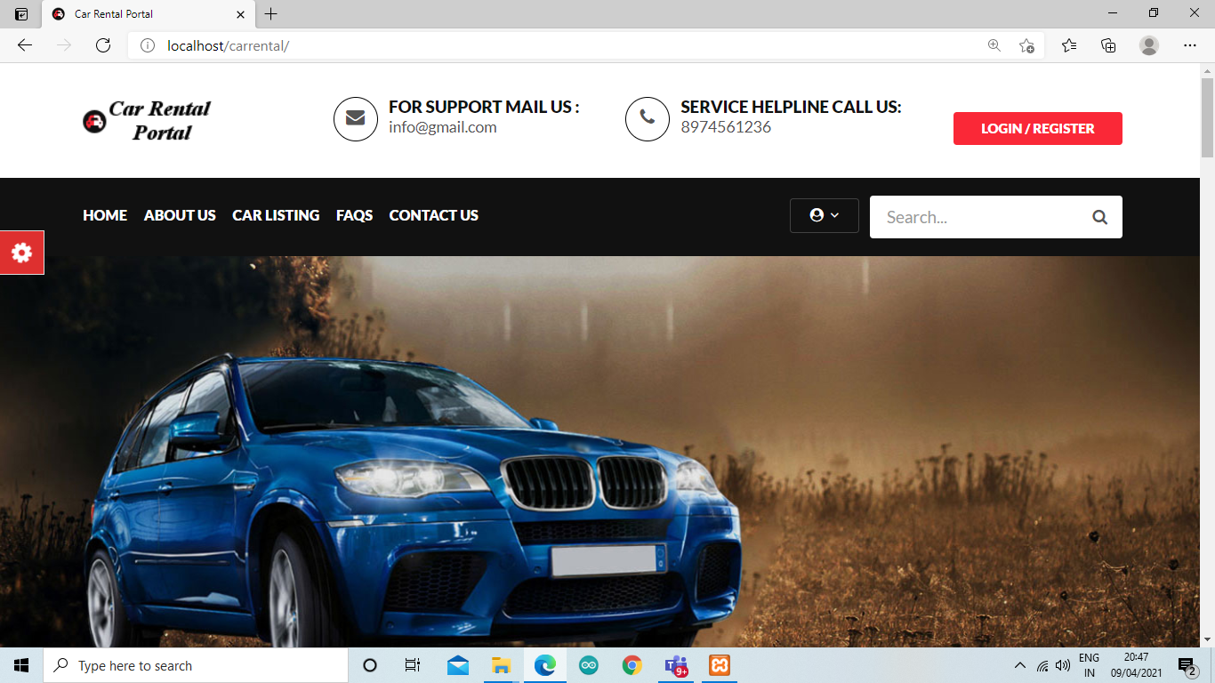

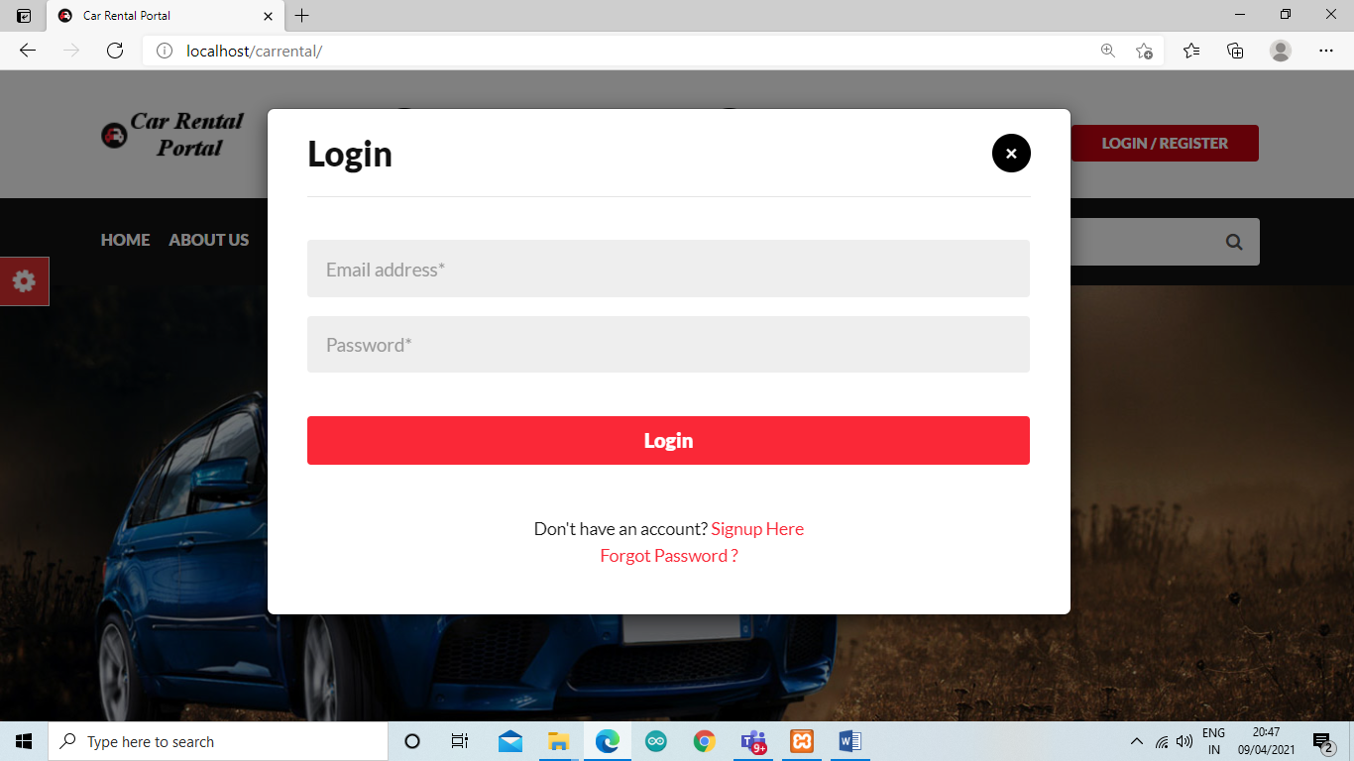

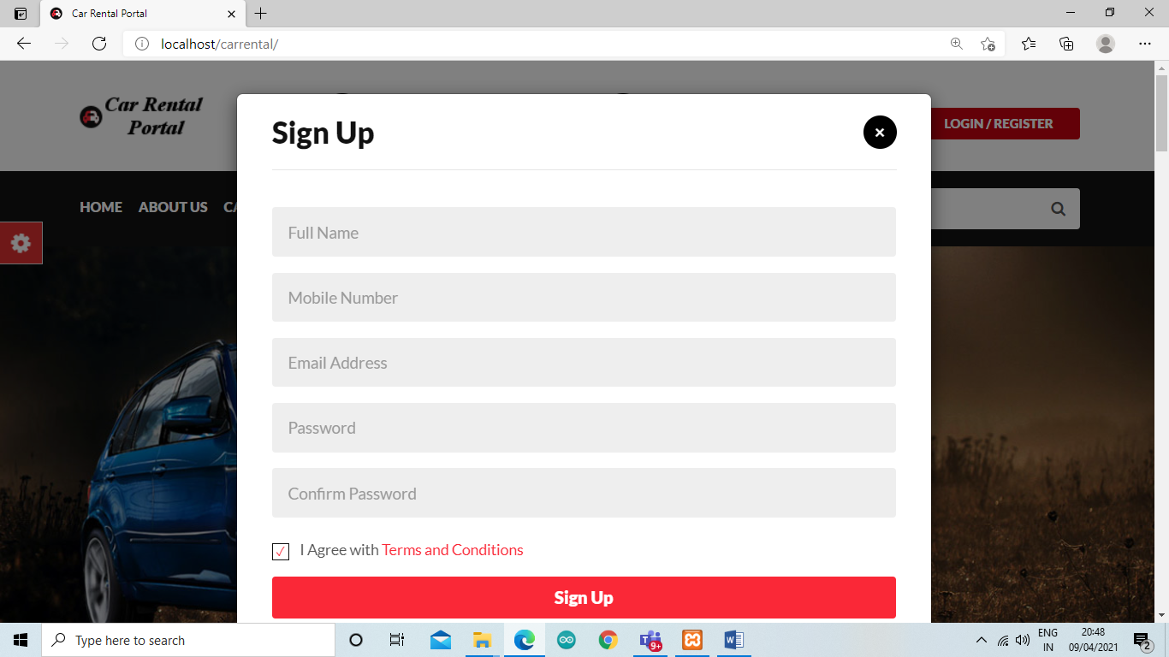

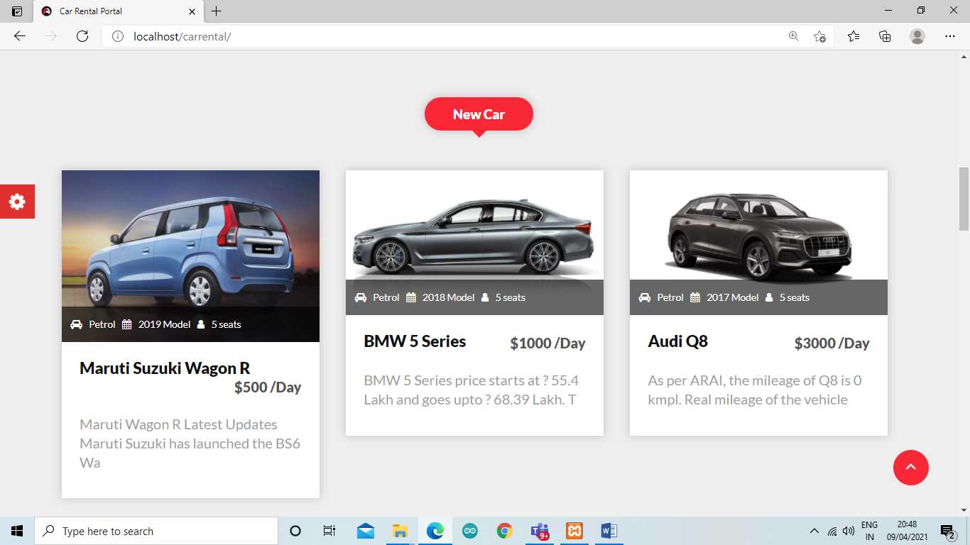

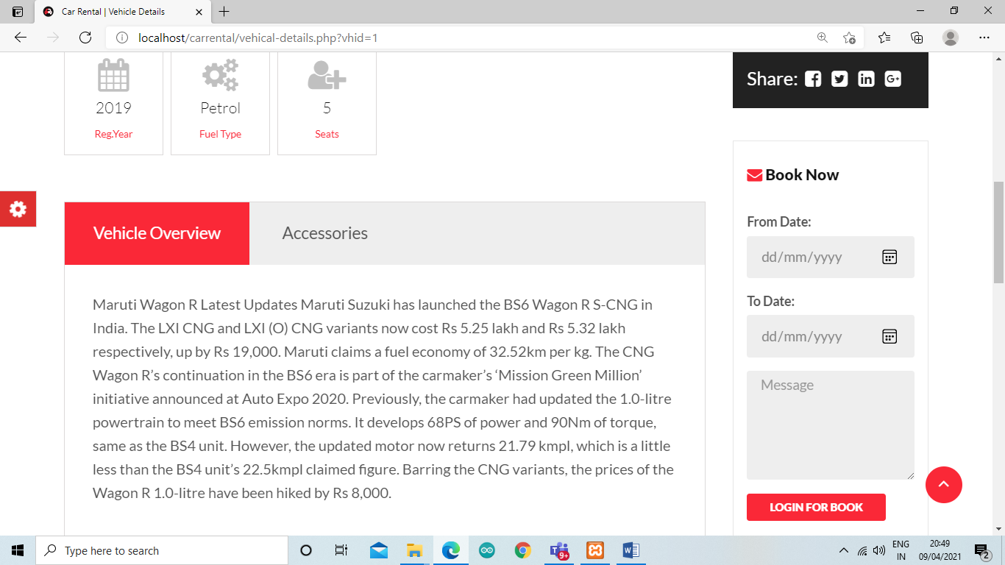

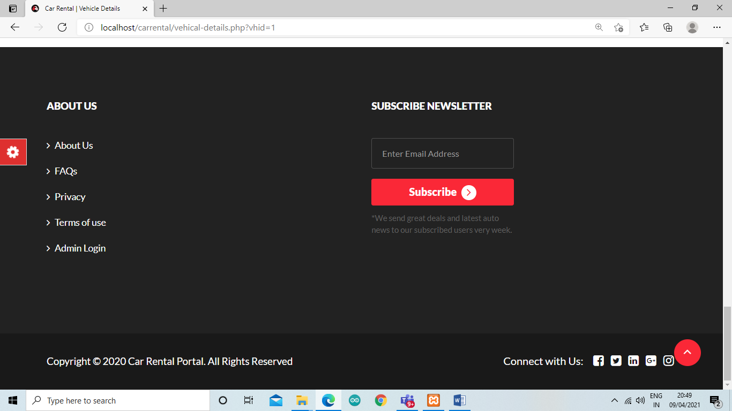

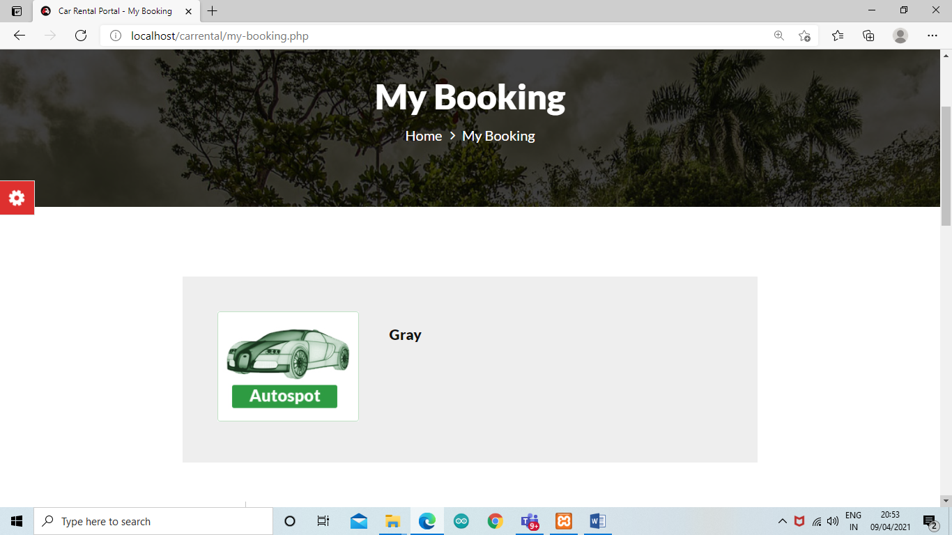

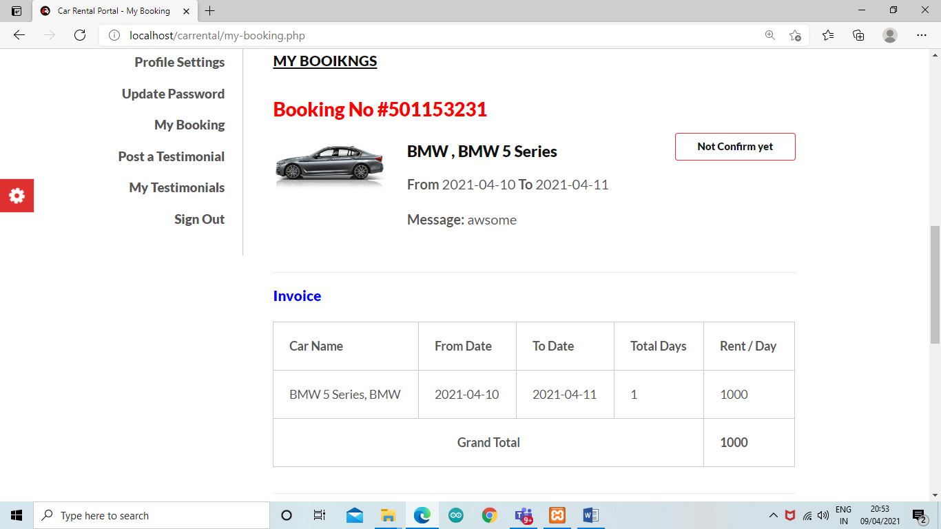

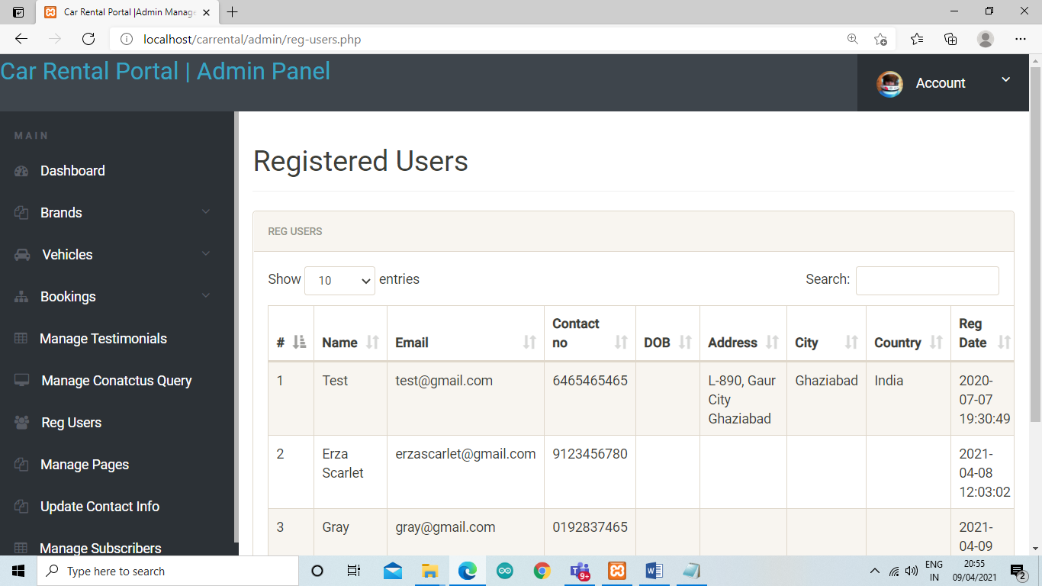

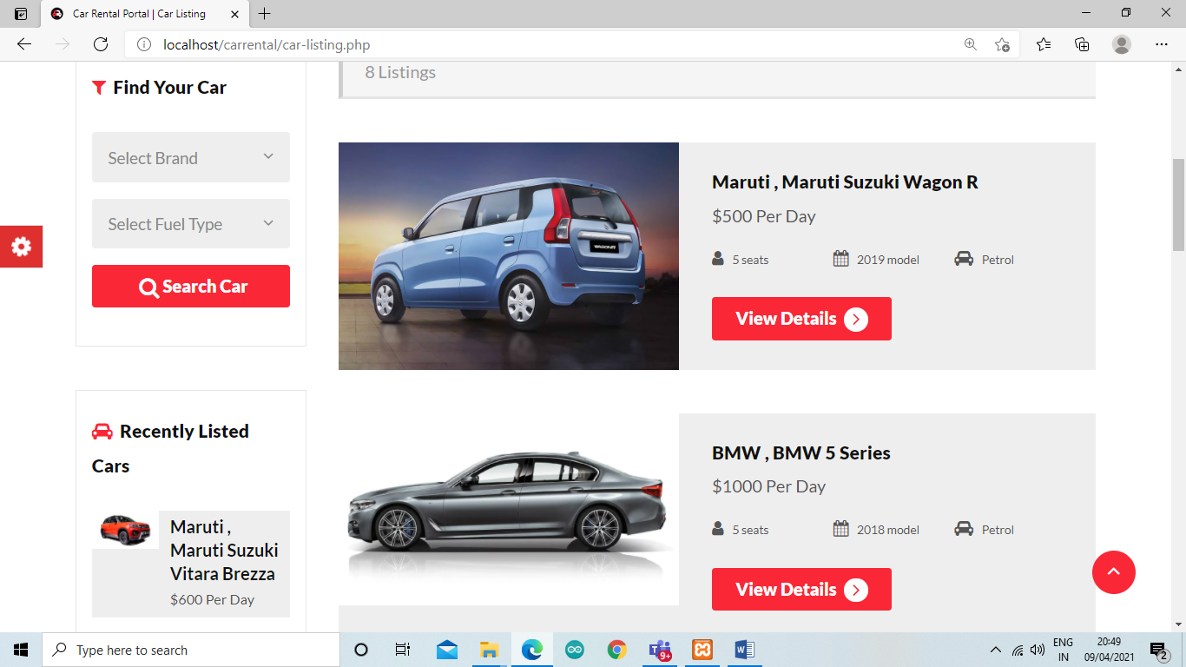

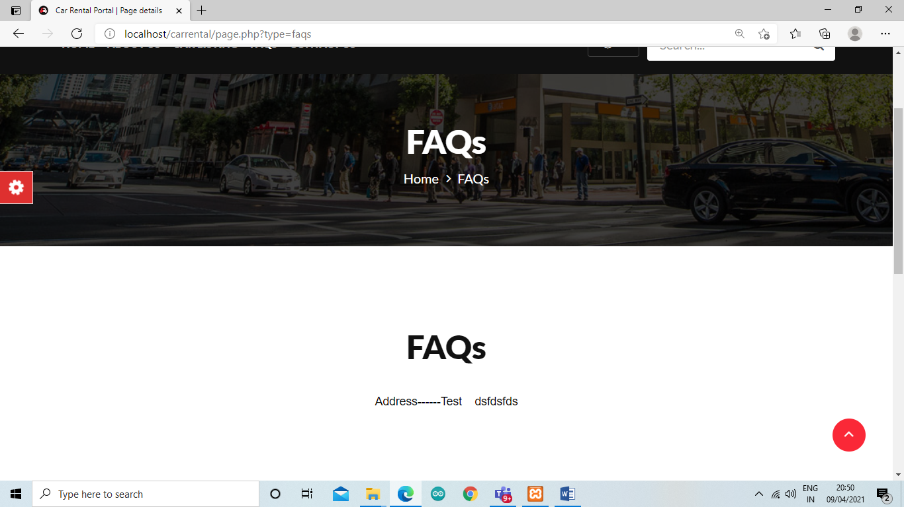

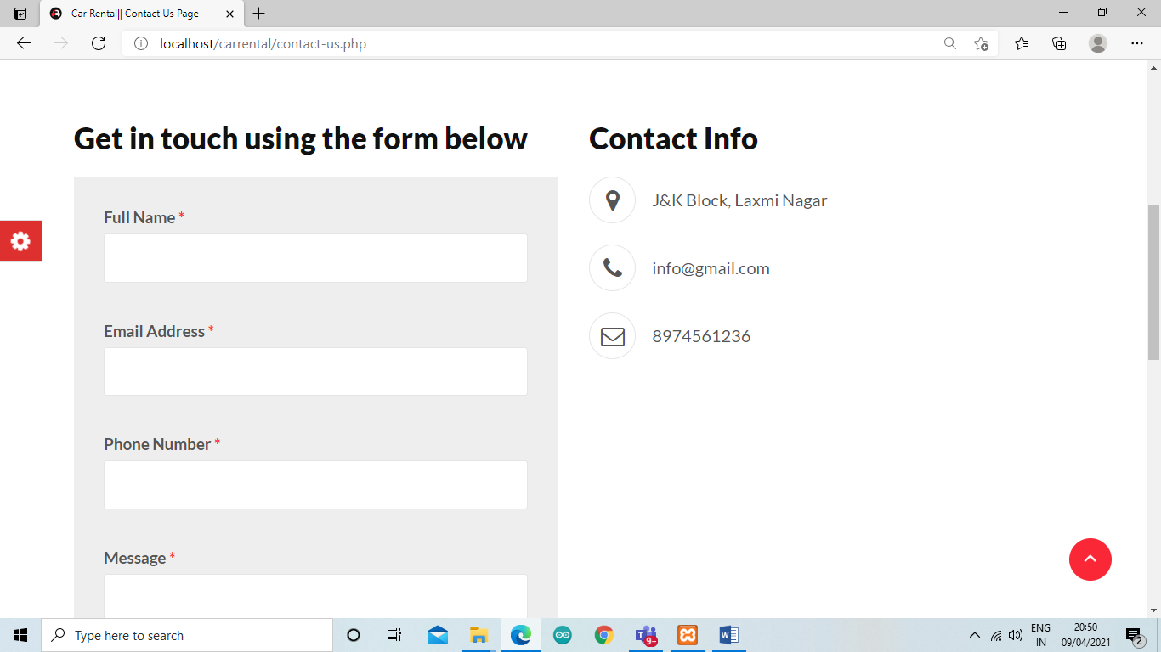

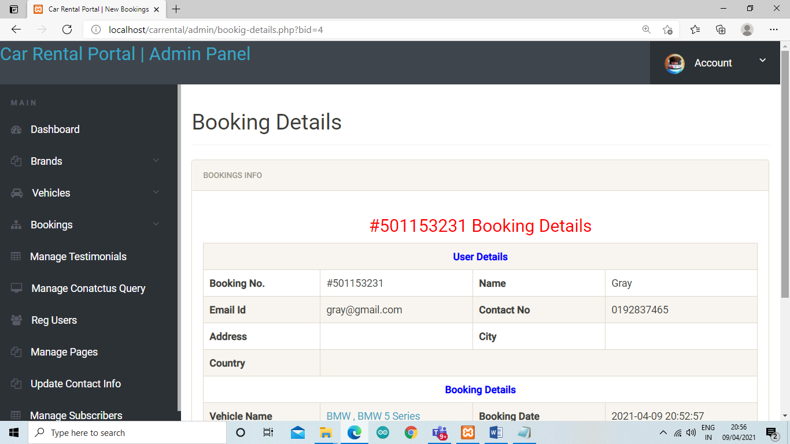

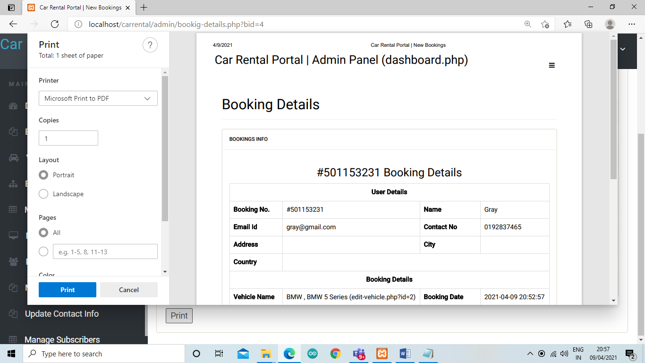

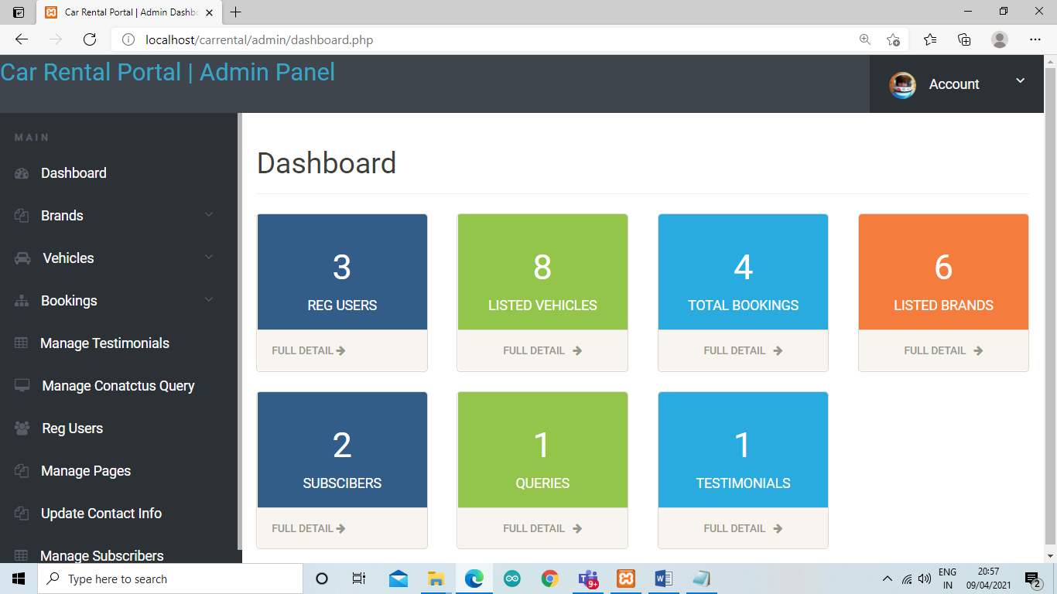

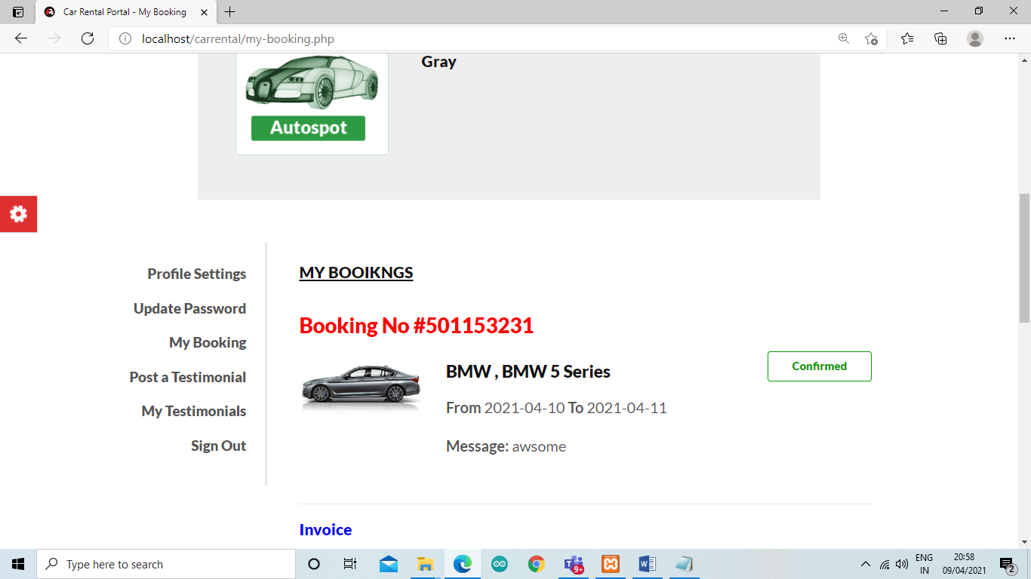

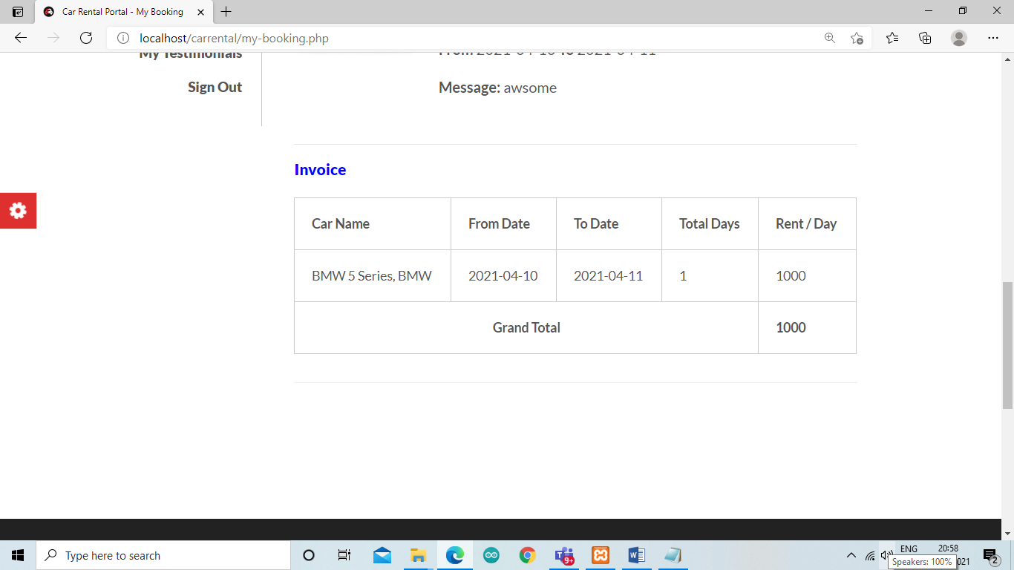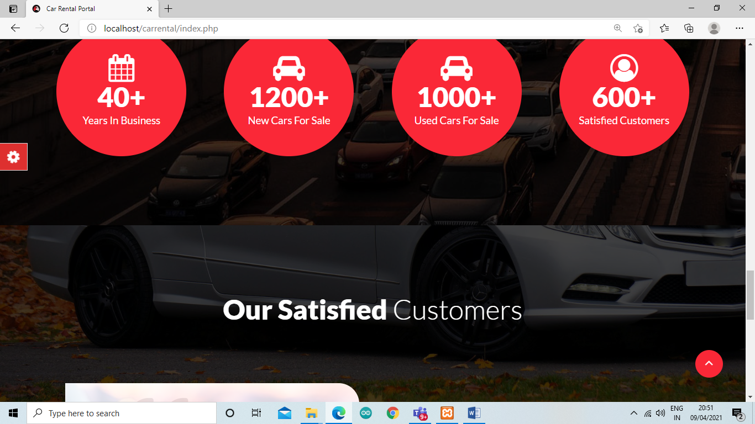

**Testing**:

The systems have the following inputs:

* First the customer has to make a reservation and later on in the process has to doregistration.
* Second if the customer had already registered himself then he can continue booking in his own account by giving his customer id or mail id.
* Thirdly, the customer can amend details or update hisdetails.
* The main outputs are whether the booking is confirmed or not and regular information’s services to the users of thesite.

Advantages: The project can be easily used in the process of decision making. Different types of reports can be generated which help the management to take

**CONCLUSION:**

**Problem restatement**

Based on the research done, some car rental companies still use desktop application for their car rental services and thus making it to be limited to so many important feature that are not available unlike in the web based application where there are so many feature available. Also some upcoming companies do not only make use of these desktop applications, but also make use of phone call reservation, which is still lacking so many features that are needed for this type of system.

**Department of MCA,MCC**